Section 1
Kingdom Fungi

Chapter 1.
What are Fungi

Mycology is the fascinating discipline concerned with the study of fungi. This is an extraordinary field with many questions remaining unanswered. Because so much remains undiscovered about fungi and how they interact with other organisms, the field is ever-changing with new information becoming available every day. With that being said, the goal of this book is to provide some background information about fungi and how they live, as well as outline some of the major interactions that fungi have with the Cannabis plant. This includes everything from mycorrhizal fungi that help Cannabis plants gain water and nutrients to the feared pathogenic fungi that form powdery mildew.
Science has attempted to classify organisms in a hierarchical way, in order to help organize and make sense of nature. As such, the different levels of classification of organisms starts with a Domain (there are only three domains of life; Archaea, Bacteria, and Eukarya), then Clade, Kingdom, Phylum, Class, Order, Family, Genus, and finally species, going from most broad to more specific. Fungi are Eukaryotes (Domain), in the clade Opisthokonta, having their own Kingdom of Fungi. All extant organisms on earth that we know of have descended from a common ancestor, known as the last universal common ancestor (LUCA). Scientific systematics reflects the relation of organisms to other groups through this classification system.
We can use his classification system to tell us some similarities and relatedness of fungi to other organisms in general terms. For instance, since all fungi are eukaryotes, we know that they all have true nuclei and membrane bound organelles, similar to land plants and animals. It has recently been discovered that fungi are found in the major clade opisthokonta because fungi have swimming gametes at a certain point in their lifecycle, or for the many that do not, are descended from ancestors who did. This also makes fungi more closely related to animals than they are to plants.

Table 1. Hierarchical classification of some commonly encountered fungi
Kingdom | Fungi | Fungi | Fungi | Fungi
Phylum | Basidiomycota | Glomeromycota | Ascomycota | Ascomycota
Class | Hemenomycetes | Glomeromycetes | Sordariomycetes | Leotiomycetes
Order | Agaricales | Glomerales | Hypocreales | Helotiales
Family | Agaricaceae | Glomeraceae | Hypocreaceae | Sclerotiniaceae
Genus | Agaricus | Glomus | Trichoderma | Botrytis
Species | Agaricus bisporus | Glomus  mosseae | Trichoderma  viride | Botrytis  cinerea
Common Name | portabello, crimini, button mushroom | arbuscular mycorrhiza,  endomycorrhiza | Green mold | Grey mold, bud rot

Some scientists estimate that there may be somewhere around 5 million species of fungi in the world, about 70,000 of which have been described (Blackwell, 2011). Regardless of how many species of fungi there are, what we do know is that fungi are a very diverse group of organisms that are (usually) ubiquitous in nature. We still have much to learn about this fascinating Kingdom.
Although the Kingdom Fungi is extremely diverse, there are still characteristics that all, or at least most, fungi exhibit. Fungi are eukaryotic, however, fungi lack vascular tissue that would help transport nutrients or water around the body of the fungus. For example, plants have the xylem, differentiated tissue specialized for the transport water from plant roots to the above-ground portion of the plant. Similarly the phloem the transports sugars from photosynthesis and other nutrients to the roots. Humans have a circulatory system that circulates blood, delivering oxygen and other important nutrients around the body. Since fungi lack such a system, they have evolved other means to transport nutrients around their body.
It is important to differentiate here that all mushrooms are produced by fungi, but not all fungi produce mushrooms. Not even all fungi undergo sexual reproduction, that we have observed, in nature. This means that a majority of the fungi that exist, we never see. This is either because they are too small to see with a naked eye or the are growing inside a substrate that keeps the fungus hidden until it is ready to reproduce.
Many fungi spend all of their life in a soil substrate and play immensely important roles in nutrient cycling and in agriculture. Therefore, some of these soil fungi still remain unknown to mycologists, fulfilling slightly different ecological niches.
Then there are also fungi that live a majority if not all of their life inside of plant tissue, whether it be in a root, stem, or leaf. Fungi that live inside of plant tissue are referred to as endophytic fungi. Endophytic fungi were gaining popularity in university research around 2010 and we are still trying to figure out exactly the role these organisms are playing inside the plant tissue.
All of these various types of fungi may look different superficially, but all of these organisms share some of the same features, which allows scientists to begin to classify these organisms. This allows us to start classifying and organizing the fungi in a meaningful way.
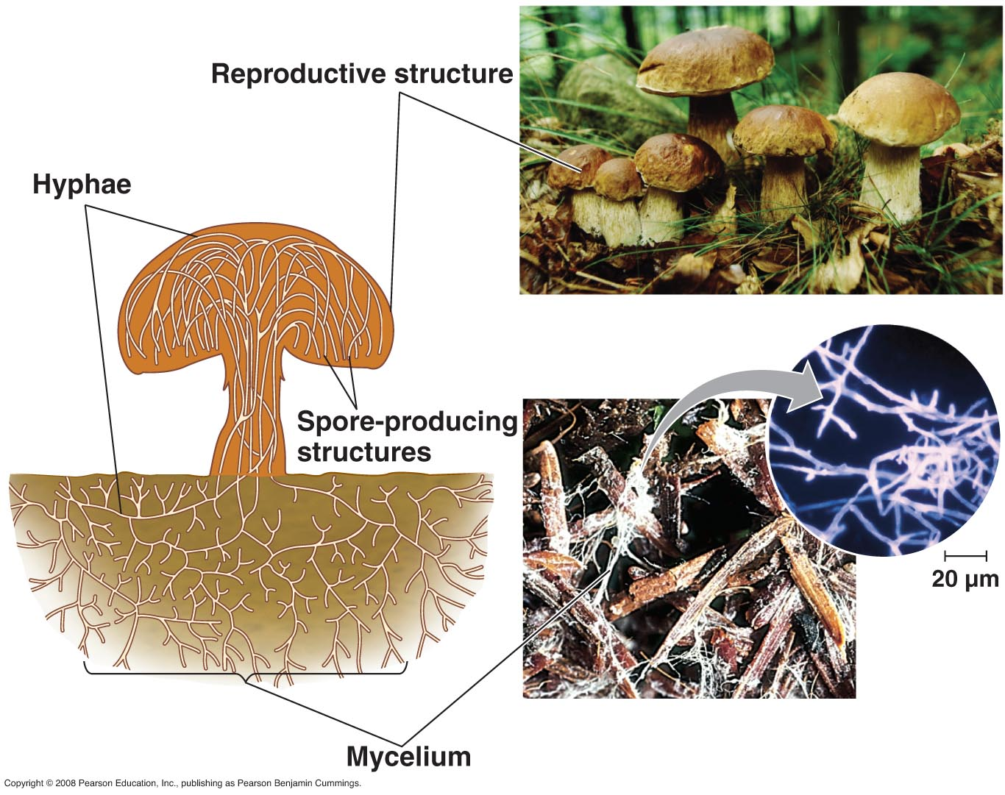
Figure 1. Mycelium comprises the totality of individual hyphal strands from a single fungus. Mycelium grows around and through food sources, such as the decomposing woodchips pictured. Once the proper environmental cues are received, mycelium begins to coalesce into tightly packed structures with will grow into mushrooms. The mushrooms are the part of the fungus that bear the reproductive structure where spores will be produced via meiosis. (http://biology-pictures.blogspot.com/)

Chapter 2.
Fungal Growth

There are two main types of vegetative growth forms that fungi display; filamentous and yeast. Both have cell walls composed of chitin and share some other characteristics as well. The body of filamentous fungi is made of thin, thread-like, typically cylindrical cells called hyphae (sing. hypha). These cells allow filamentous fungi to penetrate through substrates. All of the hyphae from an individual fungus is collectively called mycelium (plural mycelia when referring to more than one fungal individuals). The mycelium is the vegetative body of the fungus and is the necessary form for the filamentous fungi to collect nutrients and water (see Fig. 1).
Yeast forms grow as a single cell and can replicate via budding, creating an exact genetic copy of itself. However, the term ‘yeast’ refers to a single cell fungus. Yeast fungi can also reproduce via sexual replication.
These are the two main growth forms that fungi use to grow and acquire nutrients, and some fungi can even take on both a yeast and a filamentous form, depending on the growth stage and environmental conditions.

Filamentous fungi

Within the hyphae there are various organelles. Many of these organelles are ubiquitous among eukaryotic organisms (endoplasmic reticulum, mitochondria, golgi apparatus, etc.) including nuclei that house the fungus’s genetic material. Saprophytic fungi are fungi that decompose dead material. Many of these use filamentous growth to obtain nutrients by releasing enzymes out of the hyphal tip. These enzymes then break down complex materials into simpler compounds that the fungus can then assimilate and take back into the hypha. Once inside the hyphae, molecules are further broken down and metabolised by the fungus for everyday functions such as growth, synthesizing proteins, cell walls, hormones, sending signals to other parts of the fungus, etc. This is how a fungus ‘eats’ and grows. As a keen mycologist once put it, “It would be as if I went to a 5 star restaurant and ordered the surf and turf (or tofu surprise) and then when the meal came I vomited all over the dish and then stuck my hands over the mess to absorb the nutrients back into my body.” Quite the image.

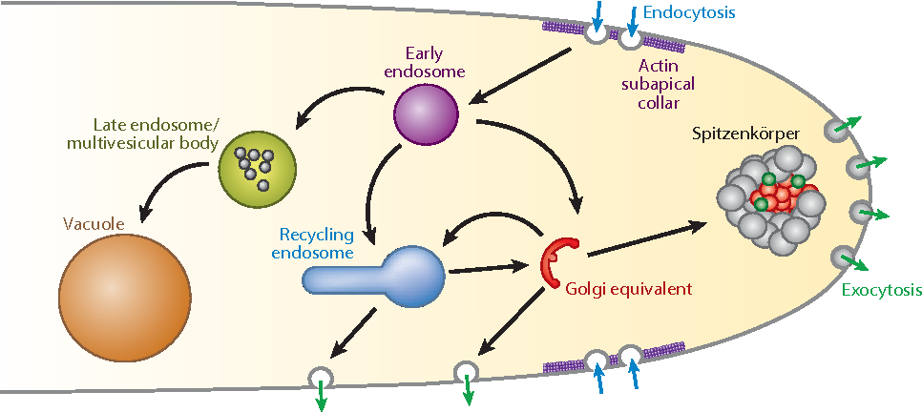
Figure 2. Growing fungal tip secreting enzymes and releasing into environment (exocytosis) and then transporting smaller molecules back into the hypha for growth (endocytosis). (Riquelme 2013).

Filamentous fungi have an organelle-like structure that is called a spitzenkorper at the tip of growing hyphae (Figure 2). This microtublue-dense organizational center delivers vesicles full of enzymes directly outside the growing fungal tip. This external enzyme bath breaks down complex materials into nutritive molecules which are then accessible for endocytosis by the fungus. Additionally, the breakdown of solid substrates clears a path for physical growth of and occupation by the fungus.
Another trait that some filamentous fungi possess is having septa. Septa are walls that some fungi produce behind the growing tip in order to divide the hyphae into different ‘cells’. These septa are perforated, allowing some organelles to pass while blocking others. There are two main different types of septa that are found in fungi; simple porate septa and dolipore septa. These different septa morphologies can be used to distinguish the phylum that the fungus is located in. Fungi in the phylum Basidiomycota have what is called a dolipore septum with a clamp connection. This type of septum has a membrane covering the central pores, allowing for the fungus to maintain its dikaryotic state (2 types of nuclei per cells) while still allowing small organelles and chemicals to pass.
Fungi in the Ascomycota phylum have simple porate septa. These septa have a central hole with no membrane to block certain organelles from passing from one cell to the next. Therefore, large organelles including membrane-bound nuclei are free to travel through the septa. Often there will be an accumulation of nuclei at the growing tip of ascomycete fungi.
If the hyphae does not have any septa at all, this is also an important feature, and is termed coenocytic or aseptate (Fig. 3). The unrestricted connectivity within the body of ceonocytic fungi and ascomycetes permit them to function as single, multinucleate cells. This allows the fungus to have many nuclei at the growing tip. In multinucleate fungi, genomic variation among nuclei allow these types of fungi more plasticity to adapt to the environment they are growing in.

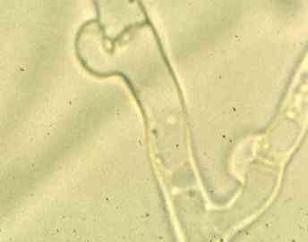
Figure 3. Clamp connections of a member of Basidiomycota at 40x. This feature is useful for identification purposes. (http://archive.bio.ed.ac.uk/jdeacon/microbes/basidio.htm)

Some filamentous fungi will produce a fruiting body collectively called a mushroom. A mushroom is simply a reproductive structure that certain fungi have evolved to produce. In general, mushroom producing fungi are not too involved with Cannabis, but there are some instances. For example, Pleurotus osreatus, the common oyster mushroom, can be cultivated on the dead biomass of Cannabis plants (the stems, the leaves). Another example of a mushroom producing fungus that aids in Cannabis cultivation is Stropharia rugosa-annulata or the garden giant (aka wine cap). This fungus is particularly good and decomposing organic materials such as wood chips or straw and is commonly inoculated in garden beds. Using the garden giant will help aid in nutrient cycling, improve soil structure, and may release compounds that influence plants and/or soil biology.
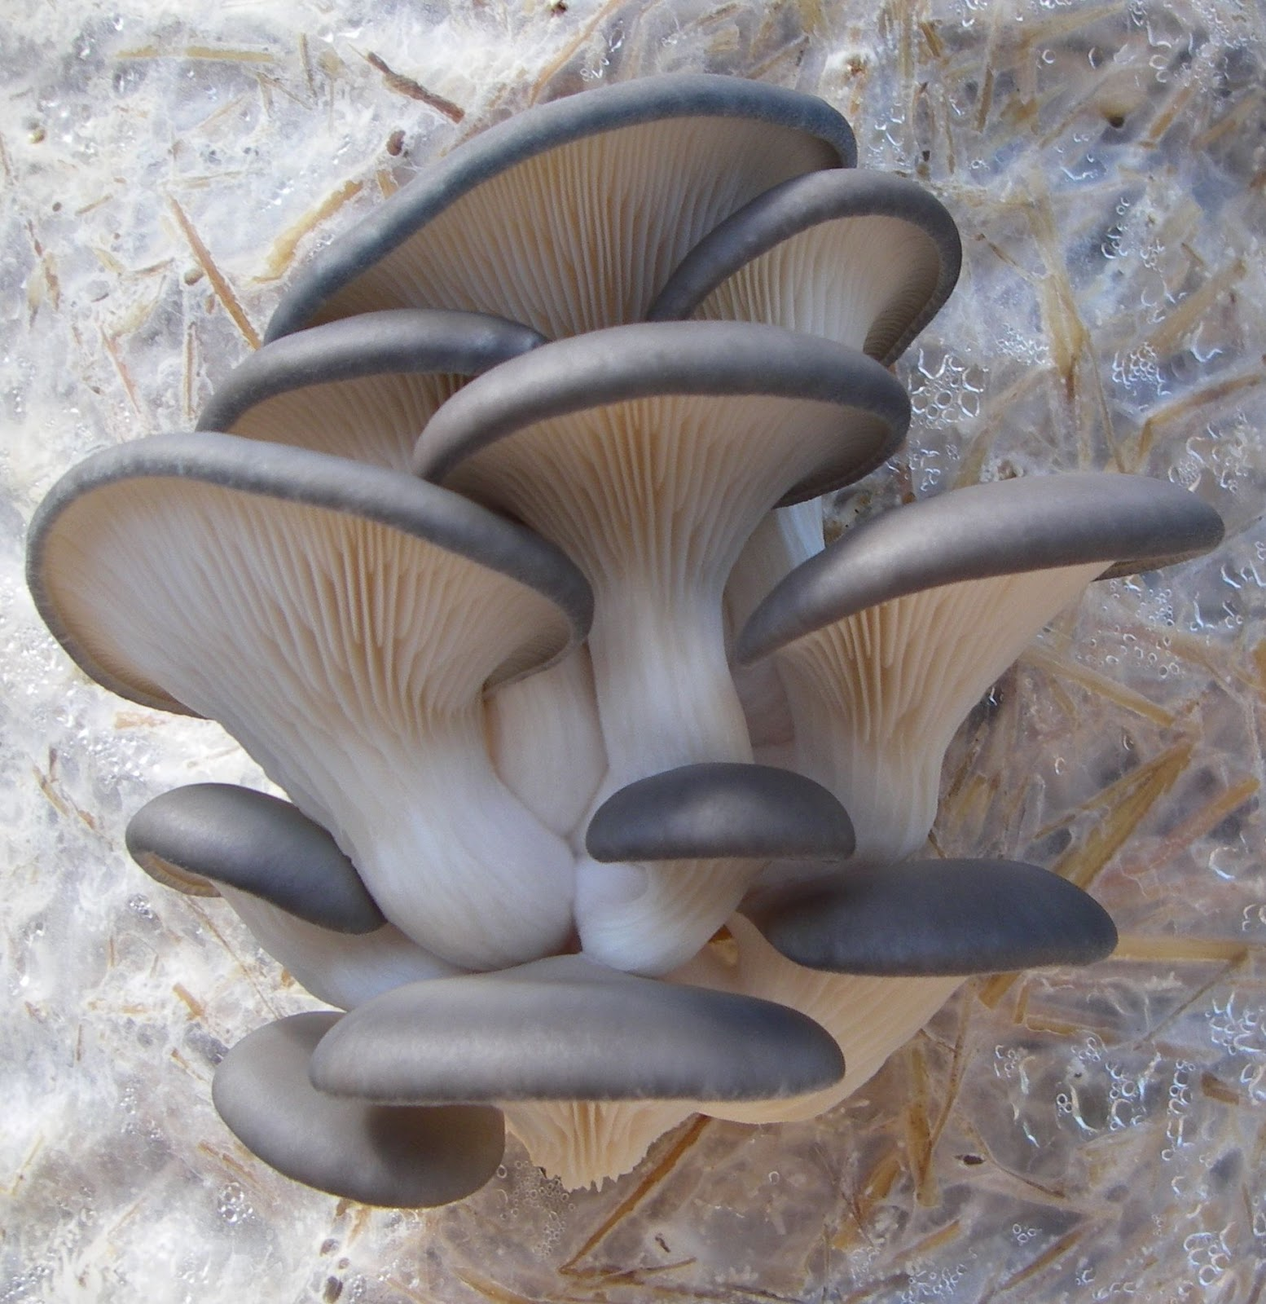
Drhealthbenefits.com 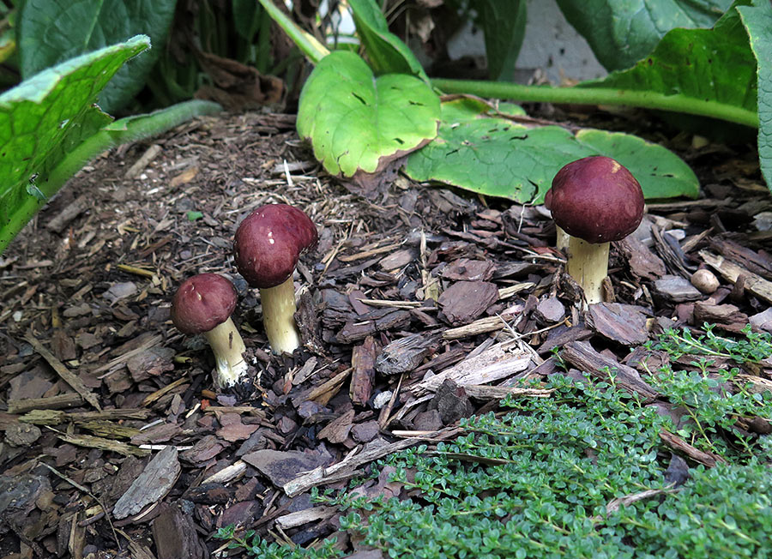AlboPepper.com
Put on 2 pages next to each other

Currently there is misinformation going around in the Cannabis industry, in particular in relation to soil fungi and compost tea. Some people say that if a fungus has septa, then the fungus is beneficial and will help with decomposition and plant growth. However, if the fungus does not have septa (coenocytic), then it is a pathogenic fungus and will kill plants and harm your soil community. While there is some instances where this may be true, this is a broad over-generalization and should not be used to identify beneficial vs pathogenic fungi. Possibly, what people are referring to is Oomycetes, or water molds, which a coenocytic, pathogenic, and also are not true fungi. (See chapter 5 for how to use a microscope to find key identification features of fungi).

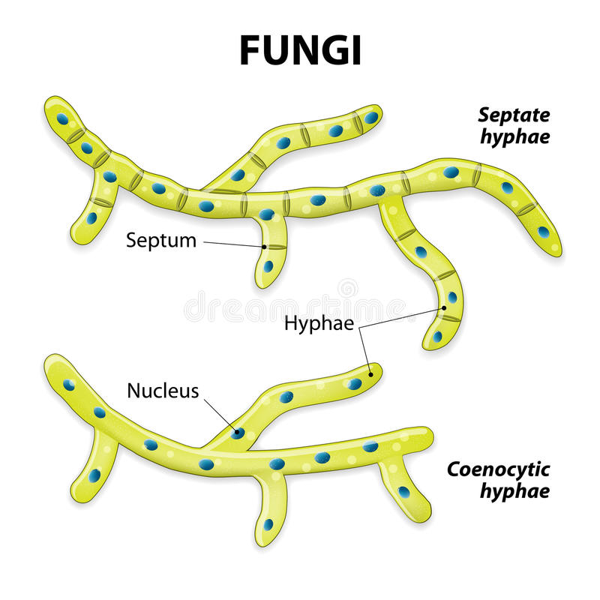
Figure 4. Fungal hyphae with septa (top) and without septa (coenocytic) on bottom. (dreamstime.com)

Yeast fungi

Yeasts truly are single celled fungi. An individual yeast cell is very small and cannot be seen with the naked eye. Therefore, the use of microscopes has greatly helped the field of mycology, in particular with yeasts. In general, yeasts are quite ubiquitous and are found throughout the world and in a range of habitats. The most famous yeast, Saccharomyces cerevisiae or the brewers yeast, is used not only to brew delightful beverages but also to bake bread. The same species (but different varieties/strains) are used for both processes. Thus humans and yeasts have a relationship as long as history. Some species of yeasts, such as Blastomyces dermatitidis which causes blastomycosis, are capable of causing serious diseases among humans.
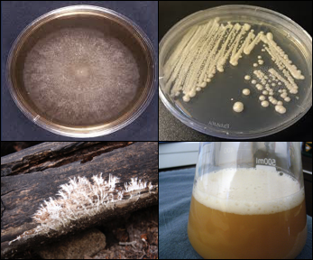
Figure 5. Counter-clockwise from the top left: 1. Filamentous fungus growing on a petri dish in a laboratory, 2. Filamentous fungus growing on/degrading a log (saprophytic fungus), 3. Yeast being grown in liquid culture to pitch for brewing beer, 4. Yeast being cultured on a perti dish in a laboratory. (1. http://microbiologyonline.org/, 2. eurekabrewing.wordpress.com, 3. gardenoftomorrow.com, 4. dcylab.wordpress.com)

Yeast are very difficult if not impossible to identify simply by looking at a microscope. There are some yeasts that display unique physiological traits that allow them to be identified by simple observation, but many need to be subjected to metabolic tests or, the most rigorous method of identification currently available, by using molecular techniques.
Even though yeasts may be hard to see and often go unappreciated, they too play an important role in the soil and in agriculture in general. The full role that yeasts play in soil and on above ground biomass of plants is poorly understood, but what we do know is that they are present when we look for them. These single-celled fungi help decompose organic matter, act as a food source for other soil life, produce novel metabolites that may influence plant growth, and help shape the soil structure. Without them, the soil and therefore the plants would behave very differently.
Another example of a fungus that forms yeast is Ustilago maydis, or corn smut. This fungus infects kernels of corn while the ear is still on the plant. The fungus hijacks the plant cells and causes them to grow larger than normal (hypertrophy) and causes an increase in cell division (hyperplasia). The kernels swell into gall-like cells that are then eaten and are an important ingredient in some Mexican cuisine (known as huitlacoche). This fungus actually lives as a yeast but also forms filamentous hyphae.
Most fungi either grow as a yeast or have a filamentous body of hyphae collectively called mycelium, or may switch between these forms. However, there are some other weird morphological shapes that fungi can take on that are not going to be discussed here because they do not have much, if any, interaction with the Cannabis plant. Some of those are chytrids, slime molds, and water molds (the latter two are not even true fungi, but they will be discussed shortly).
Filamentous growth offers certain advantages over yeast forms for the performance of particular tasks. The absorptive eating strategy employed by fungi benefits from a highly branched, fast expanding body with favorable surface ratio for the exploitation of an abundant food resource. As digestive enzymes released from the growing tip of the fungus, the hyphal body can absorb the products of the substrates decomposition via endocytosis. Filamentous fungi may also differentiate into specialized structures and have complex patterns of nutrient transport and metabolic coordination.
However, being small and simple in design has its benefits as well. Yeasts are capable of reproducing at an extraordinary rate. Because they are just a single cell, everything the organism needs to survive and reproduce is kept in every cell. Therefore, yeasts are quite efficient and have a high fitness rate.
As you can see, fungi can be quite diverse in appearance both macroscopically and microscopically. While these differences have proven useful as diagnostic features for the identification and classification of organisms, the true utility of these features is to allow fungi to specialize and exploit various ecological niches. Now let us explore further how fungi live, grow, and gather nutrients from their environment.

Chapter 3
Lifestyle

Fungi are eukaryotic organisms that do not have chlorophyplasts for the performance of photosynthesis. This has important consequences for members of the fungal kingdom. Lacking chlorophyll or any other chemoautotrophic biopathways, fungi cannot be autotrophic (produce their own food) and thus are reliant on the environment they live in for their nutrient demands. As such, fungi typically fit among three different types of lifestyles that they use to get nutrients. Those lifestyles are saprophytes (fungi that degrade dead organic material), parasites (fungi that live on another living organism and cause the host some degree of harm) and mutualists (meaning there are benefits to both the fungus and its symbiont). In addition to these lifestyles there are some fungi that derive all or part of their nutrients from carnivory; they do so by trapping soil inhabiting invertebrates using specialized hyphae. There are also some fungi that do not read the book and switch from being a parasite to being a saprophyte or a mutualist at one point and then a parasite later in the fungus’ life cycle. A good parasite never kills its host!
Saprophytes are very important in many ecosystems because they are the ‘grand recyclers’ and take dead material and make those nutrients available for other organisms to utilize. Therefore, saprobes play an important role in nutrient cycling. This makes these fungi very important for organic Cannabis agriculture. The garden giant (Stropharia rugosa-annulata) is one such fungus that is often incorporated into raised beds. The mycelium is mixed with pasteurized straw and then used to cover the soil on the garden bed. This not only cools the soil surface temperature and reduces weeds but it also adds nutrients to your soil and plants. Theis occurs because fungus is constantly excreting enzymes and breaking down complex compounds into simpler molecules that can eventually be assimilated by the plants. The garden giant fungus is also relatively easy to grow outdoors and produces an incredibly tasty mushroom, making it a perfect companion for outdoor plantings with Cannabis. It should be noted that care should be taken to ensure adequate nitrogen availability when adding low N mulch material; in the short term, N will be pulled from the top layers of the soil by saprophytes as they colonize and degrade new mulch.
Other saprophytic fungi include edible, mushroom-producing fungi such as oyster mushroom, shiitake mushroom, and button mushroom. Many soil fungi, including Trichoderma and Penicillium species, are saprophytes that do not produce mushrooms but play key roles in the conversion of organic matter into usable nutrients. In addition to decomposing materials and aiding in nutrient cycling, many soil fungi can produce novel metabolites that can influence the soil biology and can therefore affect plant growth. Without these amazing saprophytic fungi, the planet would literally be covered in dead organic waste comprising plant material and dead animal carcesses. Thankfully, fungi can act as nature’s recyclers! Whereas saprophytic fungi are growing on dead organic matter, parasitic fungi grow on living organic matter.
Parasitic fungi can grow on many different organisms, ranging from animals to plants, to even other fungi! By definition, parasitic fungi are fungi that derive their nutrients from another organism with no apparent benefit to the host. There are some fungi that act as human pathogens and can cause serious illness, especially in patients that already have a compromised immune system. For instance, athletes foot and ringworm are both diseases that affect humans that are caused by fungi in the genus Arthroderma! Then there are lots of other fungi that act as pathogens to plants. Some of these species of fungi are generalists and can live on a variety of host plants, whereas other species are specialists, growing only on specific host plants. For the Cannabis plant, there are a variety of fungal species that can act as pathogens and they range in the amount of damage to the host (Table 1.).
Though there are a number of fungi that act as parasites, there are also many that have beneficial relationships with other organisms. For our purposes, we will be focusing on fungi that interact with Cannabis plants to improve their growth; in return the fungi also benefits from its plant associate in some manner. This type of symbiosis, where two organisms interact physiologically to form a mutually beneficial relationship, is called a mutualism. For example, a lichen is a mutualism where a fungus acts as a mycobiont and an algae or cyanobacteria will act as a photobiont; together they create one organism, a lichen. Another example of this is mycorrhizal fungi. Mycorrhizal (myco- meaning fungus and -rrhiza meaning root) fungi form associations with the roots of many different plants and help deliver the plant water, minerals, and nutrients (in particular phosphorus) and in return the plants gives the fungus sugars that it makes in photosynthesis.
A fourth type of interaction that we see fungi engage in is called commensalism. This is when one organism uses another organism to its benefit, without causing harm to the other organism. In other words, when an epiphytic orchid is growing high up in the crevasse of a tree, the orchid has an advantage over other orchids because it is higher up and therefore is closer to sunlight and the tree (the other organism in this interaction) is not being harmed or helped.

Table 2. Important saprophytes, parasites, and mutualists for cannabis growers
Saprophytes | Parasites | Mutualist
Soil:  - Penicillium spp.  - Aspergillus spp.  - Trichoderma verde  - Trichoderma hazarium  Wood Rot:  - Pluerotus spp. | - Fusarium oxysporum  - Botrytis cinerea  - Erysiphe cichoracearum  - Podosphaera macularis  - Septoria cannabis | Arbuscular (Endo-):  - Glomus spp.  - Rhizophagus intraradices  - Funneliformis mosseae  - R. irregularis  Berruti et al 2015

Although these four different types of interaction or lifestyles may seem clearly defined, realistically in nature theses relationships are on a continuum. These four different lifestyles that we just described (Saprophyte, parasite, mutualism and commensalism) are all terms that were created by humans to help us understand nature. However, nature is not confined to such borders and therefore we see some organisms that are mutualists at one point in their life, and then they switch to being a parasite, and eventually they act as a saprophyte because the organisms is consuming the dead host that it just parasitized (Fig. 4). So, although we do our best to describe and make sense of nature, we always have to remind ourselves that nature doesn't always follow the book.

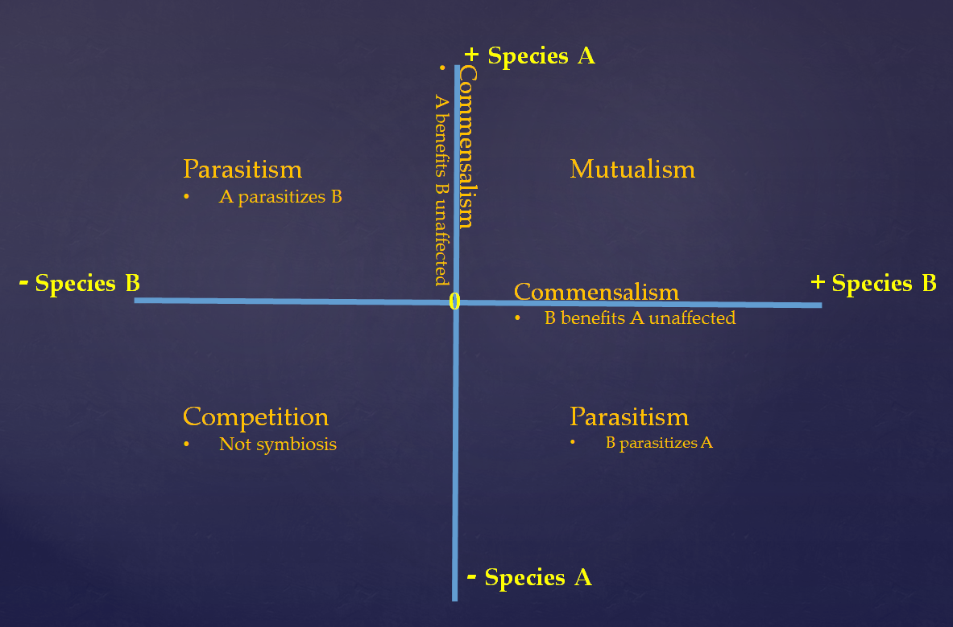
Figure 6. Symbiosis in a quadrant to depict the continuum of interactions that two or more organisms may display in regard to each other.

Chapter 4
Fungal characteristics

Historically fungi have been grouped closely with plants. To this day, within academia fungi are generally reserved for the purview of the botanists. We are aware of no University with a “Department of Mycology.” When University department or college is does include “mycology” in its title, it is invariably paired with the “botany” or “plant pathology.” While there is a level of logic behind this, as these two kingdoms are intimately linked in practice through symbioses, the original grouping of fungi and plants together was an academic mistake.
Fungi superficially grow similarly to to plants, with macroscopic forms appearing as sessile organisms with cell walls similar to plants and dependent on dispersal of reproductive structures for survival. Botanists, beginning with Pier Antonio Micheli who published Nova plantarum genera in 1729, were the first western scientists to pioneer the study of fungi. Pier Antonio Micheli was the first person to show fungi reproduce via spores. Before his experiments showing that spores transferred to a new substrate gave rise to the same species of fungi from which they came, the dominant view had been that fungi spontaneously generate.
The scientific study of mushrooms was mostly confined within botanical taxonomy for the next hundred years or so, pioneered by Carolus Linnæus. Linneaus’s work was expanded upon by other botanists, such as Christiaan Hendrik Persoon and Elias Magnus Fries. The person widely considered the father of plant pathology and mycology is Heinrich Anton de Bary. De Bary proved that potato blight was caused by an infectious agent, Phytophthora infestans. Before this work people believed fungi on diseased plants were a result of host illness, and not the cause. De Bary also intensively studied lichens and coined the terms “symbiosis” and “endophyte.”
Throughout this period fungi were considered lower plants. Ironically this tradition of grouping unrelated organisms within an unrelated field continues; the Amoebozoid “slime molds” (Myxostelida Dictyostelida,Labyrinthulida, and Plasmodiophorida) and the Chromistan fungi (Oomycota) are not true fungi. Nonetheless, the similarity of physical appearance, growth characteristics, and economic impacts of these organisms reinforce their retention as the domain of mycology (and likewise mycology of botany). In fact the aforementioned Phytophthora infestans, among the most famous ‘fungal’ plant diseases of all time due to the Irish Potato Famine, isn't a fungus at all; it’s an Oomycete (Heterokonta). Incidentally, Oomycetes are referred to by the confusing common name of ‘water molds’. This is same class as the genus Pythium, a common cause of damping off among seedlings of many plant species. Thus, the linkage of Plant Pathology studies and Mycology becomes clear.

Table 3. Hierarchical classification of 3 domains of life.
Domain | Kingdom
Bacteria | Bacteria
Archae | Archae
Eukaryota | Excavata | Various flagellate protozoa
 | Amoebozoa | Most lobose amoeboids and slime moulds
 | Opisthokonta | Animals, fungi, choanoflagellates
 | Rhizaria | Radiolaria, and various other amoeboid protozoa
 | Chromalveolata | Stramenopiles (Brown Algae, Diatoms etc.), Haptophyta, Cryptophyta (or cryptomonads), and Alveolata
 | Archaeplastida | Land plants, green algae, red algae, and glaucophytes

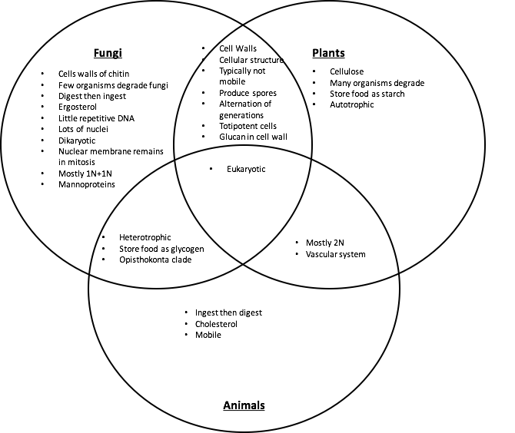
Figure 8. Venn diagram comparing fungal, plant, and animal characteristics, both similarities and differences.

Plants and Fungi

While the relatedness of fungi and plants has stunted scientists for generations, the aid of molecular sequencing techniques has recently helped unravel some of these mysteries. In the past, however, scientists were only able to observe morphological characteristics in these organisms and did there best to group them.
As stated before, plants and fungi share a number of similar characteristics but there are also some key differences between the two. To begin, both organisms are eukaryotic and have membrane bound organelles and a nucleus that houses the genetic material; DNA. However, fungi have relatively small nuclei with little repetitive DNA. Fungi can have one to many nuclei per ‘cell.’ Often these are genetically distinct nuclei when plasmogamy has occurred in the individuals history, among previously separate individual mycelia with either vegetative or mating compatibility. This allows fungi to be extremely adaptive to their environment. Plants have relatively large nuclei that are typically diploid in all cells except the sex cells (like animals) that contain the instructions to produce many different, complex structures and molecules.
A structure that both plants and fungi produce is cell walls. This allows both to have sturdy structures capable of above ground growth. Cell walls also serve to protect the cellular components and organelles found within. However, the composition of the cell walls is where the two differ. Plants have cell walls composed of cellulose (and sometimes lignin) whereas fungi have cell walls of chitin.

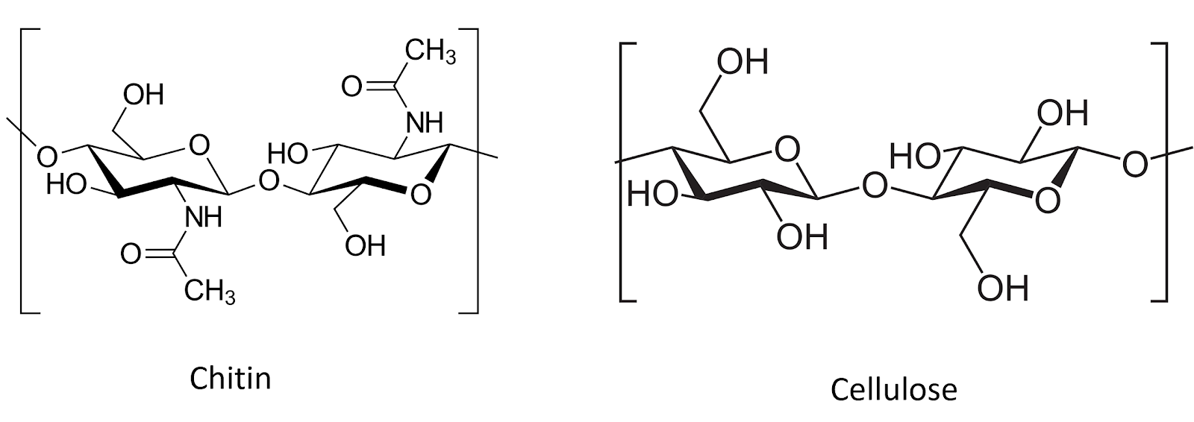
Figure #. Chitin and cellulose are both polysacharide chains of β1-4 linked monosacharide monomers. Chitin comprises chains of N-Acetylglucosamine monomers, whereas Cellulose is made of D-glucose monomers.

Because of the rigidity of the cell walls, both plants and fungi are generally sessile and must use alternate means to find nutrition. Plants are autotrophic and therefore able to produce their own food via photosynthesis. They also rely on root systems to gather essential elemental nutrients from the medium in which they grow. Fungi are heterotrophic, meaning they are unable to produce their own food. Therefore, they are entirely reliant on their mycelium (or yeast body) to get nutrients and food from the environment. Ultimately all of any fungi’s food is derived directly or indirectly from carbon sources produced from the fixation of atmospheric CO₂ by plants.
While fungi are generally ‘non-motile,’ their cells are connected in such a way as to allow much of the cytoplasmic contents to flow through the tubular hyphae. In this way a fungus can transport nutrients around its mycelium. While a fungus cannot move its existing body to a new location they are able to exploit cytoplasmic flow in order to change or expand locations by growing hyphae in new directions, flowing their cytoplasm into the newly formed mycelial body, and walling off older sections of their mycelium. In this way they may gain functional motility beyond that of most plants, despite lacking moving appendages and musculature, while maintaining a rigid cell wall which prevents ameboid movement via pseudopodia (although some yeasts can move in this fashion).
Another implication of being unable to move is that like plants, fungi cannot evade predators. Therefore, they are forced to come up with alternate defense mechanisms. Plant can develop thorns and spikes as part of their physical structure to discourage predators from attacking, however they also produce a variety of novel secondary metabolites that act as defense compounds. Fleshy fungi have generally not developed physical defense structures but they do also produce secondary metabolites to ward off competitors or predators. Some of these compounds include famous antibiotics such as penicillin or the citric acid that is produced from Aspergillus niger fermentation.

Animals and Fungi

There are a number of other key similarities and difference in plants and fungi that can be found in Figure 7. However, as mentioned before, fungi are actually closer to animals than humans. Again both organisms are eukaryotic with DNA and organelles. What makes fungi closer to animals than plants is the fact that they both evolved from the clade Opisthokonta. A common trait of this clade is mobile gametes at some point in the organisms’ lifecycle.
Obviously, most animals are mobile organisms that are adept at moving around to find nutrients and food, and evade predators. The cholesterol and lack of cell walls in animals assists in allowing them to be mobile. Fungi synthesize ergosterol as a sterol for the cell membrane and possess cell walls, preventing them from mobility. Both of these sterol compounds are derived from the same precursor, Lanosterol (Fig. 9), and help the cellular membrane to remain fluid. This fluid membrane allows for selective uptake of nutrients and compounds and also offers a degree of protection for the organelles found within the cell.
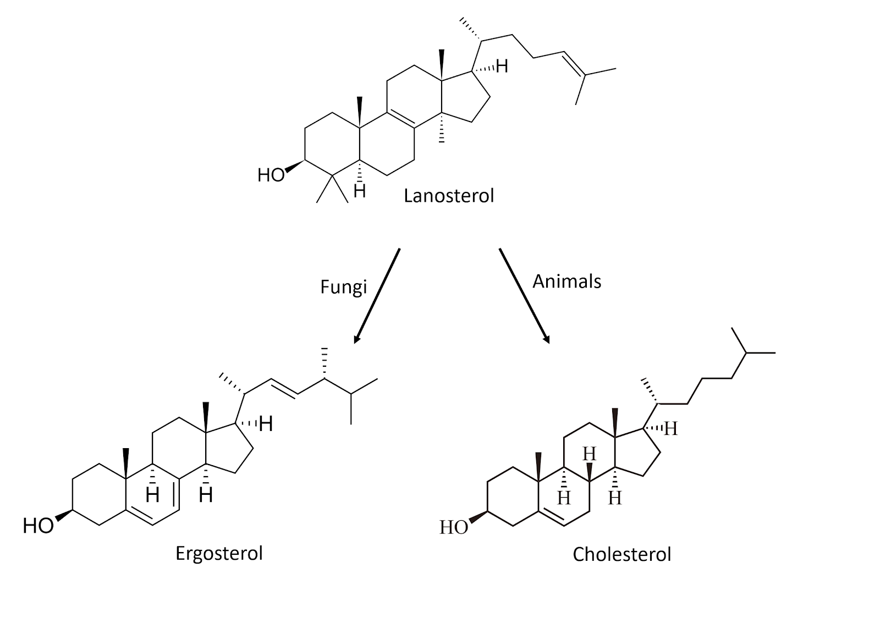
Figure 9. Chemical structures for sterol compounds found in fungi (Ergosterol) and animals (Cholesterol)

Both animals and fungi are heterotrophic thus neither can produce their own food. Thus, animals will ingest and then digest their food, whereas fungi digest (by releasing exoenzymes into the environment) and then ingest (by actively transporting nutrients back into the fungal body).
In addition to all of the mentioned similarities and differences to animals and fungi, there are some key metabolic differences as well. We do not need to have an exhaustive list here, but the key point that we want to make is that by determining the differences between animals and fungi we are able to develop drugs that can selectively kill (pathogenic) fungi that are causing harm to human health. We will touch more on this later.
Fungi, however, are extremely unique and diverse organisms that contain some characteristics that are not found anywhere else in nature. The way that fungi grow and obtain nutrients is completely different than any other organism. The fact that they are mono- or dikaryotic with many nuclei per ‘cell’ is fascinating. Also, most fungal cells are a little different than traditional biological cells. Yeast cells look similar to some bacterial cells, but are usually larger and spherical. However, with filamentous fungi the entire vegetative body is essentially one cell. Each portion of hyphae is interconnected (with or without septa), where organelles and sometimes nuclei are free to travel throughout the mycelium. These mycelia can be dikaryotic meaning the have two genetically distinct types of nuclei existing simultaneously. Eventually these nuclei will fuse, creating a diploid zygote, which will then undergo meiosis to create four genetically different offspring. However, existing in this dikaryotic state for an indefinite amount of time is truly unique to the fungal kingdom and could contribute to their success in nature.
Reproduction is fungi also contributes to them so successful in nature. Most members in the fungal kingdom reproduce via spores, where they produce a huge number of potential offspring in hopes that just a few will land in a new suitable environment and begin life again.

Chapter 5
Fungal reproduction

One of the main reasons why fungi are so successful and therefore so ubiquitous in nature is due to their mode of reproduction; spores! Most species of fungi produce spores in incredible quantities, both sexually and asexually. Clearly, fungi produce spores in such great numbers in hopes that at least some of the spores will land in a suitable environment where they can germinate and begin the process all over again.

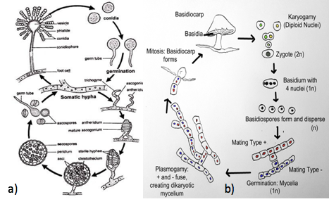
Figure 10. Life cycle of an Ascomycete (a biologydiscussion.com/fungi/aspergillus-habitat-reproduction-and-importance-ascomycotina/24000) and Basidiomycete (bstudy.com/academy/lesson/basidiomycota-life-cycle.html) fungus.

All fungi begin life as a spore (Figure 10). The spore can then germinate into either a hypha or a yeast, depending on the species. For some dimorphic species (capable of growth as a yeast or a filamentous mycelium), environmental interactions will determine their growth form. The hyphae will grow, secreting extracellular enzymes (exoenzymes) into their environment, allowing the fungi to penetrate and grow through substrate, in three dimensions. This hyphae only possess one type of nucleus.
When a hypha has only one type of nucleus in the cell, it is called monokaryotic. When one monokaryotic hypha meets another mating compatible hypha, the two will fuse, or undergo anastomosis, and the resulting hypha will be dikaryotic containing many nuclei with two distinct genetic codes. The two different nuclei will live separately in the same cell until the environment signals to the fungus that it is time to reproduce. At that time to two nuclei will fuse (karyogamy) and fertilization will take place. The result will be genetically different, sexual spores. Spores can be a result of sexual reproduction (meiosis and genetic recombination) or they can be produced asexually.
If a monokaryotic hypha is unable to find a compatible hypha to fuse with, this somatic hyphae can undergo asexual reproduction in order to create replicas of itself to further its distribution in hopes of landing in a suitable area where a compatible mate may be. Not all fungi are capable of producing asexual spores (conidiospores), which are genetically identical to the parent fungus. Sexual spores get half their genetic material from one parent and half from the other parent (similar to us!).
Spores also vary quite drastically in shape and size. As a matter of fact, spore shape/size/features/colors are often an extremely useful tool in identifying fungi. How spores are developed on the reproductive part of the fungus can be another useful tool in identifying the fungus in question.
In Basidiomycota, the spore will germinate and the haploid hyphae will grow searching for a compatible mating type, at which point anastomosis will occur and the resulting mycelia is dikaryotic. As the hyphal tips grow, a unique type of septum, a dolipore septum, will form. When this feature forms, a clamp connection will form as well, securing two distinct nuclei per hyphal section. The dolipore septum has a membrane covering the septal pore that blocks certain organelles (including nuclei) from passing, maintaining the dikaryotic state.
When environmental conditions are correct, which may be long periods of time, the two nuclei will fuse and a basidium (club like structure) will form. After the fusion of the two haploid nuclei, a diploid zygote is formed. This is the only portion of the fungal life cycle that is diploid. Following this, meiosis will occur, resulting in four, genetically different daughter nuclei. Each of these nuclei become a spore that is born on the tips of the basidia. The formation of this structure occurs on the fertile area of the fungus, i.e. the gills or pores of a mushroom.
In Ascomycota, again a haploid mycelium will grow until it finds a compatible hyphae, the two will fuse and dikaryotic hyphae will form. Ascomycete fungi wil form septa, however these fungi have a septal pore that is not cover by a membrane and thus nuclei and other organelles are free to travel. This has several implications. First, since nuclei are not restrained to a particular section of the hyphae, there tends to be lots of nuclear travel and a particularly high concentration at the growing tips. Having a large concentration of nuclei at the growing tips allows the fungus to be highly adaptable.
However, when sexual reproduction takes place, an ascogonium and antheridium will both form, the antheridium will coil around the ascogonium and karyogamy will occur. The resulting diploid zygote will undergo meiosis which produces four genetically unique nuclei, which then undergo mitosis resulting in eight total nuclei that is each destined to become a spore. This happens in the ascus (plural asci).
For some fungi, if they are unable to find a compatible mating time, can perform asexual reproduction. Lets face it, sex is hard and consumes a great deal of energy. By reproducing via asexual means and create genetically identical copies of itself, the individual fungus is able to expand its reach and colonize new environments, in hopes of finding a suitable mate. Some fungi produce both asexually and sexually, but some fungi are only known to reproduce asexually, and those fungi are placed in the artificial Phylum ‘deuteromycota’, or the imperfect fungi.
Septate fungi have an additional mechanism governing anastomosis (hyphal fusion) beyond mating type compatibility. Operating independently of mating type compatibility is vegetative compatibility. Vegetative compatibility is a self/self recognition system which allows septate fungi to form complex, reticulated mycelial networks by fusing each time hyphae from the same individual come in contact. This ability to form netted connections confers additional benefits for filamentous fungal growth.
Vegetative compatibility also offers a way to increase genetic diversity. If the hypha of two genetically unique individuals of the same vegetative compatibility group meet, their hyphae will also fuse (so it's more of a self/close-enough-to-self recognition system). The resulting mycelium will contain two (or more as occurrences of vegetative anastomosis accumulate) heterogeneous nuclei. Hyphae frequently occurs in a multinucleate state via this mechanism. This has important implications; the diversity of nuclei within an individual mycelium permits increased adaptive ability, conferring fitness to a wider range of potential environments.
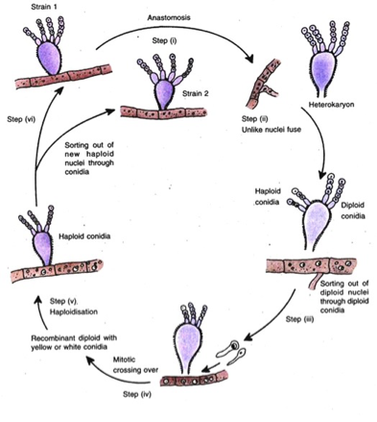
Fig _. Parasexual cycle in Fungi from Pontecarvo’s 1958 idea.

Following vegetative anastomosis some fungi, mostly the asexual deuteromycota, are able to undergo a pseudosexual genetic reshuffling without the use of meiosis. Following anastomosis (plasmogamy) the hypha is in a dikaryotic state. In the parasexual cycle, two heterogeneous nuclei fuse (karyogamy) forming a single diploid nucleus. A period of growth follows, with many cycles of mitotic divisions with occasional crossing over. Some of the resulting diploid daughter nuclei then undergo haploidization through a series of aneuploid intermediates. Aneuploidy refers to aberrant chromosome numbers in a cell. This differs from polyploidy in that individual chromosomes may be missing or duplicated, rather than complete sets. Through this irregular parasexual cycle (Fig _.), nuclei containing recombinant genomes derived from two parents may be created without meiosis.
Reproduction in the Glomeromycota (arbuscular mycorrhizal fungi) is a little different and not very well understood. Typically when mycorrhizal products are sold, the label will have a guaranteed minimum of fungi in the product. This is usually expressed as propagules per gram or spores per gram. Mycorrhizal species, especially endomycorrhizae, likely perform sexual reproduction, but it has not yet been witnessed in the lab or in nature. Therefore, producers use asexual spores that are typically produced at the terminal ends of hyphae. These asexual spores are relatively large and are genetically identical to the parent fungus that produces the spores. Some mycorrhizal fungi can produce asexual spores intercalary, or in the middle of growing hyphae. Regardless if that are at the tip of a hypha or found in between growing hyphae, they are often referred to as chlamydospores. These spores are thick walled resting structures that are capable of surviving long periods of time and even in harsh conditions.
The spores and spore bearing-reproductive structure are obviously gravely important for the reproduction and survival of these organisms. However, these structures are also extremely useful for people in identifying fungi.

Chapter 6
Fungal Taxonomy and Systematics

As we begin to attempt to identify different types of fungi, it is important to keep in mind what makes all fungi similar and also what makes a button mushroom different, from say, a morel mushroom. Macroscopically there are some clear differences. However, with the help of a microscope, there are features that easily separate out the various phyla of fungi. This will help out immensely when attempting to identify moldy fungi.
The hierarchical classification follows the same arrangement for all living organisms. That is, the classification begins with the most broad, least discriminatory features, and gets more and more specific with every step of the way. Therefore, all organisms are sorted into one of three domains, then into clades, followed by kingdom, then phylum, class, order, family, genus and species being most specific. Together, we use all of this information to create the ‘tree of life’ which help us visualize to relatedness of all organisms, from singled-celled bacteria all the way up to the high and mighty human being.
The scientific names of species, known as their specific epithet, consists of the two most restricted levels of the categorical titles mentioned: genus and species. This naming system is referred to as binomial naming and was pioneered by Carl Linnaeus, who also pioneered the hierarchical classification system. Linnaeus, working a century before the Theory of Evolution was to be elegantly described by Charles Darwin and Alfred Russel Wallace, was of the contemporary opinion that species were immutable and unchanging from their original creation. Therefor, Linnaeus's classification system was a taxonomy, concerned only with the naming of organisms and grouping together those those that appeared similar. Modern taxonomy now incorporates the Theory of Evolution to include not just diagnostic features of species phenotypic expressions, but also the relatedness of species through time. This synthesis of taxonomy and evolutionary relatedness is systematics.

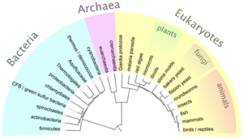
Fig. _. Example of a basic tree of life.

Depending on what source you read, there are 5-7 phyla in the kingdom fungi. We learned it as 5 phyla in the fungal kingdom. Those are the club fungi, Basidiomycota, the sac fungi, Ascomycota, the zygote forming fungi, Zygomycota, the endomycorrhizal fungi, Glomeromycota, and finally the mobile ‘little pot’ fungi , the Chytridiomycota.
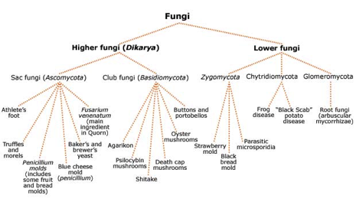
Figure 2. Fungal kingdom tree of life.

The two largest of the five fungal phyla are Basidiomycota and Ascomycota (these are also the two phyla that all mushroom producing fungi belong). In Basidiomycota, spores are borne exterior on a club-shaped structure called a basidium in groups of four, typically. Whereas in Ascomycota, spores are developed inside a sac-like structure called an ascus, typically in groups of eight spores. Throughout our journey with mycology we will see time and time again the spores and spore-bearing structures will aid us in identification.
Although people have been studying and attempting to classify fungi for hundreds of years, fungal systematics is in a state of constant flux. Scientists and researchers frequently go back and forth on where certain fungal organisms belong on the tree of life. With the advancement of various molecular techniques we are able to better estimate the relatedness of different fungi. However, names and placement on the tree of life is still changing frequently and it is important to remember that these are classification systems are our best current understanding of these organisms relatedness in nature. With that in mind, we must accept that some fungi that we now know by certain names may be given a new name in the upcoming years.
For our purposes, the main phyla that we will be concerned with as farmers and growers are Ascomycota, which is home to many soil decomposers and also dreaded pathogens, the Basidiomycota, which contain many of the typical mushrooms we think of that are responsible for some of the primary decomposition, and the Glomeromycota, which are the arbuscular mycorrhizal fungi.
The fungi found in these three phyla have vastly different modes of reproduction and thus have clearly been grouped into different categories. There are a number of features that these fungi share but there are also key differences that become very useful when attempting to identify unknown fungi. Scientist have used these traits and features to group like organisms, and now, with the advent of molecular sequencing, have confirmed the relatedness of many of these fungi.
The first group of fungi we will discuss are found in the phylum Ascomycota. These are the mold fungi and often go unseen. Many of these organisms are filamentous molds that grow via hyphae. They will be found in most soils where any amount of organic matter is present. Some ascomycete fungi are actually responsible for remediating contaminated soil sites (ADD CITATION!!!).
Fungi such as Trichoderma, Aspergillus, and Pennicillium are all soil fungi belonging to this phylum. It is important to remember that because they are found in Ascomycota, this means they have interior borne spores that are produced in asci, the will have simple septate hyphae, and will often undergo asexual reproduction.
The consequences of this are organisms that are able to rapidly reproduce and mutate. These fungi are wildly adaptable to new environments and produce a slurry of novel metabolites. Some of these compounds may be extremely important to mankind and agriculture (ADD CITATION!!)
The ascomycete fungi, however, are not solely responsible for the breakdown of organic material. Fungi in the phylum Basidiomycota also assist on the breakdown of cellulolytic and lignin based materials.
The fungi that we are concerned with in Basidiomycota are primarily saprophytic fungi that degrade organic material and aid in nutrient cycling. These are mushroom-producing fungi. They can break down woody plant material from leftover crop residues and also herbaceous material.
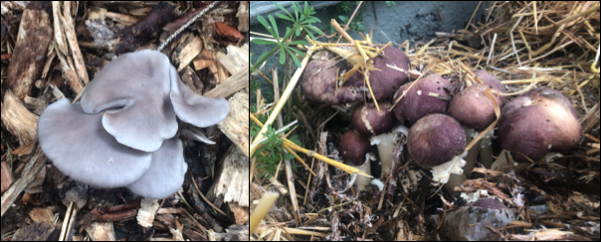
Fig. _. Woodchips/straw mulches can be inoculated with various Basidiomycete fungi to help break down organic materials and make nutrients more bioavailable to your crop.

These macrofungi act as primary decomposers, usually being first to the scene where the begin to digest the carbon based material. This break down adds organic matter back to the soil, but also releases nutrients in a more bioavailable form. Adding Stropharia rugosa-annulata or Pleurotus osteatus (Fig. _?) to the mulch layer on top of the soil can help release nutrients over the course of the season. Doing so will also increase the soil biology.
Often when these organisms colonize straw or mulch on the top layer, this draws earthworms and insects and bacteria to the soil system. This in turn speeds up nutrient cycling and thereby increase the amount of nutrients that are available to the plants. Adding biology to your system may help make the soil community more robust and resistant to possible pathogens.

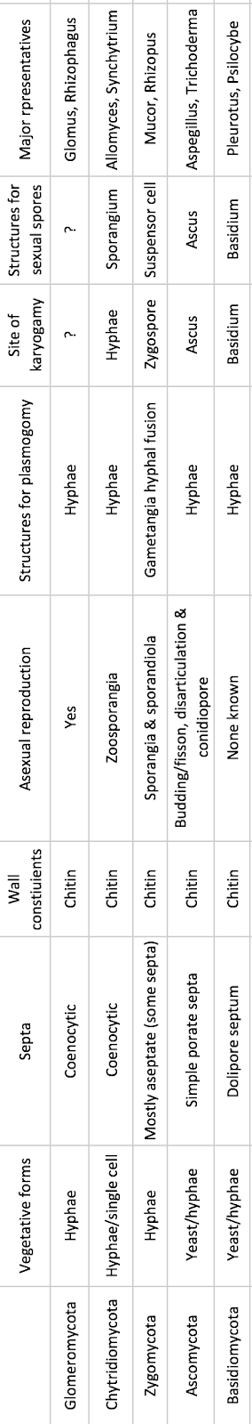

Section 2
Fungal Friends

Chapter 7
Symbiosis and mutualisms

Time and time again in nature, we witness two or more organisms living together in harmony, sharing some sort of physiological interaction. Images of clown-fish swimming through anemone may come to mind, or maybe a monarch butterfly pollinating flowers (Fig. 1). In fact, there are more non-human cells on/in the human body than actual human cells. This is due to the countless bacterial and fungi cells on our skin, in our mouth and stomach, aiding in the digestion of our food. Well, these are all examples of mutualistic interactions where both organisms involved are benefiting from these evolutionary partnership.

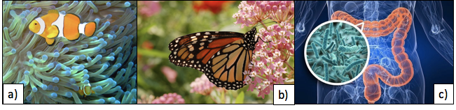
Figure 1. Common Mutualistic symbiosis examples a) clownfish protecting anemone in exchange for protection against enemies, b) Monarch butterfly pollinating milkweed plant in exchange for a safe location to lay eggs, and c) bacteria in the gut and intestinal of humans, aiding in the breakdown of food and digestion of nutrients in exchange for free food and a safe place to live.

Symbiosis refers to two or more organisms interacting physiologically. As discussed earlier, there are three typical relationships that are observed; mutualism, commensalism, parasitism. It is a common misconception that symbiosis refers to only beneficial interactions (mutualisms) but according to the definition, symbiosis encompasses parasitic and commensal interactions as well. The interacting organisms have coevolved with each other, influencing their lifestyles through selective pressures, shaping how they both live. These interactions have been evolving for many thousands of years and are still evolving to this day! For this section, we are going to be discussing mutualisms between the Cannabis plant and members of the Kingdom Fungi.
Microbes are found everywhere! And they interact with all sorts of organisms, causing animals to get sick, but also helping us digest and get valuable nutrients from food. They are found on all parts of our body (inside and out!), so it is no surprise that they are found in outstanding numbers in the air and soil. In fact, with every breath we take we are inhaling an incredible amount of spores and cells and then exhaling them (hopefully!). Soil scientists have determined that there are more organisms in a gram of soil than there are humans on the planet. (10,000,000,000 bacterial cells per gram soil, population of earth July, 2018 ~7,600,000,000) (Raynaud & Nunan, 2014).
Clearly, microbes play a variety of roles in all ecosystems and are key for maintaining homeostasis. As such, many soil organisms interact both directly and indirectly with Cannabis plants. Fungi found in the soil include not only mycorrhizal fungi such as Glomus and Rhizophagus species but also common soil saprophytic fungi including Aspergillus and Trichoderma species (Fig _.). These different groups of fungi interact with Cannabis in vastly different ways but are both key to the health and survival of these plants, indoors and out.

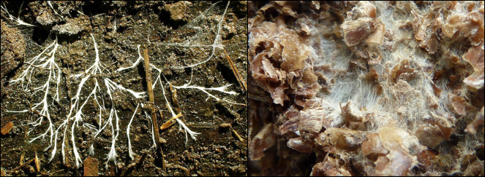
Figure 2. Fungal mycelium growing in soil, digesting organic matter and releasing bioavailable nutrient.
Chapter 8
Mycorrhizae Fungi

One of the oldest examples of a mutualistic symbiosis where both partners benefit is the example of land plants and mycorrhizal fungi. It is said that these fungi, which reside on and/or in the roots of plants and help the plant acquire water and nutrients, are what enabled plants to move out of water and onto the land. What an evolutionary partnership! Since this relationship has been developing for hundreds of millions of years, it is easy to understand why about 95% of land plants form some sort of mycorrhizal interaction with fungi. In fact, some plants (sometimes even individual roots) can form associations with more than one mycorrhizal fungus!
Clearly, since this relationship has been developing and evolving for millions of years, both partners must be pretty happy. But what is each organism getting out of the relationship?
Well, fungi are not plants and therefore cannot photosynthesize to produce their own sugars. So these fungi need a carbohydrate source to survive and plants are able to synthesize sugar from sunlight, CO2 and water. Since the plant has more sugar than is required for the plant to grow, the plant shuttles a majority of its sugars down to its roots where it is released around the root zone in the rhizosphere. These sugars are combined with other compounds and excreted to attract a desired community of microorganisms to help the plant.
Of the microbes attracted to this sugary extracellular matrix, mycorrhizal fungi are included. Spores of some mycorrhizal fungi even depend on the presence of this root exudate to germinate. Once the spores detect the presence of certain compounds, they begin to swell and hyphae emerges from the germinating spore. The hyphae will continue to grow towards the root and, depending on the particular fungus, may penetrate the plant cell or may form a sheath surrounding the plant root (Fig. 1). Either way, the plant will send sugars to the root to feed this fungus and begin the mutually beneficial partnership in life.
Once the plant and fungus have developed this connection, the fungus begins acquiring water and nutrients from its surrounding environment. The fungal hyphae are much thinner than a plant root and are very highly branched. This means that by having the fungus attached to a plant root and extending out into the soil substrate, the plant greatly increases its root surface area and is able to access areas that the plant would not be able to penetrate without the help of fungi.
Mycorrhizal fungi also release organic acids and chelating compounds into the environment to break down complex molecules into simpler compounds. Thus the fungi are able to acquire mineral nutrients that plants are unable to. The fungi then share these minerals with the plant in exchange for the sugars that the plant made during photosynthesis. There are different forms of mycorrhizal fungi, but in general, this is what each partner gets out of the relationship.
In nature, there are many different types of mycorrhizal relationship that we can observe. There are three main types of mycorrhizal interactions, with many sub-classes being discovered every year. Some people consider there to now be as many as seven different types of mycorrhizae! The three that we were taught are: endomycorrhizae, ectomycorrhizae, and orchid mycorrhizae. We will discuss each of these briefly but will focus on endomycorrhizae, because those are the only known mycorrhizae that Cannabis partners with.

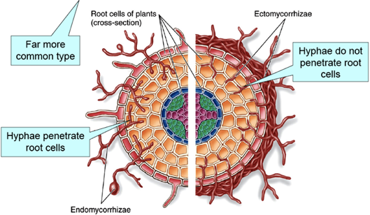
Figure 1. Endomycorhizzae vs Ectomycorhizzae. The major differences being the mantle formed around the root with Ecto and the fact that Endo penetrate the root cell, whereas Ecto do not. https://www.plantscience4u.com/2013/03/ectomycorrhizae-and-endomycorrhizae.html#.W14dsBOPLBI

Table 1. Common species of Endomycorrhizae vs Ectomycorrhizae
Endomycorrhizae | Ectomycorrhizae
Funneliformis  Glomus  Rhizophagus  Gigaspora | Tuber (Truffle)  Aminita  Laccaria
Plant associates: most vegetable and hebaceous plants, many grasses | Plant associates: Hardwood and soft wood trees, many woody plants

Endomycorrhizae
Endomycorrhizae (aka arbuscular mycorrhizae ‘AM’ or vesicular arbuscular mycorrhizal fungi ‘VAM’) are fungi that penetrate the plant cell wall, but do not enter the plant cell membrane (Fig. 1). Part of the fungus lives in the soil where it encounters organic compounds, excretes extracellular acids, and then absorbs nutrients that the fungus then shares with the plants. The other part of the fungus lives inside the plant root. Once inside the plant cell wall, these fungi will often form an arbuscule, which is a highly branched, terminal end of a hypha. Arbuscules are where the plant and the fungus exchange nutrients because of the great surface area of contact that the two organisms share, allowing maximum interface between the fungus and the plant cell.
These fungi are very common in nature and are often times considered ‘generalists’ due to the fact that they can inoculate many different plant species. It is estimated that over 80% of all land plants form associations with this type of fungus (Schu ̈ßler et al., 2001). Typically, it is said that mycorrhizal fungi help plants by delivering them with minerals, in particular phosphorus, and water. Therefore, in environments where there is excess phosphorus, this interaction is less likely to take place and the fungus may actually negatively impact the plants. Hence it is important for conventional Cannabis growers that use salt nutrients to be extra conscious when they are applying mycorrhizae, especially if they are using bloom boosters. Environmental conditions that favor endomycorrhizal associations are neutral pH soil, that are mineral-rich, and are not over saturated with water (lots of air for the fungus to grow!). Tilling fields has been shown to disrupt the mycorrhizal community in your soil by tearing up all of the mycelium and thereby killing the organisms found in that soil community.

Important Note:

In high phosphorus environments, mycorrhizal associations may not develop and in some instances, the fungus may actually negatively impact the growth of the plant (Cornwall et al. 2001).

In addition to helping Cannabis plants scavenge nutrients, these fungi have also been shown to help plants ward off unwanted soil fungi that are pathogenic. Example of pathogenic soil fungi include Fusarium and Verticillium species. Not only do the mycorrhizal fungi physiologically protect the root, but these fungi are connected to the hyphal system of other plants of the same species. Therefore, the fungus can then help the plant send distress signals to other plants nearby, informing neighboring plants of potential danger. Thus, the mycorrhizal networks found in the soil really connect many, if not all of the plants in that ecosystem, allowing the plants to communicate and send signals back and forth. This may be one reason why growers are beginning to use more raised beds where multiple plants are grown in the same container and thus the roots of neighboring plants can interact (higgins and Hussey 2019). It is really fascinating to find out more about the intricacies of nature!

Mycorrhizae in the garden

There are many commercially available mycorrhizae products on the market today. Go into any nursery or super store and there will likely be numerous products that contain various mycorrhizal species. When shopping for the Cannabis plant, it is important to be selecting products that contain endomycorrhizal fungi. The timing of application is also important to increase the effectiveness of the various products.
Many of the products are sold in a dry powder or granular form. We like to use these products whenever transplanting plants. Take some of the dry powder (we like to put the powder in an old seasoning bottle for easy application) and pour directly onto the exposed roots. We will then rub the powder along the roots to ensure even application and that spores will come in direct contact with the roots. These dry products contain the spores of mycorrhizae fungi and/or propagules. The propagules are typically root fragments that have previously been colonized by a mycorrhizal fungus which will eventually grow out and colonize the new root zone.Other products are sold as a wettable powder that is meant to be watered in as a soil drench, thus getting the mycorrhizal spores/propagules close to the rhizosphere.
Alternatively, some companies have begun to sell liquid mycorrhizae products. These products contain mycorrhizal propagules that will begin to grow and search for roots once watered into the medium. As such, these products can be used to inoculate plants at any time in the growing phase. It is particularly important to inoculate roots when they are young and developing lots of root hairs and branching. The liquid products can also be put into a spray bottle and sprayed directly onto roots at time of transplant. Do not spray on any part of the plant besides the roots.

**Pic of seasoning shaker myco root application
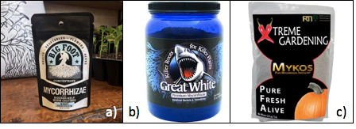
Figure _. Commonly available mycorrhizae products geared towards the Cannabis industry.

These mycorrhizal networks that connect plants can be fragile and relatively close to the soil surface. Therefore, by tilling up soil prior to planting, you may be disturbing the mycorrhizal communities. Following a disturbance, there are likely to be fungal spores that remain in your field, however, it will take more time for the fungus to find the plant root and form an association. This is one reason why some farmers are beginning to switch to no-till techniques.
So how exactly does a non-motile spore find a stationary root? This is a complex question that scientists have not yet fully understand. What we do know is that both of these organisms can grow toward each other, even though they are unable to physically move (another challenge of being a plant!). Since plants must remain in one location for the entirety of their life, they instead attract and cultivate a community of microorganisms which may benefit their own grown and well being. Plants do this by excreting chemicals, mostly carbohydrates and pheromones, from its roots. This microenvironment proximate to and permitted by the roots of a plant is known as the rhizosphere.
These root exudates are complex, consisting of many different types of compounds to select for a diverse microbial community. Research has shown that a significant amount of the sugars that a plant produces from photosynthesis are actually shuttled to the roots where they are secreted to attract these organisms (Kaiser et al. 2014). So by releasing sugars, which are mainly carbon, and other pheromone-like compounds into the rhizosphere directly surrounding the root, the plant is able to signal compatible organisms, like endomycorrhizal fungi, to grow towards the root. Often the fungus relies on these signals before a spore will even germinate. Eventually, the hyphae from the fungus will reach the root, where the hyphae will grow and penetrate the cell wall and enter the plant root. At this time the fungus may develop an arbuscule inside the cell wall (arbuscules do not penetrate the cell membrane) to increase the surface area of the interface of the fungus and root, thereby allowing for maximum transfer of nutrients and water.
In addition to attracting fungi and other beneficial microbes, root exudates deposit carbon into the soil, which can improve the soil organic matter while at the same time sequestering carbon from the atmosphere.
By incorporating mycorrhizae into your indoor Cannabis garden, you can increase the tolerance of your plants to abiotic stresses, such as heat and drought, and biotic stressors, including molds and insects. Plants with mycorrhizal partners are also better at scavenging nutrients and minerals, often times leading to larger, more robust, healthier plants (Fig. 2).
In outdoor Cannabis garden it becomes even more important to inoculate plants with mycorrhizae. Depending on the location and past uses of the farm, there may be spores in the soil, but it is better to inoculate plants anyways to be sure. Outdoor soils typically can have a more diverse microbial community and are often subjected to more stress. This is because they are not being grown in a totally controlled environment where the cultivator can change the temperature, humidity, and a number of other variables. Outdoor soil also behaves differently (chemically, physically, and biologically) than indoor potting media. Depending on the soil type, many ionic nutrients may be bound to soil particles and mycorrhizae fungi are particularly good at freeing up these elements and sharing them with the plant.
There are very few studies that have documented the benefits of using mycorrhizae in hydroponic systems but there is research being conducted in this area (Ojala and Jarrell 1980, Aini et al. 2019, Caser et al. 2019). Many have reported anecdotal evidence that incorporating these fungi in the system has benefits, but solid evidence and hard data is somewhat lacking in regards to Cannabis production in hydroponic systems, but hey, prove us wrong!

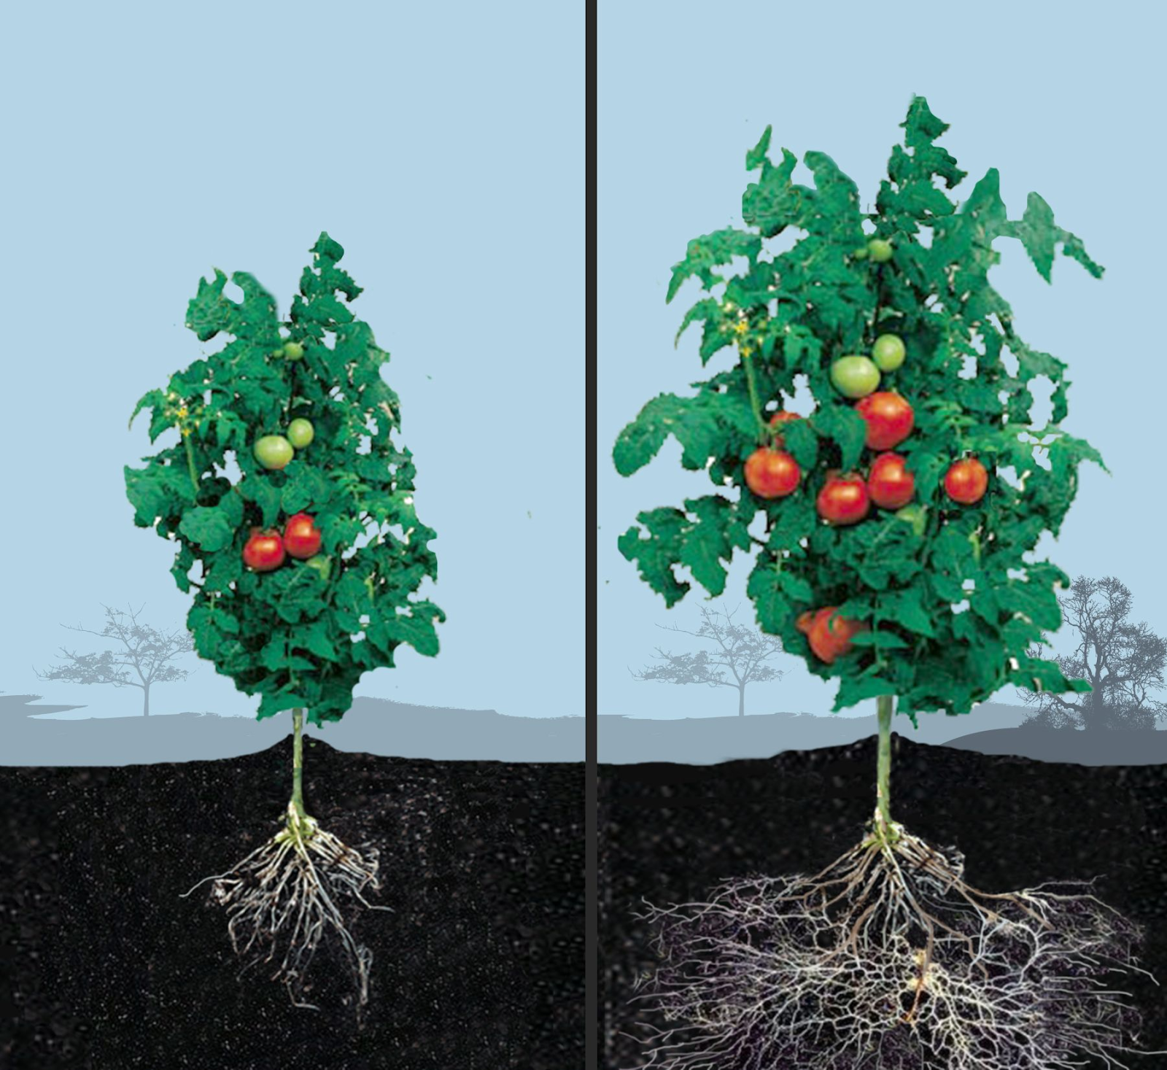
Figure 2. Tomato plant grown without endomycorrhizae (left) and with endomycorrhizae (right). https://herb.co/marijuana/news/elite-nutrients/

Ectomycorrhizae
Ectomycorrhizae (ECM) are a group of fungi that develop a sheath of fungus all around the outside of the plant root (ecto- means outer). ECM grow and envelop the plant root , with some hyphal filaments extending out into the soil and some hyphae that enter the root, but never penetrate the cell wall of the plant (Fig. 1). These fungi will form a network of hyphae in the intercellular space between the plant cells. This branched area of hyphae is known as the Hartig Net, and is used to maximize the interface between the plant and the fungus. It is similar in function to arbuscules in endomycorrhizae.
Unlike endomycorrhizae, ECM fungi will often form large mushrooms, some of which are edible and quite delicious whereas others can make you extremely sick or hallucinate. The stereotypical ‘Alice in Wonderland’ mushroom, Amanita muscaria, is an example of an ectomycorrhizal mushroom. Some species of ECM can be quite particular about the host that they form a relationship with, while others act as generalist and will form relationships with many different partners, often at the same time. Not only can one individual fungus associate with multiple plant species, but a single plant root can have many fungal species growing on different sections of the root. The relationships can get quite complex.

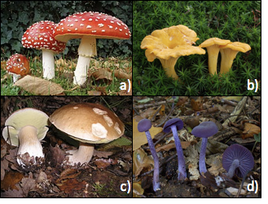
Figure 2. Common ectomycorrhizal fungi. a) Aminita muscaria; hallucinogenic, b) Cantherellus cibarius; choice edible, c) Boletus edulis; choice edible, d) Laccaria amethystina; edible.

Ectomycorrhizal fungi can belong to the phyla Basidiomycota, Ascomycota, and sometimes Zygomycota. These fungi may produce mushrooms (Fig. 2) that can appear at the base of trees, often forming ‘fairy rings’ around the tree.
However, ectomycorrhizae are more often seen infecting perennial woody plants and trees; both hardwood and softwood. So we do not really encounter these fungi much in the vegetable or Cannabis garden, even though some companies are currently sell products designed for use with Cannabis that contain ectomycorrhizal spores. In our opinion, this is a prime example of ‘label dressing’, where companies try to make products look more attractive by increasing ingredient list, even though the ingredients serve no purpose. These companies are preying on an uneducated customer base. Not us anymore!
Orchid Mycorrhizae
A very unique and specialized example of mutualistic symbiosis in nature is that of the orchid and the fungus. As the name implies, this relationship is strictly with plants in Orchidaceae family, and is not very relevant for Cannabis growers so we will only briefly touch on this.
Orchids are typically known for their large, showy flowers. Although these plants are very commonplace in our lives (available in many grocery and retail stores), not too many are familiar with how this plant is produced. Unlike most plants, Orchids are typically propagated through tissue culture or other methods of asexual reproduction. Asexual propagation involves ‘cloning’ the plant, making two (or more) plants that are genetically identical. Alternatively, creating a seed is a method of sexual reproduction, where the male gamete (pollen) fertilizes the ovary, which then swells and a zygote is formed, eventually becoming a seed. The seeds of a parent plant are genetically different than other seeds produced by the same plant and are also genetically different than either parent. As water enters the seed, the seed coat begins to swell and the pressure from the growing embryo breaks open the seed coat and a radicle (beginning of root) emerges.
Because the orchid seed is so small and contains very little nutrition, once the radicle develops from the seed coat, it begins to look for a fungal partner. Fungi are particularly good at scavenging nutrients, including minerals, especially nitrogen and phosphorus. Once the root and fungus meet, the hyphae will enter the plant tissue and eventually forms coils in the plant cell called pelotons. These clusters of hyphae will eventually die and their nutrients absorbed by the plant. Thus the fungus provides the plant with minerals and the plant gives the fungus sugars and carbohydrates from photosynthesis. Therefore, growing orchids from seed can be very difficult, requiring sterile areas and the correct fungal partners. Frequently, the fungus colonizing the newly emerged orchid root is a member of the phylum Basidiomycota (the same phylum as most ectomycorrhizal fungi and the majority of mushroom producing fungi).
Although not involving Cannabis, this clearly demonstrates the intricacies of nature and how specialized some relationships are. Think of the consequences when species are erased due to anthropogenic forces. With everything in nature so tightly interconnected, by harming organisms in the environment, we may actually be harming ourselves in the long run.
Mycoparasitic Plants
Symbioses are relationships under constant evolutionary pressures where the nature of the interactions may shift back and forth over evolutionary time and under different environmental conditions. In one such example, some plant species have hijacked the mycorrhizal relationship so that they are able to siphon off nutrients from a fungal partner without contributing photosynthetically fixed carbon molecules in return (“mycorrhizal cheaters”). Many of these parasitic plant species no longer produce chlorophyll at all, instead being 100% dependent on the acquisition of food resources through their mycorrhizal partner. This trophic lifestyle among some plants is known as myco-heterotrophy. The nutrition mycoparasitic plants siphon from their mycorrhizal hosts is ultimately derived from other, non-cheating symbiotic plant partners with which the fungus has also formed connections.
Mycoparasitic plants that form relationships only with ectomycorrhizal are not a concern for Cannabis cultivation, as Cannabis does not associate with these types of fungi. However, it has been shown that mycoparasitic plants are also capable of forming relationships with endomycorrhizae as well, and therefore may represent potential indirect parasites of Cannabis (Epiparasitic plants specialized on arbuscular mycorrhizal fungi). Several broomrape species (Orobanche ramosa, O. aegytiaca, and O. cernua) may affect Cannabis. However, like mistletoe, broomrape directly parasitizes its host plant by penetrating and tapping into its vascular system rather than through a mycorrhizal intermediate.

Mycorrhiza Taxonomy
As with every other group of fungi, the taxonomy of mycorrhizal fungi is in a state of constant flux. Constantly species are being renamed or reclassified as we learn more about the fungal kingdom and as our identification techniques advance and get more sophisticated. However, there are some broad guidelines that are generally followed.
For endomycorrhizae, these fungi have their own phylum called Glomeromycota. This means they evolved separately from the mushroom producing species found in Ascomycota and Basidiomycota. Fungi in Glomeromycota lack septa, thus are coenocytic, and are obligate symbionts of members of the Kingdom Plantae. Cultivation of these fungi can be difficult because they cannot be cultured in the lab (In vitro) but must be cultured with its plant symbionts and then they spores are collected after the plants grow and die. Spores are much easier to collect from mushrooms than from soil!
Ectomycorrhizal fungi are typically from the phyla Basidiomycota or Ascomycota and thus often produce mushrooms. These fungi associate with most deciduous and coniferous trees. These fungi are often found in all types of forest, but in particular old-growth forest where the soil has never been disrupted. There is no evidence that these fungi can infect a Cannabis plant.
Most other mycorrhizal fungi are either from Basidiomycota or Ascomycota phyla. This includes Orchid mycorrhizae (Basidio), Erociod mycorrhizae (Asco), and Monotropoid (Baidio). Again, these species are not of importance to Cannabis farmers, we just wanted to make you aware of their existence.

Chapter 9
Saprophytic Fungi

Saprophytic soil fungi
As we have stated before, healthy soils can contain a tremendous amount of fungal diversity and biomass. A majority of these fungi are likely to be decomposers, aiding in nutrient cycling by breaking down dead organic materials into small molecules and particles for other members of the soil food web to then come consume.
Having saprophytic fungi in your soil can offer great benefits to the plants. Not only do these fungi break down organic material and amendments found in your soil, thereby releasing plant available nutrients, but they also produce a variety of other compounds such as organic acids, vitamins, and a number of secondary metabolites. The compounds that fungi release can have a dramatic influence on the soil microbial community but also on the plants found in the soil as well. Examples of commonly available soil saprophytic fungi are Trichoderma verde and also the mushroom producing Stropharia rugosa-anuulata.
Fungi that are saprophytic are typically classified as either brown rot or white rot fungi. The former decompose cellulose, leaving lignin behind whereas the latter digest lignin, leaving cellulose behind (Fig. 1). Therefore, anywhere where there are dead or dying plants, there will be fungi there working on digesting this material and returning the nutrients back into the soil.
These fungi are extremely important for nutrient cycling and the soil food web. Many saprophytic fungi are primary decomposers, being the first one to the site to work on breaking the material down. Later secondary and tertiary decomposers (fungi, bacteria, actinomycetes) can come in and further breakdown there materials. As fungi and other soil biology biodegrade large organic materials, this will help contribute to the humus layer of the soil. Having a diverse soil microbiota will help develop humus more quickly in your soils (Dick and Gregorich 2004). The higher your humus or organic matter levels in your soil, the higher your cation exchange capacity (CEC) will be (Fig _). The CEC is a metric that is used to measure how much nutrients your soil can hold on to; the larger the CEC, the more nutrients your soil can retain and then make available to the plants as they need them. Literally, the cation exchange capacity is defined by the amount of cations that can be held by the negative exchange sites found on clay particles or in organic matter. The humus layer of soil as can improve water retention, provide a buffer for temperature control and offer a number of other benefits to soil.
Humus is typically the black, crumbly soil aggregates that is made from soil life breaking down dead organic material to a point where it can not be further degraded. This leaves a material that is rich in polysaccharides and humic acids, full of positive and negative exchange sites for ions to bind to, dramatically increasing the CEC of the soil. The humus layer is found on the top most layer of soils, just above the topsoil. This layer provides an excellent habitat for soil organisms to thrive.

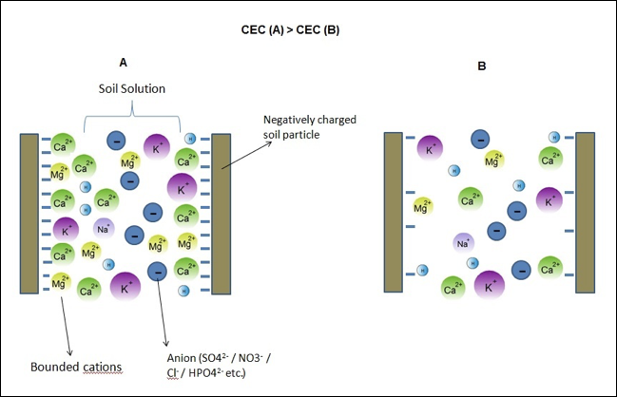
Figure _. Soils with a higher CEC (A) will be able to hold on to more cations, thereby improving nutrient retention, than a soil with a lower CEC (B). https://www.smart-fertilizer.com/articles/Cation-Exchange-Capacity

Through the use of synthetic, chemical nutrients, we are reducing our soils’ organic matter and humus layers. Applying chemical fertilizers with high salt levels to agricultural soils not only feeds the plants directly, totally by-passing the need for any microorganisms, but it also damages the cell walls of the soil biology, often times causing them to shrivel up and die (Bulluck et al. 2002). The osmotic potential of the fertilizers damages them physically and also leave the fungi without anything to eat. This can have long term impacts such as soil compaction and erosion (Ruser et al. 2006), but also has more immediate consequences such as increased need of pesticides and plants that are more susceptible to abiotic and biotic stressors (Abawi and Widmer, 2000).
By treating our soil right and incorporating carbon-based nutrients and plant residues back into our soils, we are helping to maintain and stimulate our microbial populations, thereby lessening our need for fungicides and herbicides and heavy salt fertilizers (Higa and Parr, 1994). This makes farmers less reliant on these large companies producing perto-based chemicals and the pesticides to go along with them. Big agriculture is following a system that makes the farmer more and more reliant on these large companies, allowing them less and less margins for saving while at the same time destroying the soils that are so important for the future of life on this planet.

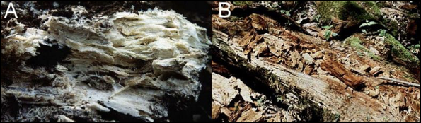
Figure 1. White rot fungi (A) that degrade lignin leaving the white cellulose behind vs. brown rot fungi (B) consume the cellulose and are unable to digest the brown lignin.

Another way that organic farmers are beginning to increase their soils’ CEC and organic matter levels is by applying compost to fields prior to planting. Compost is full of nutrients from the decomposition of whatever sort of organic materials were added to the compost pile. Compost made of manure from different animals will typically also have different nutrient profiles and microbial communities. In addition to the nutrients compost will add to your fields, it also serves as an inoculation of beneficial microbes to your fields.
Compost can be spread across fields after it has been sitting for the appropriate amount of time, or it can be brewed into a tea and either foliar fed to your plants or be diluted and fed to your plants as a root drench. Either way, you are inoculating your plants and your soil with bioavailable nutrients, novel compounds produced from the decomposition of organic materials, and a diversity of microbiology.
The biology and community dynamics found with-in compost can be extremely complex and variable (Fig _.). Since compost, like soil, is not a homogenous environment but instead is elaborate matrix comprised of many microclimates and niches for many different organisms to fill. This is further complicated by the fact that the community can change over time as different nutrients become available and as the environment changes.
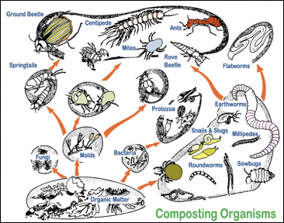
Fig _. Organisms that are typically found in compost piles. http://www.plantsgalore.com/care/compost/03-Organisms.htm

Temperature plays a large role in composting and can determine which organisms can be present. When a compost pile is first formed, the raw ingredients are mixed up and the microbes begin to go to work. Some of these microorganisms were already on the raw materials at the time of building the compost pile, whereas others were floating in the air and happened to land on the pile since it was formed.
After a few days (depending on a number of variables), the piles will begin to heat up. This is the result of microbes being active and releasing heat as a by-product of their metabolism and the exothermic chemical reactions from the breakdown of organic materials. The key components of a compost pile are simply organic material, air, water, and living organisms.
The beneficial microorganisms that we want to promote require air (for the most part) and water, in addition to a food source. Therefore, it is important to keep composts (and soils) moist to ensure that the biology can survive. As we turn compost piles, which introduces new air to parts of the pile, this will cool the pile down in the short term, but after a few hours the pile will begin to heat up again due to the new air that is stimulating microbial growth.
For a thermophilic compost pile to be complete, a minimum internal temperature must be reached and held for a certain number of days. If a compost pile is not heating up, this indicates a lack of biological activity which could be the result of not enough or too much moisture or not enough oxygen is getting into the compost.
Filamentous fungi are more active at cooler temperatures, where bacteria and yeast dominate in periods of higher temps. As a compost begins to finish, temperatures will begin to cool and eventually reach near ambient temps. This is a sign that most of the organic matter has been digested to a point where it is relatively stable. At this point, compost can be used by farmers both as a source of nutrients for their soil and plants but also as a way to inoculate soil with beneficial bacteria, fungi, protists, nematodes and many other organisms.
Soil is a complex matrix consisting of a variety of microclimates that can be quite diverse in nature. As such, there are a diversity of fungi and other organisms playing a multitude of roles.
In addition to saprophytic soil fungi, there are also fungi that act as a parasite on host organisms and consume living invertebrates such as nematodes or rotifers (e.g. Arthrobotrys oligospora). These fungi have developed specialized mechanisms for attracting and consuming these organisms and therefore play an important role in determining the soil ecology. Some of the parasitic fungi can even consume other fungi, acting as mycoparasites.
Fungi can act as parasites or pathogens on pretty much every other form of eukaryotic life. One group of soil-borne fungi, known as entomopathogenic fungi, will germinate spores once they come in contact with the proper insect body, then they hyphae will grow into the body of the insect, slowly digesting all of the organs and finally signaling to the insect to crawl to a high point (on a tree) so the fungus can produce a spore bearing structure and disperse its spores to a larger range (e.g. Beauveria bassiana) . What a unique symbiosis that has evolved here!
Identification of soil fungi, regardless of the role they are playing, is complex and not always accurate or a true representation of what is really there. Physical morphological identification by observing through a microscope can give you an idea if fungal hyphae are present, but does not give a real measure of the species that are present. One can look at the diameter of hyphal strands and the presence or absence of septa and clamp connections but this only gives so much information about the fungi.

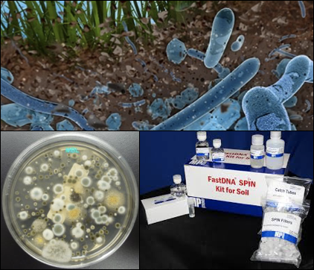
Figure _. Diagram of soil life (top), soil fungi being cultured on a petri dish (bottom left) and a commonly available kit for molecular identification of soil organisms (bottom right).

Therefore, we are left to rely on culture based techniques to identify what is there. This also has its own drawbacks and limitations. Only certain fungi are able to be cultured in vitro so we are selecting for species that can be cultured. This potentially limits us to only a fraction of the fungi that are actually present. Culturing soil fungi also does not tell us the relative abundance of a particular species either.
A much more rigorous and perhaps accurate way of determining what fungi are in a particular soil is to use molecular techniques to identify the fungi. This involves extracting to fungal DNA within a particular sample, amplifying said DNA using Polymerase Chain Reaction, and then sequencing the DNA and comparing it to other samples that have previously been sequenced. Obviously, this has its own limitation, but at the moment, this is the most precise data that we can collect for species present and relative abundance.
To date, there have been no reports or complete surveys for all of the fungi that are found in soils. This is partially due to the ubiquitous nature of soil fungi and the extreme variability in sampling procedures. The more we look at and attempt to identify soil fungi, the more species we are likely to find. Soil fungi have been extremely important to humans not only for helping protect and feed our crops but also because of the unique compounds that some of them produce. For example, penicillin is produced by a species of the soil fungus Penicillium. There are likely far more fungi that are living in the soil that produce different novel compounds that we have not even begun to identify.
Regardless of how soil fungi may benefit us, there are clear interactions with all plants grown in soil. Therefore, Cannabis farmers can use this information about fungi to promote the diversity of fungi in their soil. This will help increase nutrient availability and also promote stability in the soils. By taking care of the biology found in the soils we cultivate for crops, this will help ensure that we can plant in the same area for seasons and seasons to come.
In addition to decomposing organic materials and recycling nutrients, soil fungi have also demonstrated an important role in soil remediation. Different fungi have been shown to help remediate areas that are exposed to some sort of contaminant whether it be chemical or biological. Some fungi can consume heavy metals, thereby removing them from contaminated sites, whereas other fungi produce exoenzymes or organic acids that may assist in the breakdown of harmful compounds, and still others can kill and/or consume harmful bacteria.
The Cannabis is also relatively successful at remediating contaminated areas that are full of heavy metals. This is a great example of phytoremediation, remediatings areas through the use of plants, as opposed to mycoremediation, remediating areas through the use of fungi. Either way, it is not desired to be growing Cannabis in contaminated soils or at sites that may have some sort of contaminant, unless the Cannabis grown there is not destined for consumption but is intentionally planted to clean up a site. If phytoremediation is the goal, then planting Cannabis inoculated with mycorrhizal fungi would be a logical selection to help remove contaminants from an ecosystems. The plants would then be removed from the area after a period of growth, transported to a destined area, incinerated, and then the ashes disposed of properly. However, given the current legality of this plant, Cannabis may not be the most ideal candidate for phytoremediation projects at the moment.

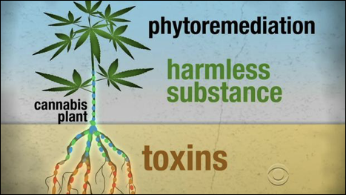
Figure _. Even CBS is giving notice to Cannabis for its ability to remediate contaminated sites by removing heavy metals and toxins from soils.

Chapter 7
Endophytes

Introduction

Endophytes are a diverse group of unrelated organisms typified by their ability to reside inside the bodies of apparently healthy host plants. Species among archaea, bacteria, and fungi are all able to live endophytically within plants. Some endophytes are extremely host specific, associating only with a specific plant species or even race of species. Whereas others are generalists, capable of living within a diversity of host plant species.
Since the existence of endophytes was first noted by Henry Anton De Barry over 150 years ago, there have been various debates about what constitutes a true endophyte (1866). A commonly accepted definition is that of Petrini: “all organisms inhabiting plant organs that, at some point in their life, can colonize internal plant tissues without causing apparent harm to the host” (1991). However, nature is prone to resisting the human compulsion to classify it. Many endophytes are close relatives of pathogenic species, with role switching frequently occurring over evolutionary time. Individual endophytes may even vary from mutualist to pathogen themselves, depending on environmental circumstances.
Endophytes occur ubiquitously within nearly all plants and in all regions within a plant body, including inter- and intra-cellularly within roots, stems, barks, leaves, and seeds. Often, different tissue types (leaf, petiole, stem, bark, ect) harbor different groups of specialized symbionts. This means that a Cannabis plant is most likely colonized with many different fungal species. There could be a community of fungi living in the roots, and different groups living in the stem tissue, and yet another assemblage of fungi existing in the flowers of Cannabis.
To add to this complexity, endophytes themselves may host intracellular prokaryotic endosymbionts. Furthermore, any of these symbiont layers may host viruses. Each of these levels of symbiosis has a role in altering the phenotype of the host plant (Márquez et al., 2007).

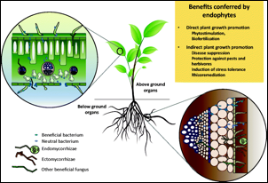
Figure 1. Diagram of fungal colonization of various plant parts.

Endophytic fungi may be transmitted to new host plants vertically (seed borne) or horizontally (environmentally acquired). Seed borne endophytes are usually highly specialized symbionts that form extensive, systemic infections, and may be host plant species specific. Common examples of such endophytes are the Claviceptacean endophytes of grass. Claviceps purpurea, known as ergot and a source of lysergic acid, is an example of a claviceptacean endophyte. Vertically acquired endophytes infect the embryo of the developing seed while it is still attached to its mother plant. Horizontally acquired endophytes, on the other hand, must disperse into the environment, then find and infect a suitable host plant.

Host infection by endophytes

Endophytes passed vertically from parent to offspring may be transported within the bodies of generations of its host without ever being exposed to the external world. However, this occurs on a continuum. While more specialized endophytes may have lost the ability to produce reproductive propagules and spread horizontally among a population of plants, other endophytes may both be vertically transmitted as well as capable of forming spores able to infect new host lineages horizontally. The aforementioned Claviceps purpurea still causes its host grass to abort some seed, replacing it with a fungal sclerotia capable of ascospore production. The grass endophyte Epichloë, have lost the ability to disperse via spores and do not abort their hosts seed.
Endophytes that spread horizontally require dispersal into the environment, the location of a suitable host, followed by successful infection of that host. Infection of a host necessitates entering its body. Once a fertile propagule lands on a suitable host plant it must first overcome physical defenses innate to any plant. This includes breaking through protective barriers of dead bark tissue, waxy cuticle, and cell wall, which may be accomplished in several ways. Wounded host tissue offers a shortcut for entry when a spore or growing hyphae happen upon it. Alternatively, if a spore lands on healthy plant tissue, fungi must proactively form penetrating structures called appressoria.

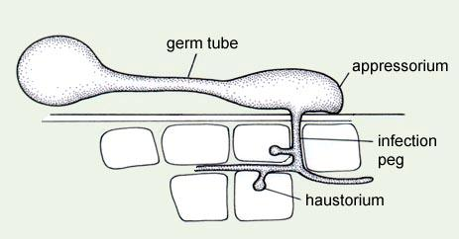
Figure 2. Fungal spore germination, emitting a germ tube which gives rise to an appressorium for the fungus to enter into the plant cell and produce a haustorium to acquire nutrients.

An appressorium forms following spore germination or from mature hyphae. Appressoria are specialized hyphal structures which release exoenzymes onto the leaf surface, weakening the physical strength of the cuticle and cell wall below. At the same time a large amount of turgor pressure builds within the appressorium and is focused on a developing outgrowth of hyphae called the penetration peg. The fungi successfully infects its host if the penetration peg breaks through into the host body and the fungi is able to take up residence. Pathogenic fungi gain entry to the plant body in the same way (and provoke many of the same plant defenses). Among some pathogens and endophytes, haustoria may penetrate the cell walls within the host plant; these haustoria do not penetrate the cell membrane, but greatly increase surface contact, and therefore potential nutrient transfer with the affected cell.

Evolution and Ecology

Endophytic associations of fungi within plants began early among, if not coincidentally with, the invasion of land by plants. Direct fossil evidence showing endophytic fungi has been found, and the coevolution of endophytes and their plant hosts can be inferred from the correlation between the phylogenies of extant endophyte lineages and that of their corresponding plant host taxons (Krings et al., 2007; Sieber, 2007). The long evolutionary history of specialist endophytes and their hosts preclude them from acting as devastating pathogens (Sieber, 2007). However, endophytes exist on a continuum from pathogen to mutualist; many pathogens are closely related to commensal or mutualistic endophytes, with frequent role switching having had occurred through evolutionary history (Sieber, 2007). The close relation between pathogens and mutualist symbionts is a common feature among plant-microbe interactions. In some cases the switch can be governed by a single gene. Inoculation of susceptible plants with non-pathogenic strains of harmful plant pathogens can act as biocontrol to prevent plant disease.
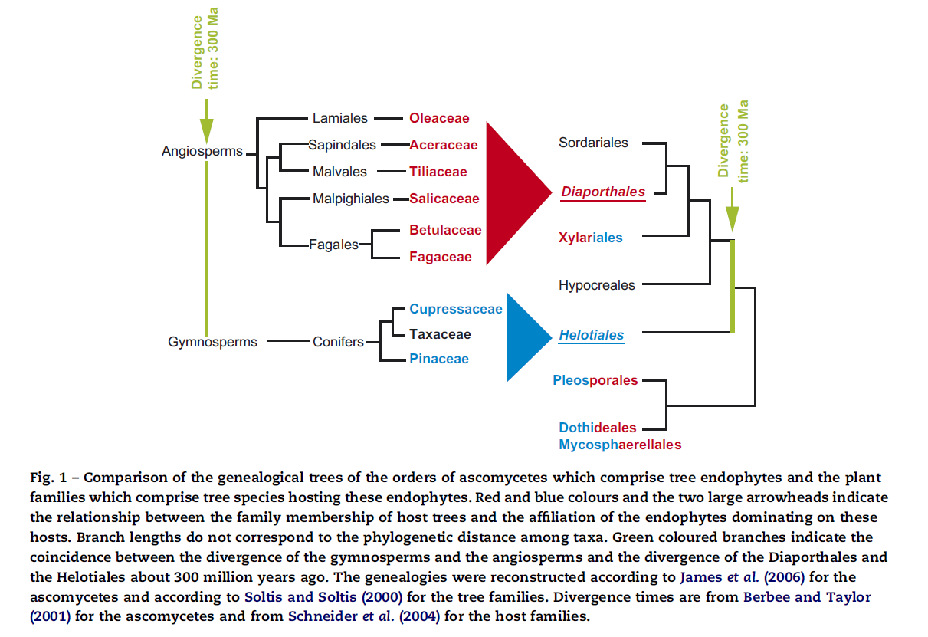

Cannabis endophytes

Endophytes have been variously classified. Most broadly they are separated into the Claviceptacean endophytes, which are the classically studied endophytes common among grasses, and a second catch all group called the non-claviceptacean endophytes. Rodruguez et all (200X) proposed reclassifying the Claviceptacean endophytes endophytes as Class 1 endophytes, then further separating the NC-endophytes into 3 additional classes based on their life histories, where Class 2 from extensive infections throughout the plant body and are seed borne and Class 3 and 4 endophytes of Cannabis are horizontally transmitted, but affect ariel or below ground tissue, respectively. Class 4 endophytes are also known as the Dark Septate endophytes (DSE) due to their characteristic dark color from melaninization and the presence of septa.
Table 1.
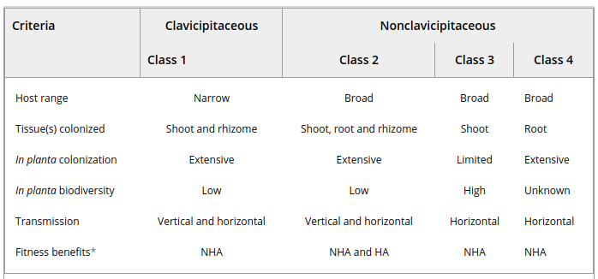

Endophytes of Cannabis are likely dominated by horizontally transmitted, taxonomically diverse Class 3 and 4 endophytes sensu Rodriguez. Class 3 endophytes form localized infections throughout the host plant body, whereas Class 4 endophytes are restricted to the roots, but may form extensive infections. Vertically transmitted, systemic Class 2 endophytes that are transferred from parent to offspring via seed, are also probable; such endophytes would be attractive targets for the development of growth promoting endophytes and biological control agents. Various commercially available products include putative Cannabis endophytes, such as various Trichoderma species or Beauvaria bassiana, at least some of which are likely capable of forming extensive in planta infections, possibly including vertical transmission through seed.
Because it is likely that the majority of Cannabis endophytes are horizontally transmitted they must be acquired from ambient inocula during an individual plant's lifetime. Therefore the local inocula will determine the endophyte population within a Cannabis plant. Perhaps if we inoculate one corner of a field with fungal endophytes we may be able to see how particular species move throughout the population of plants through continual monitoring throughout the season. It is likely that when spraying compost tea and other forms of fungal inoculation, some of these organisms may be able to act as endophytes and enter into the plant tissue (through a wound, stomata, or via an appressorium).
With this fact in mind, the ecology of Cannabis endophytes among crop grown marijuana is potentially complicated by the illicit nature of the crop, historically. In regions with long and continuous histories of either stable populations of wild Cannabis or relatively large scale cultivation as a crop, Cannabis-specialized endophytes may develop and persist. In order for such a mutually beneficial symbiosis to develop, the host plant and fungal partner must co-evolve over generations under conditions which favor their partnership. Conditions must improve the fitness (i.e. the reproductive ability) of both the host and the endophyte. If this were to continue to an evolutionary extreme, the organisms begin to become obligatory partners, at least under the given conditions. Class 2 endophytes may represent organisms that are trending towards such obligatory partnerships, given their vertical transmission and host specialization.

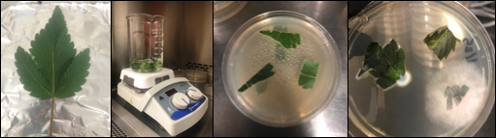
Figure 4. The isolation of Cannabis fungal endophytes can be done in a laboratory setting using only a few tools and aseptic technique.

Endophytes of Cannabis are able to pass from the parent plant to its offspring. They may do so either by surviving within the body of the seed, or on the seed surface. If it is passed on the surface it must persist throughout seed dormancy, waiting to infect the newly germinating seedling as it emerges. Microorganisms harbored on the seed surface are susceptible to treatments (bleach, Trichoderma) prior to germination. Such treatments can reduce seedling losses to seed batches from parent plants infected with pathogens, particularly Botrytis cinerea.

Table 2. Endophytes of Cannabis reported in the literature.

Table 3. Endophytic fungi known to be isolated form Cannabis to date.

Genus | Specific epithet | Human pathogen | Mycotoxin producing
Penicillium
a= Cite sources for each; b;c;d

Clonal lines and endophytes

There is frequent discussion within the Cannabis industry about the loss of vigor among long lived, clone-only lineages. This is not an issue unique to Cannabis. In fact many crops are propagated clonally from highly desirable, elite individuals (McKey 2009). This includes many fruit crops (grapes, apples, citrus, blueberries, ect.), as well as most root tuber crops (potatoes, sweet potatoes, sunchoke, cassava, yams), and nearly all perennial ornamentals. There has long been debate about the causes of such deterioration within lines. Some have argued it is caused by a breakdown of genetic material or an accumulation of somatic mutations (often incorrectly referred to as “genetic drift,” which is an entirely different phenomenon where allele frequency changes over generational time due to random chance, rather than selective pressure).
Changes in phenotype can occur following somatic mutations; distinct phenotypes that emerge in this way are referred to as sports. However, it is now believed that the more likely causes of observed clonal-drift are not due to changes in the genetic sequence. Rather an accumulation of deleterious viruses, viroids, and pathogens are primarily responsible for loss of clone vigor. It should be noted that some of these deleterious “pathogens” may have once served their host mutualistically under a set of conditions it had experienced in the past.
In addition to direct somatic mutation and pathogen load, epigenetic changes, alteration in the expression of a plants DNA rather than changes to the code sequence itself, may also be induced during a plants lifetime as a result of environmental effects. Epigenetic control of gene expression is what permits the specialization of cells and the formation of specialized tissue types. The mechanism of epigenetic control is primarily the methylation of DNA and methylation and acetylation of the histone proteins around which DNA is organized. While most epigenetic alterations that occur during an individual's lifetime are removed from its gametes during gametogenesis, a minority may persist for several generations.
Tissue culture techniques may be used to clear deteriorating clonal lines of accumulated endophytes, viroids, and viruses, as well as possibly resetting some of the induced epigenetic changes by inducing a juvenile plant stage. Therefor the persistence of epigenetic changes in tissue cultured plants may be less stable than in seed propagated plants. Tissue cultures are also more susceptible to the development of somaclonal variants than mature plants.

Epigenetic aspects of somaclonal variation in plants

To clear tissues of internal passengers, explants should consist of the smallest section of tissue possible. The apical meristem, not yet connected to the vascular system, should be targeted to exclude viruses which are less likely to have infected this region of a plant.

Epigenetics:

Epigenetics refers to heritable traits that are unexplained by alterations in the DNA sequence itself. In popular usage, the term is often used to refer to culturally inherited characteristics, traditions, and knowledge that operates “above” (i.e. epi-) the level of genetics: a force acting to affect human phenotypes across generations, but independent on the hereditary molecule, DNA. But epigenetics is not unique to humans, and is not dependant on culture.
Epigenetics changes are the result of real, physical changes in the structure, though not sequence, of DNA and the histone proteins around which it is packaged. These physical changes are the methylation of DNA or variously complex modifications of histones (usually methylation and acetylation). These physical changes to the DNA molecule and their packaging proteins results in persistent alterations in gene expression. This is a major mechanism controlling gene expression which permits the specialization of cells and the formation of tissues in complex, multicellular organisms. Among humans, cultural epigenetics, including nutrition and lifestyle, may induce physical epigenetic changes in individuals characteristic of those cultural environments. In some cases these induced epigenetic changes may reinforce the culture which induced them, leading to a positive feedback loop.
Histone modifications and DNA methylation act to “expose” or “protect” certain areas of the DNA. If exposed, the cellular machinery responsible possible transcription of a DNA sequence into RNA may access the gene. This is the first step in possibly expressing the phenotypic information contained in a gene. Various downstream post transcriptional and post translational regulation may ultimately prevent a transcribed gene from being expressed as a phenotype. Epigenetic mechanisms are generally relatively persistent gene switches. In fact, epigenetic modifications can be so persistent that some may survive the chromatin remodeling which occurs during gamete formation to persist up to four generations removed from the parent generation in which it was induced.

Characteristics of Mutualistic Endophytes
The nature of the host-endophyte relationship is not only dependent on the species involved, but a range of abiotic and biotic factors (Partida-Martínez and Heil, 2011). For instance, an endophyte that enhances host fitness by reducing predation or pathogen damage may become a net cost to the host in the absence of such stressors. For the moment we will only focus on endophytes that are mutualistic, in that they benefit the fitness of their host plant in some manner across a wide range of conditions.

Pathogen Protection

Beneficial endophytes may act to protect their host from pathogens by a variety of mechanisms. These include modulating their host’s immune system, promoting host plant growth, production of antimicrobial secondary metabolites, occupation of a pathogen’s niche, or direct physical antagonism of a pathogen (Gao et al., 2010). Endophytes also may benefit their host in unexpected and indirect ways; Lehtonen et al., (2006) showed reduced virus infection among endophyte infected plants due to reduced herbivory by the virus’s aphid vector. It is likely that Cannabis infected with mutualistic endophytic fungi will have superior disease resistance traits compared to uninfected crops. Effective endophyte applications have the potential to improve the health of crops while simultaneously decreasing the need of synthetic pesticides.

Table 4. Mechanism and mode of action induced by endophytic partners.
Mechanism | Mode of Action
Induced resistance | Plant Immune response is activated (PTI and ETI)
Competition | Physical occupation of niche and differential resource acquisition
Antibiosis | Negative interaction of one species to another, usually in response to excreted metabolic substances
Hyperparasitism | Pathogenic organism is parasitized directly
Plant growth promotion | Improved resistance may result from general growth promotion. Endophytes may increase growth by the production of plant hormones and improved nutrition (siderophore production, N-fixation, ect.)

For a fungus to persist as an endophyte within a plant host’s body, it must necessarily have at least some antagonistic abilities in order to evade host immune response and persist within its tissues (SchulZ and Boyle, 2005). Plants recognize the presence of invaders via microbial/pathogen/damage-associated molecular pattern-triggered immunity and effector triggered immunity. When the plant senses invaders, it triggers induced resistance and/or systemic acquired resistance, which are both whole-plant immune responses. Endophytes capable of persisting in planta only trigger induced resistance, a milder response. Endophyte and host actions muse remain balanced for successful endophyte infection (Schulz et al. 1999).
Endophytes may benefit the host plant in ways beyond induced resistance. Other benefits may derive from the upregulation of host production or direct synthesis of secondary metabolites otherwise absent in the host plant; increasing host nutrient acquisition and growth by producing chelating compounds, enzymes and phytohormones; or by improving oxidative stress tolerance of the host (Mucciarelli et al., 2007; Yuan et al, 2010; White and Torres, 2010).
Endophytes are also able to exclude pathogens from a host plant via direct competition for, and physical occupation of, the same habitat niche (Gao et al., 2010). Research has confirmed extensive niche overlap among endophytes and pathogens of a plant species (Blumenstein et al, 2015). Endophytes that come into direct physical contact with a pathogen of their host may also act directly to antagonize its competitor through chemical defenses or direct hyperparasitic attack. Trichoderma spp. for instance, which commonly occur as endophytes, are hyperparasites capable of coiling around and directly lysing the hyphae of other fungi.

Pest Protection

Clavicipitaceous endophytes have a proven history of usage in turf grass as a means to reduce insect herbivory and improve stress tolerance (Clay, 1991). Endophytes ave also shown utility in woody plants for reducing herbivory (Miller and Adams, 2007; Wilson and Carroll, 1997).

Plant Growth Promotion
Endophytes may increase plant growth via several mechanisms. These include direct production of phytohormones, production of siderophores and chelating compounds, and atmospheric nitrogen fixation.

Improved Product Quality or Potency
Endophytes may alter the phenotype of their host in a number of ways beyond pest protection and growth promotion. Of the most potential interest to Cannabis farmers is the prospect of endophytes to increase terpene or cannabinoid content. Endophytes have been shown to greatly increase terpene content in planta among mint plants (Mucciarelli et al., 2007). No research specific to Cannabis has yet been published. Endophytic alteration of terpene expression could prove to be a valuable tool in Cannabis agriculture. Endophytes may affect cannabinoid production in similar fashion. This is an area in need of research and with high potential for exploitation by farmers. Some cannabinoids identified in Cannabis for which no synthesis genes are known may actually be microbially modified in origin (Robertson, 1975). The production of novel cannabinoids by the endophytic and post harvest microbiome may alter the pharmacological activity of the flower.
Manipulation of endophytes may improve product quality in another indirect way: by reducing the occurrence of human pathogenic and mycotoxin producing fungi among Cannabis destined for human consumption. It has been shown that known pathogenic fungi, such as Aspergillus niger, and mycotoxin producing fungi, including Penicillium citrinum and P. fodahfdokshflkasdfhlkdsa are potentially common in Cannabis from American dispensaries (McKernan & other papers). At least some of the species that pose dangers to humans are likely normal, probably mutualistic, fungal epiphytes and endophytes of Cannabis. Applying alternative microbes that may fulfil the symbiotic role of such fungi may be a viable option for excluding completely or vastly reducing the population of undesirable fungi without the use of chemical fungicides. Regulators should keep this scenario in mind when developing regulation for measuring fungal contaminants in agricultural products. Total yeast and mold counts fail to differentiate harmless microbes from the dangerous human pathogens and mycotoxin producing fungi, and farmers growing under such regulations may not be able to apply beneficial inocula. Techniques able to differentiate among microbes, in order to identify those that pose danger to humans, such as molecular techniques, are preferable for ensuring the safety of consumable Cannabis.
Current Applications of Endophytes Among Cannabis Cultivation

Some currently available products contain entomopathogenic species that may live endophytically across a broad range of host plant species, likely including Cannabis. Beauveria bassiana, Isaria fumosorosea, Lecanicillium and Metarhiszium spp. are all commercially available fungi that are bioinsecticides. While these are not usually marketed for foliar application, doing so may inoculate plants with persistent enfophytic infections of these beneficial biopesticides. Trichoderma and Clonostachys rosea f. Rosea (Gliocladium catenulatum) containing products may be similarly applied as a persistent, endophytic biofungicide. Both aerial and root portions of the plant may benefit from endophyte application.
While not the focus of this book, there are also prokaryotic species that may act in the same fashion; various Bacillus species are readily available commercially and will serve this purpose. Frequently, these species also benefit the plant when residing as endophytes by improving host immune response or promoting growth in myriad ways. Kandel et al. has shown that naturally occurring bacterial endophytes of Poplar trees in Washington state may be introduced with positive effect into crop species, including maize, tomato, squash and pepper (2017). One way some bacterial endophytes may increase plant growth, in which fungi cannot, is the fixation of atmospheric nitrogen.

Table . Commercially available products with off- label uses as endophytic biopesticides when applied as a foliar spray.
Fungal endophytes | Species | Commercial formulations | Target effect
 | Gliocladium virens | Soil guard | Damping off
 | Clonostachys rosea f. Rosea (syn Gliocladium catenulatum | Primastop | Botrytis, Verticillium, Alternaria, Damping off, Broad spectrum fungicide
 | Beauveria bassiana | Mycotrol | Aphids, thrips, whitefly
 | Trichoderma harzianum | RootShield | Damping off
Bacterial endophytes | Streptomyces griseoviridis | Mycostop | Pythium, Alternaria, Botrytis
 | Streptomyces lydicus | Actinovate
 | Bacillus thurengensis var isrealiensis | Gnatrol | Mosquitoes, fungus gnats

In Defense of Endophytes in Agriculture
As should happen with any new technology, the manipulation of endophytes for agronomic reasons has been questioned. Some of the concerns about the application of endophytes are legitimate, as will be discussed. These concerns, however, do not preclude responsible integration of these organisms in Cannabis agriculture. The crux of the concern lies with the potential for an endophyte to (1) cause disease in non-target organisms and (2) for the alteration of the general ecology of endophytes.
The first concern, non-target effects, must be considered during product development for any biological control organisms. Releasing a biological agent into an ecosystem from which it is not native poses inherent, undeniable risks. Useful biocontrol agents, by their nature, are able to cause disease or otherwise reduce the fitness in target organisms. Therefore the potential for them to do so in non-target organisms is a real possibility. Often times the most successful biocontrol agents are organisms that are not native to the particular region in which they are being applied.
The second concern, alterations of endophyte ecology, is more nuanced and difficult to evaluate for many reasons. Not least of which is our still incomplete descriptions and poor understanding of endophyte ecology. For many years most endophyte research was descriptive, simply listing species found to occur as endophytes among various host species. Such research has been crucial to elucidating the extent and nature of the niche exploited by endophytes. Such research showed that many species are host restricted, while others are generalists capable of colonizing a wide range of host species. From this origin, researchers have also moved towards the investigation of ecological roles of endophytes and the physiological effects they can have on their hosts.
Many potential endophyte species recommended earlier in this book are already used extensively in agriculture. Most of these are races of species found ubiquitously in nature. No known negative environmental effects have occurred due to the use of these species. While the absence of proof is not evidence of absence, environmental effects and non-target effects from these commonly occurring organisms is likely very low or nonexistent when applied to agricultural crops. There is potential that the application of large amounts of inocula for these species may affect the endophyte population of the nearby flora. Confirmation and quantification of this would require significant resources. Endophyte communities would have to be compared from the area before and after inocula application, or among similar, paired plots of affected and unaffected forest on the edge of treated agriculture fields.
If it is found that endophyte application does reduce native endophyte diversity we must balance this against the environmental effects of alternative pesticides and insecticides. Improving desirable species by pairing them with the most beneficial endophytes also may reduce the need to alter the genetic makeup of the host species through genetic modification. In this way we may be able to confer beneficial traits to plants without ‘polluting’ their genome with new genetic material which may escape the GMO population and taint the species or its wild relatives more broadly.
Furthermore, even if the endophyte community is affected, we should also balance any effects or non-effects on the greater ecosystem. Does displacement of the native endophyte community negatively affect other ecosystem components? The answer will be difficult to quantify, but is likely yes, as most all management options will have ripple effects among all connected species. Endophytes ecology is dependent on host population dynamics and propagule dissemination. Therefore, literally any land use activity by humans will affect endophyte ecology. To not use any endophytes in agriculture due to a vague fear of causing unintended consequences, however well intentioned, is an unnecessary crippling of a potentially valuable tool for reducing environmental damages caused by agricultural practices. Regardless, it remains desirable to reduce or eliminate unintended effects.
A technique that can be utilized to reduce the potential for the aforementioned risk is to ‘mine’ the local endophyte population for applicable biocontrol agents. By collecting and testing endophytes native to the region or ecosystem where they will be applied, you will eliminate much of the risk associated with the transportation and introduction of exotic species which may result in potentially devastating unintended side effects. This can easily be done at any Cannabis farm and would be a simple way to increase the population of fungi.

Endophytes as Commensals (Latent Decomposers or Latent Pathogens?)
Some endophytes, depending on the circumstances, may not cause any overall benefit or harm to the host organism. In this case the endophyte is in a commensal relationship with the plant, were the endophyte is receiving some benefit while causing no effect to the host. This functional delineation is quite narrow, as any endophyte is going to trigger a physiological interaction and is therefore unlikely to cause no cost or benefit to the host. However, there are some groups of endophytes for which this grouping is useful, even if somewhat artificial. These include endophytes that may be acting as latent decomposers.
The rapidity with which recently dead plant tissues are colonized has lead to the suggestion that some saprophytic fungi may take up residence in living plants, then behave as dormant or innocuous commensal endophytes waiting to be triggered by a change in the environment, possibly reduced moisture content of dead and dying wood. In this manner it may be possible for saprobic fungi to make claim to their food resource before it is ready to be consumed. This would give a head start over competition saprobes attempting to move in once the host material has died. Some of these putative commensal saprobes may lean towards parasitic roles, residing in symptomless tissue as latent pathogens lying in wait.
A commonly observed example of this, for those living where birch trees occur, is the prolific fruiting of Fomitopsis betulina. This fungus prolifically fruits along the entire trunk of recently dead or weakened birch trees, seemingly overnight. Artificial inoculations of F. betulina into healthy birch trees may persist, but do not cause disease; alternatively, stored logs of birch do not become infected (Adams, Piptoporus betulina aspects of pop).
Fomitopsis betulina is likely playing an ecological role along the continuum from latent decomposer to latent pathogen. It is unable to kill healthy plant tissue, nor is it able to compete against more vigorous saprobes to colonize recently dead wood. Instead it takes up residence in healthy or wounded trees and lays dormant until the tree becomes stressed by drought, fire, or competition. Whereupon it overcomes the balanced antagonism which had been holding it at bay and acts as a weakly necrotrophic pathogen (meaning it actively kills living tissue in order to consume it).
Control of weak and latent pathogens should focus on maintaining healthy host plants throughout their lifecycle. This begins with providing proper and complete nutrition to the plant, as well as maintaining proper osmotic potential.

Section 3
Fungal Foes

Ch 8. Powdery Mildew
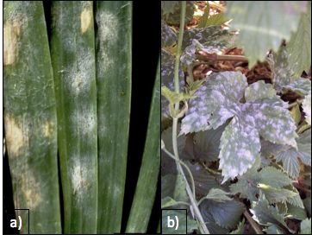
Figure 1. Leveillula taurica growing on onion plant (a) and Podosphaera macularis growing on hops (b). The fungi themselves can look pretty similar, even under microscopic observation.

Taxonomy
Kingdom: | Fungi
Phylum: | Ascomycota
Class: | Leotiomycetes
Order: | Erysiphales
Family: | Erysiphaceae
Genus: | Gloviomyces; Podospheara
Species: | G. cichoracearum; unresolved

Introduction

One of the most ubiquitous and well known of the fungal pathogens on Cannabis are the powdery mildews. Caused by multiple organisms, this dreaded pathogen first manifests itself as a white, cottony growth that begins to form on the top surface of leaves. Once conspicuous on the leaves, the spores of this fungus are likely to be everywhere in your grow, whether it is indoors or out. However, there are various effective treatments that can eliminate this fungus (depending on the stage and degree of severity) and practices that can be used for preventing this fungus from getting established in the first place. Most growers have experience dealing with this fungus at one point or another. In many regions, PM is so common that one should assume that there are always going to be mildew spores in the air, unless you are growing in a filtered indoor space. Even then, starting with an assumption that you have spores in your garden will help you to develop and maintain a solid Integrated Pest Management program (IPM).
Just like everything else in the Cannabis industry, there are some clear misconceptions about these fungi that can be misleading and very confusing. To start, powdery mildews and downy mildews are not the same thing, and should not be treated in the same way. Downy mildew is typically less commonly seen on Cannabis crops, but growers should still be aware of the pathogen and the symptoms associated with it (see Chapter XX: Leaf Spot Diseases for more information on Downy Mildews).
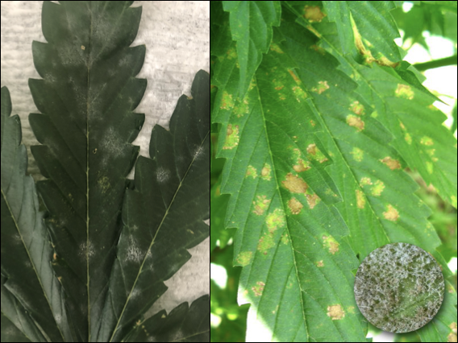
Figure 2. Powdery mildew on Cannabis leaf on left vs. downy mildew on Cannabis on right.

Elucidating the species of powdery mildews affecting Cannabis will assist cultivators in controlling the disease. Most species of powdery mildews are very host specific and have limited alternate host ranges on which to hide from farmers whose crops may be affected. Definitive knowledge of the species affecting Cannabis will help us prevent cross-contamination from susceptible neighboring host plants, though no matter which powdery mildew species you have, any applied treatments will be the same. Three separate reports have identified Golovinomyces cichoracearum sensu lato as the powdery mildew affecting Cannabis in Canada and France based on ITS sequencing (Pépin et al, 2018; Punja, 2018; Rodrigues et al, 2015) and G. spadiceus has been identified from Kentucky (Szarka et al, 2019). Unfortunately G. cichoracearum sensu lato is poorly defined phylogenetically, likely comprising many cryptic species, including many with unknown sexual states. Macpartland et al. 2000 documented two species of powdery mildew infecting Cannabis, Leveillula taurica and Podosphaera macularis. However, under current nomenclature systems Podosphaera macularis is host restricted among Humulus species only and cannot be responsible for powdery mildew infections occurring on Cannabis (Uwe Braun, personal communication). Therefore the isolate must have either been misidentified, or an undescribed Podosphaera is infecting Cannabis. A private lab also reported an unknown genetic isolate from Cannabis grown in the Northeast United States. They claimed a full genome sequence did not match any known Erysiphales in GenBank (a universal genetic depository for researchers), and that the northeast isolate was not a Golovinomyces (Medicinal Genomics). Of the species reported to infect Cannabis only G. cichoracearum sensu lato and G.spadiceus have molecular support reported in the literature at this time.
These mixed and unclear results are not all that surprising given the fact that Cannabis has been illegal to grow and most scientists did not have access to or the ability to work with this plant. Also, molecular fingerprinting has only been around since the mid-1980’s and there are still many organisms that have yet to be sequenced. Powdery mildew is an obligate biotroph, meaning that it requires a host plant in order to live, grow, and survive. This fact makes this organism incredibly difficult to study compared to saprophytic or necrotrophic fungi. Powdery mildews cannot be cultured in a petri dish with an agar medium and thus must be kept alive by growing the pathogen with a susceptible host. Additionally, powdery mildew can be extremely difficult to identify, even with a microscope. The keys that are available use very small, difficult to see features to distinguish among powdery mildew fungi. A major diagnostic feature for the identification of powdery mildew anamorphs (asexual state) are characteristics of the appressorium following conidia germination. Accurate identification of many anamorphs is not possible by diagnostic characters alone, and requires molecular techniques. Molecular techniques such, such as polymerase chain reaction (PCR) have enabled great strides in genetic sequencing, however these approaches also have drawbacks and are not widely available outside of academia and specialized private labs. Among fungi, the inter transcribed spacer (ITS) and ribosomal RNA of the large subunit (LSU rRNA) are often used for phylogenetic analysis.

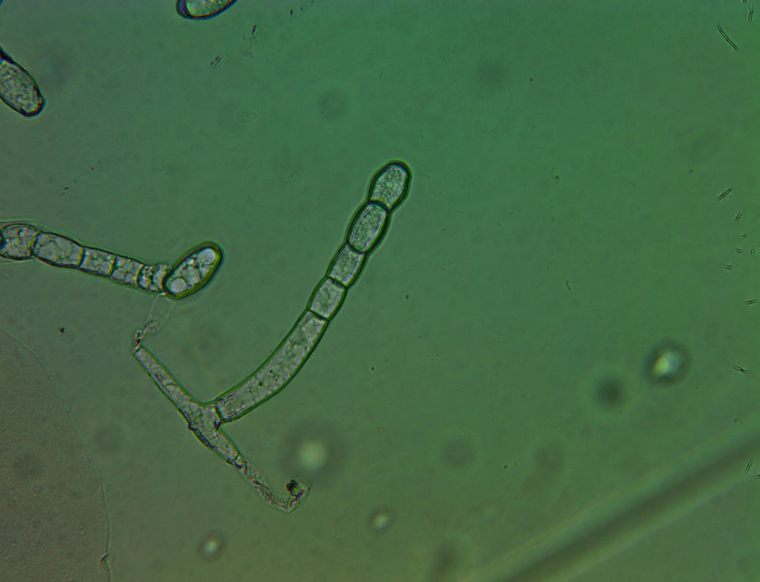
Figure 3. Powdery mildew conidiophore found on Cannabis leaf surface grown in a greenhouse in Oregon. Tape mount at 40x

Like many other groups of fungi, the taxonomy of the Erysiphales (powdery mildews) is in a state of flux. As our understanding of the evolutionary relationships of each discrete species improves, names are changed and species are moved among taxonomic groupings so that our taxonomic system increasingly represents underlying phylogenetic relationships. There are certainly more than one species of Erysiphales affecting Cannabis which may have differing geographical distributions and host ranges. Definitive knowledge of the identity and geographic range of powdery mildew affecting Cannabis, as well as alternate host-plant species, will advance the ability of cultivators to effectively control pathogen outbreaks. It is likely that at least one of the PM species affecting Cannabis cultivators in North America has a relatively broad host range.
An occasional debate in the Cannabis industry is whether or not powdery mildews are systemic. All the scientific evidence that we have seen, in combination with direct observation and knowledge of fungal biology, points to powdery mildew not being systemic. For a pathogen to be systemic, the pathogen would be able to infect one point on the plant (say a leaf) and then travel within the plant to infect other, distant plant parts. Powdery mildews typically form superficial infections restricted to the epidermal tissue. Some species are known to penetrate into the deeper palisade layers of the mesophyll, but no powdery mildew in the entire Order Erysiphales are known to form extensive systemic infections within their respective plant host (Uwe Braun, personal communication).
Farmers often observe large outbreaks on individual plants, fail to take clean clones from plants with infection elsewhere, or experience vertical, seed borne transmission; all of these suggest systemic infection. However PM prolifically produces spores. The spores are then wind and animal dispersed, quickly traveling from one part of a plant to another or even throughout an entire garden. Therefore, once you spot the fluffy white mass growing on a plant, the fungus has most likely already began to produce spores and it is almost guaranteed that there are other PM spores in the air. Seemingly systemic infections are actually the coalescence of individual colonies, each representing an infection point. The fact that powdery mildew colonies almost always manifest as circular growths indicates they are individual colonies. This is analogous to fairy rings or colonies in petri dishes, which expand outward from an original inoculation point. Seed borne transmission of powdery mildew is possible, however it is exclusively (or nearly so) due to conidia on the seed surface, rather than an infection within the embryonic plant body. Because of this, seed borne infections of powdery mildew can be prevented by surface sterilizing seed prior to planting.

Biology and lifecycle

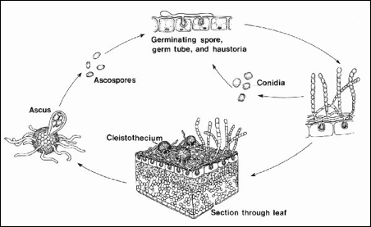
Figure 4. Life cycle of a typical powdery mildew fungus. Only asexual reproductive structures (conidia) have been reported on Cannabis. Either the sexual stage of PM specie(s) affecting Cannabis occurs on alternate hosts, or they may exist as solely as fungi imperfecti, reproducing only in their mold state.

The life of a powdery mildew begins, like other fungi, with a spore (either a sexual ascospore or an asexual conidium).When a spore lands on an area that is suitable for growth it will form a germ tube, a primary hyphae strand. The hyphae will grow from stored energy, but quickly needs access to nutrients for survival. As an obligate parasite, PM must invade host tissue in order to siphon off nutrition. In order to gain access to host tissue, a specialized structure, called an appressorium, capable of exerting high amounts of pressure onto a concentrated point on the plant surface is formed by the developing fungi. Often appressoria will form above inherent weaknesses, such as directly above a stomata or at the meeting point between two epidermal cells. While it exerts pressure on the leaf surface it also releases enzymes that degrade the cuticle and cell walls of the plant tissue it is trying to penetrate. If successful, the hyphae will form a puncture hole into the plant body through which it extends a specialized hypha termed, haustorium. Haustoria are lobed, prong-like projections able to penetrate the cell wall of plant cells (though not the membrane). The haustoria absorbs nutrients from the plant in the extracellular space between the plant cell membrane and wall. The haustoria forms a specialized, convoluted membrane in this space (called the extrahaustorial matrix) along the plant membrane in order to maximize the surface area across which it may absorb nutrients . (https://onlinelibrary.wiley.com/doi/full/10.1111/j.1462-5822.2010.01530.x).. The fungus now has a source of nutrients to continue to grow and mature. The fungus translocates this food throughout its entire body -including the epiphytic portions.
The hyphae can continue to spread endophytically to nearby plant cells, as well as epiphytically over the leaf surface and create new invasion points to access the plant body by extending haustoria. After a short period of vegetative growth in a conducive environment, the fungus will produce conidiophores. Erysiphales are capable of producing conidia in great numbers.
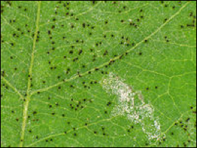
Figure 5. Powdery mildew chasmothecia (small black spots) growing on the underside of a leaf.

Until recently, only the asexual state had been observed on Cannabis. Szarka et al, however, observed G. spadiceus readily forming chasmothecia in autum on Cannabis in Kentucky (2019). Chasmothecia (or formerly, cleistothecia), are the sexual structures formed by members of the Erisyphales. They appear as dark, spherical structures made of tightly interwoven hyphae with simple appendages. Inside there are multiple asc, each containing 8 ascospores. Once the asci and ascospores are mature, the chasmothecium will burst and the spores will be released and dispersed into the environment. When sexual reproduction occurs in Erysiphales it may be homo- or heterothallic, depending on the species. This means that an individual may mate with itself (homothallic), or require a different individual (heterothallic) to form sexual spores.
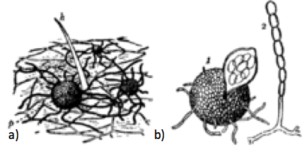
Figure 6. Podosphera macularis reproductive structures. Chasmothecia in the soil (a) and then a chasmothecia next to a conidiophore producing conidia to the right (b).

Powdery mildew can overwinter in the form of this resistant chasmothecia structure. Thus the can lay dormant in your soils of fields and then when the environment is sufficient for growth, the chasmothecia will open and release spores into the wind. If the spores land on a suitable host, the spore will germinate, a germ tube will form and the life cycle begins again!
The usual lack of chasmothecia on Cannabis among may indicate a biological impediment to fruiting body formation when the most common powdery mildew species infects Cannabis. If sol, there may be alternate hosts on which the sexual stage of the pathogen occurs, or these races affecting Cannabis may have lost their sexual state and exist only as an anamorph.

Prevention and treatment

There are a wide variety of treatments for powdery mildew, both at the store and in the literature, and everyone seems to have their own opinions on what works best at what time. The old saying that an ounce of prevention is worth a pound of treatment is especially true when it comes to fungal diseases. The best way to deal with PM is to never get it in the first place. This is accomplished by having a strong IPM program, including set scouting schedules and good cultural practices.
In general, PM species affecting Cannabis thrive in warm, humid, dim conditions. Anywhere from 60oF to 85oF and humidity levels above 50% will create the perfect habitat for these fungi.. Higher light intensity is associated with reduced disease incidence, with the shaded interiors of canopies being most at risk for PM infection. Large swings in day/night temperature and humidity can exacerbate the issue. Many growers clean out the interior of canopies, believing airflow will reduce powdery mildew infections. It has actually been shown this is an effective technique due to increased light penetration, rather than reduced canopy humidity. Regardless, maintaining a canopy with good light penetration reduces PM incidence and severity..
The different species of powdery mildews will have slightly different ecological niches and may respond differently to cultural controls. As the science progresses and the species causing disease in Cannabis are better understood, more specific measures can be taken to help control PM. For instance, alternate hosts may be a significant factor in maintaining a reservoir for PM innocula. Knowing what other plant species are capable as serving as alternate hosts for the relevant PM species will greatly assist growers in keeping the local area clear of PM.
Leveillula taurica can also cause PM on onions and several other common garden plants such as eggplant, tomato, peppers, and others. This species has only been documented in the western United States, as this species prefers slightly drier, warmer climates. Podosphaera macularis commonly grows on hop plants, and has been frequently reported from the hop fields of Oregon and Washington. This species prefers high humidity. A large swing in the daytime/nightime temperatures and humidity will also increase the chance of infection.
All PM species will produce conidia in great numbers, so it is very important to maintain daily scouting programs and preventative sprays if you are growing in conditions that are conducive to mildew growth. Once the white, powdery growths are detected, there are almost certainly going to be conidia all over your garden.
For preventative treatments, biological sprays are recommended. A strong resident microbial community, both in your soil and in the phyllosphere (area surrounding leaf surface), has been shown to increase the plants’ innate resistance to pathogens and at the same time colonize the leaf tissue. The idea here is that you will be inoculating the leaf surfaces with a growing community of healthy microbes. Beneficial microbes act to reduce PM infections by outcompeting the mold for physical space and food resources. This is how many preventative sprays for PM work, especially if it is a biological organism (Bacillus subtilis, B. amyloliquefaciens).
Your biological spray could be a compost tea, a mixture of effective microorganisms, or plant fermentations. Commercial products are available of Bacillus subtilis, Bacillus amyloliquefaciens, Lactobacillus species, Streptomyces lydicus, and many others. All these species will have similar modes of action, where they are outcompeting pathogens for leaf space and some directly antagonize disease organisms.
Streptomyces lydicus, however, has a different mode of action, or at least an additional one. This soil dwelling actinomycete (remember, filamentous bacterium) produces many different novel metabolites. Some of these compounds that are excreted at antifungal and antibiotic in nature, and thus are very important in the pharmacological industry. Natamycin is an anti-fungal compound produced by Streptomyces spp. That is used in many different industries. This compound will bind to ergosterol in the plasma membrane of fungi and inhibit protein transport, thus starving cells of key nutrients and components they need to continue living eventually leading to the death of the fungus. Natamycin is a broad spectrum antifungal compound and will target any fungus that contains ergosterol in the membrane, comprising all known fungi.

Table 1. Common organic treatments for Powdery Mildew that are acceptable for use on Cannabis
Product | Active ingredient(s) | Mode of action
- Serenade  - Double Nickle | Bacillus subtilus  Bacillus amyloliquifaciens | - Direct competition  - Activates induced systemic resistance (ISR)
- GreenCure | Potassium bicarbonate | - Raise pH leaf surface  - Dries out mycelium due to osmotic potential
- Actinovate | Streptomyces lydicus | - Secretes antifungal compounds (natamycin)  - Direct competition
- Regalia | Raenoutria sachalinensis extract | - Activates induced systemic resistance (ISR)
- Elemental sulfur | Sulfur | - Interferes with several fungal life functions (e.g. spore germination)
- Bordeaux mixture | Copper sulfate and hydrated lime | - Copper ions inhibit spore germination, hydrated lime raises pH
Neem Oil | Plant oils, azadirachtin and other terpenoids | - Antifungal compounds  - Physical barrier

If preventative treatments are not sufficient and you see signs of PM appearing on leaf surfaces, there are still plenty of steps you can take to ensure minimum impact on your garden. The first is to manually remove infected tissue. Spray the garden down with a high pH solution to limit spore movement and disrupt fungal growth before removing infected material. Place infected leaves into a container and frequently disinfect your hands and shears as you perform this maintenance.
Spraying the plants down, even if it is with just plain water, seems to help. Conidia do not do well when saturated in water. Ultraviolet light devices designed to treat the air in growing spaces may also be effective at reducing the load of viable spores in the air and reduce disease spread.
When possible, the environment of your space may be controlled to discourage PM growth. This could include raising your temperature and decreasing the relative humidity of your room, or increasing light intensity. Whole garden heat treatments (holding the garden at 100F for 2 hours) may reduce fungal growth.
The oldest treatment for powdery mildew comes from the vineyard growers of Europe. The Bordeaux mixture stems from the late 1900 and is a mixture of copper sulfate and hydrated lime. This treatment is approved for use in organic production and is very effective at inhibiting fungal growth. The copper ion prevent conidia germination and the hydrated lime raises the pH of the leaf surface to a point that the fungus cannot tolerate. This is best used as a preventative treatment although has been shown to be effective even after the fungus has gotten a foot hold.
Other common treatments include baking soda (sodium bicarbonate), potassium bicarbonate, elemental sulfur, neem oil, or high silica fertilizers. Different situations will determine which treatment will be most appropriate. For instance, you do not want to be spraying elemental sulfur on flowering plants, especially if they are destined for extraction, because there will be a burnt rubber aroma in the concentrated product. Using a cocktail of multiple ingredients that have different modes of action seems to be a logical and effective way to treat infected plants. This way the fungus is less likely to develop a tolerance or resistance to any particular ingredient.

Ch. 9
Bud-rot: Botrytis cinerea

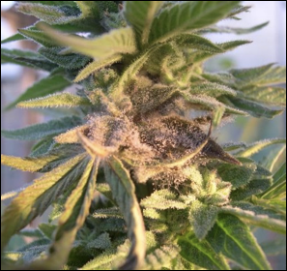
Figure 1. Botrytis cinerea growing on mature Cannabis flower.

Taxonmy

Kingdom: | Fungi
Phylum: | Ascomycota
Class: | Leotiomycetes
Order: | Helotiales
Family: | Sclerotiniaceae
Genus: | Botrytis
Species: | cinerea*
* Botrytis cineria is the asexual stage (anamorph) of Botryotinia fuckeliana. Botryotinia feckeliana is the cooresponding name for the sexual stage (teleomorph) of the same species of fungus. Such duplicate names are the result from the historical develoment of taxonomy, when the sexual and asexual stages of the same species were thought to be different. This fungus is referred to by its anamorph (asexual) name, because the sexual state (Botryotinia fuckeliana) is rarely seen.

Introduction

Another infamous fungal foes known to Cannabis growers is the bud rot causing fungus, Botrytis cinerea. Also known as gray mold, bud rot begins to grow in well developed flowers, capable of devastating maturing crops close to harvest. It is typically first noticed by yellowing or dying back of leaf or flower tissue. Upon further inspection, one will notice white to gray cotton-like growth coupled with brittle plant material and, if the fungus has matured enough, a dust of spores being released into the wind.
Botrytis cinerea is not only feared by Cannabis growers but also by vineyard managers (although, paradoxically, some vineyards artificially inoculate their grapes with B. cinerea to create the sweet flavors of dessert wine), strawberry growers and many others. This fungal pathogen can infect a wide variety of crops, meaning that spores are likely to be everywhere in the air and soil, especially if you live in a humid area with lots of agriculture. In addition to attacking the senescing parts of flowers on mature Cannabis plants, B. cinerea can cause disease among seedlings and even harvested material if it is not properly dried in a timely manner. Therefore this fungus can affect a variety of plant organs/tissues in a variety of life stages of a plant, making it an agricultural concern to farmers everywhere.
Since Botrytis is such a ubiquitous pathogen on such a wide variety of crops, it is fairly well studied by the scientific community. Much of the current research is focused on developing disease resistant cultivars for various crops and examining the host response to see which genes are activated when the pathogen is present. Some researchers are looking at the genome of this organism, or likely complex of organisms, and which genes allow them to be more virulent than other ecotypes. There are also a number of books devoted to B. cinerea that go into detail about their life cycle including how they infect plants and overwinter; it is really a fascinating organism!
All of this information is aimed at helping us as a society develop a better understanding of the organism in hopes that this will allow us to reduce the amount of food and crops that are destroyed by this fungus every year. Estimates of annual crop loss worldwide due to B. cinerea range from 10-100 billion dollars (sciencedirect.com)!
Even though all these resources are going into understanding and studying Botrytis, farmers are continually struggling with its control. It is best to assume that the pathogen is omnipresent and to be treating your plants prophylactically so that they do not suffer disease symptoms later in life. As with all Cannabis pathogens, increased legalization will increase ambient spore load as well as direct transmissions from farm to farm trasport on humans and equipment. Additionally, the large host range of Botrytis allow this organism to persist and spread in areas without historic Cannabis cultivation activities. Having healthy plants and genetic cultivars that are resistant to molds will greatly reduce your risk of disease outbreaks. The environment also plays an important role in necrotrophic colonization of the leaf or flower. Active disease is encouraged in humid environments with cool to mild temperatures or with large temperature swings.

Biology & Life cycle

Right now, science considers there to be a few species of fungi that causes bud rot, grey mold, etc. on over 1000 species of plants, but only one that has been assumed to infect Cannabis. Therefore, unlike powdery mildew, this fungus is not host specific. Also unlike powdery mildew, Botrytis is not an obligate biotroph, it is a necrotroph. This means that this fungus does not need a living host in order to grow. When disease symptoms occur, it usually begins with a flourish of growth on dead tissue; the fungus then actively attacks and kills proximate living tissue. Because grey mold does not require a live host, it can easily be cultured in vitro. The ability to culture pathogens can be an important asset for research, making them much easier to work with than obligate biotrophs.

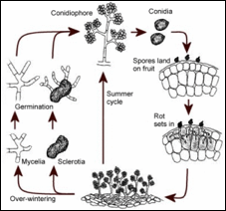
Figure 2. Simplified diagram of Botrytis cinerea lifecycle.

Another very important difference between the biology of Botrytis and powdery mildew is that B. cinerea can be a systemic fungus. The implication being that the fungus can travel throughout the plant body and infect distant areas of the plant from the original site of infection. Botrytis cinerea may even live inside the plant throughout the plant’s life cycle. When conditions are favorable for fungal reproduction, the fungus will produce reproductive structures. This may be the first point where the infection becomes visible to a farmer. Symptomless, systemic infections of plants by fungi are known as endophytes. Pathogenic species often spend some part of their lifecycle endophytically inside potential hosts. In these circumstances the fungi is often considered to be a ‘latent pathogen,’ lying in wait for the proper conditions to switch towards a necrotrophic lifestyle (actively killing host tissue). Once it makes this switch, the host plant will quickly exhibit signs of disease followed by prolific spore (conidia) production by the fungus.

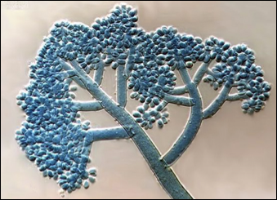
Figure 3. Botrytis cinerea asexual reproduction showing the conidiophores that bere all of the conidiospores (conidia 40x).

Increasing evidence of systemic, latent infections of B. cinerea across a variety of species, including Lactuca and Primula, suggests grey mold may colonise healthy plants as a symptomless endophyte(Shaw 2002, Shaw et al, 2016). Virulent pathovars may yet have a latent endophyte phase in their lifecycle. Botrytis cinerea living endophytically is likely fulfilling this role as a latent pathogen; colonizing healthy tissue to gain first dibs in exploiting it as a food resource once it becomes weakened or begins to senesce. Botrytis cinerea is often seedborne, usually passed on the outside of the seed coat. Though internal seed infestations have been demonstrated in other plant species, and are likely occur among Cannabis seeds, internal infections are usually a minor source of seed borne Botrytis infections among crops (du Toit et al, 2004). Therefore, nearly all seed borne Botrytis can be eliminated by surface sterilizing seed prior to planting. Botrytis is able to kill germinating seeds and very young seedlings. Disease at this stage may partly be a function of inocula density. Surface sterilization kills the vast majority of seedborne Botrytis inocula, protecting young seedlings during the short window of susceptibility to Botrytis induced damping-off. Even if some internally infested seed results in cryptic, systemic infection, these individuals will likely not have any differences in the final amount of disease compared with plants that become infected after germination (Shaw et al, 2016). Horizontally acquired infections among plants grown from cleaned seed quickly catch up to those resulting from seed borne infections among plants grown from dirty seed. An exception to this may be for growers who are in highly controlled indoor environments following effective clean room procedures; in such cases internal seed infection may become a proportionately more significant source of disease inocula than environmental sources.
Regardless of the source of infection, Botrytis cinerea needs damaged or senescent tissue to cause disease in a mature Cannabis plant. The manner in which Cannabis inflorescences mature results in the presence of susceptible plant parts well before harvest time. As flowers mature, the first to grow will begin to senesce, even though the inflorescence on average is not near maturity. Aging individual flower parts and bracts, particularly senescing stigmas (often incorrectly referred to as the pistils- in fact there is only one pistil per flower comprising two stigmas, the style, and the ovary) are prime plant tissue for active necrotrophy by B. cinerea.

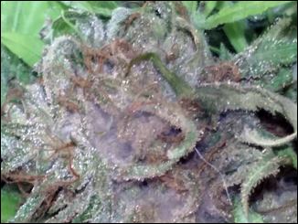
Figure 4. Cannabis flower at peak ripeness that is infested with B. cinerea.

Endophytic species considered mutualistic with their host (confir and receive an increase in fitness), are often closely related to pathogenic species. Some mutualist endophytes are even avirulent races of otherwise devastating pathogens. It is possible that asymptomatic, endophytic infections of Botrytis may represent pathovar-host combinations that include mutualisms. If this is the case, isolates mutualistic in some Cannabis varieties under certain conditions may still be devastatingly virulent when infecting more susceptible Cannabis varieties or under alternate environmental conditions. It is known, for instance, that disease outbreaks of Botrytis more commonly occur and are more destructive among unhealthy and weakened plants. This has historically been seen as increased susceptibility to new infection. However, if Botrytis is commonly endophytically occurring among Cannabis, as has been shown among a variety of other plant species (Shaw et al, 2016, Barnes and Shaw, 2002), increased disease may result from heightened susceptibility to necrotrophy arising from latent infection rather than, or in addition to, an increased ability of Botrytis to colonize host tissue. Therefore, heightened susceptibility to bud rot disease among plant hosts weakened by biotic or abiotic stressors likely results from inadequate immune response ability among already infected plants, as well as reduced ability to ward off new infections arising from conidia.
Current evidence suggests that Botrytis should be classified as a Class 2 endophyte sensu Rodriguez (Rodriquez, 2008). Class 2 endophytes are characterized by a broad host range; extensive systemic infections of shoot, root, and leaf tissue; and vertical (seed borne) and horizontal (acquired during an individual's lifetime) transmission to new plants.

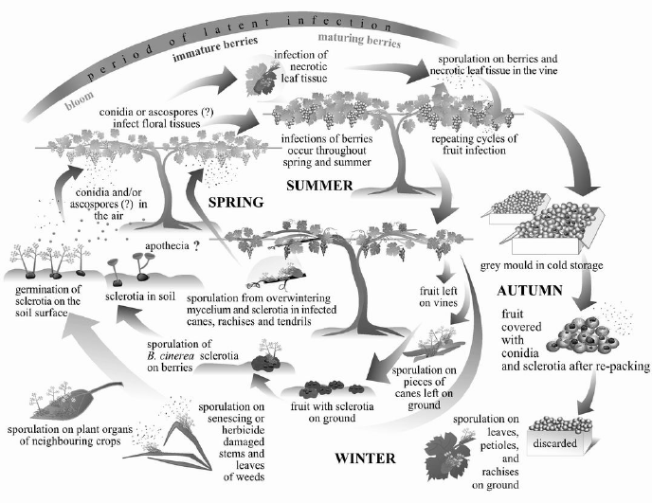
Figure 5. Life cycle of B cinerea diagramed on table grape plants (Elmer and Michailides 2007).

The lifecycle of B. cinerea begins with a spore. Usually wind disseminated, though they may also be vectored on or within insects and arthropods. Once the spore is exposed to proper environmental signals, a germ tube will sprout into filamentous hyphae. This hyphae will be monokaryotic, having only one type of nucleus. The mycelium will grow, consuming typically dead and necrotized tissue, or taking up residence in a living plant as an endophyte. Botrytis hyphae have simple porate septa, easily seen under magnification, with no clamp connections.
Suitable environment for the formation of a necrotizing infection could be dead plant tissue, such as a senescing stigma or entire, unfertilized pistil (comprising the stigma, style, and ovary); or plant tissue that has been mechanically damaged, such as by herbivory or pruning. Plants weakened by primary infection from some other pathogen or abiotic stressors (temperature, moisture, ect) are also more easily infected. Botrytis may form seemingly asymptomatic endophytic infections among otherwise healthy plants. A healthy plant may be able to control low level internal infection, or Botrytis may persist in a low virulence state before it switches to actively killing host tissue. When it does switch, it will produce proteins and toxins that kill surrounding plant cells. The non-lethal nutrient transfer between endophytic Botrytis and the host plant turns to a unidirectional flow of nutrients to the pathogen; Botrytis digests then ingests dead and dying host cells, eating the plant from the inside out. The mycelium will continue to grow. Killing, then colonizing more and more of the flower.
This fungus can reproduce via sexual and asexual methods. Asexual reproduction consists of the mycelium producing large amounts of clonal spores, called conidia, on specialized hyphal structures, called conidiophores. These conidia (conidiospores) will be genetically identical to the mycelium that produced them. Botrytis can form both macro- and microcondia. Conidiophore formation is less resource intensive than the formation of sexual fruiting bodies, and does not require the meeting of different mating types. This makes conidia production a very efficient way for the fungus to replicate itself.
When a compatible mating type is nearby, both mycelia will release signals and the two will fuse, anastomize and exchange nuclei. At this point, the fungus is considered a dikaryon and is capable of sexual reproduction, although this may not happen for a long period of time. Botrytis will continue to grow and exist as a dikaryon indefinitely until the environmental cues and signals are received to produce reproductive structures, sexual or asexual. The teleomorph (sexual state) of Botrytis cinerea has a different binomial name, Botryotinia fuckeliana. Because the anamorph was named first, is ubiquitous, and the sexual state is rare, Botrytis cinerea takes precedence.
A member of the Ascomycota, B. cinerea forms a specialized ascocarp, called an apothecium, which has an exposed hymenium (spore producing tissue) on its upper surface. When the ascospores are mature, the ascus will burst, releasing the spores into the wind. Formation of the Botryotinia fuckeliana ascocarp (sexual fruiting body) occurs directly from sclerotia formed to survive stressful environmental conditions. These sclerotia are often formed inside plant stems and are the means by which Botrytis overseasons through harsh winters. When weather is adequately warm and moist, an ascocarp emerges from the sclerotia and releases wind dispersed spores. Sclerotia look almost like irregular peppercorn kernels and can vary in shape and size. They will have a melanized rind that protects the internal vegetative hyphae.
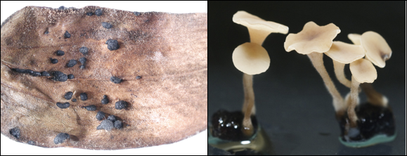
Figure 6. Sclerotia of Botrytis cinerea on a dead lily leaf (left) and apothecia of Botrytis cinerea forming out of scleriotia (rightz).

Botrytis may also survive and replicate itself is through the production of chlamydospores. Chlamydospores are asexual, thick walled resting spores of variable size and shape formed at the terminal ends or intercalary in vegetative hyphae. Like other reproductive modes, when chlamydospores germinate on suitable plant tissue, they can infect the host, grow mycelium and even produce conidia. Compared to sclerotia, chlamydospores can only serve as temporary survival structures, helping the fungus overcome short-term harsh conditions.

Prevention & Treatment

So, what does all this mean and how does it apply to Cannabis? Clearly Botrytis is a common pathogen for many Cannabis farmers causing severe crop loss every season. Therefore, by learning about how this fungus grows and reproduces, the hope is that we can better understand how to control and possibly prevent infecting plants in the first place. One of the first things we can do is to control our environment and make it less conducive for the fungus to grow. This includes reducing humidity late in flowers, avoiding large nighttime temperature drops, and encouraging good airflow through dense canopies. Regardless , cultivar susceptibility is probably a primary area where growers should focus in order to control Botrytis losses.
Keeping plants clean by removing dead leaves and unhealthy plant material can also reduce infection by removing food sources for these fungi. Even if endophytic infections are common, the easily available nutrient resources of dead plant material allow Botrytis to become necrotizing by overwhelming a plant with inocula and direct attacks. When growing plants outdoors, it is important to keep insect pests away from the flowering plants. In particular, certain caterpillars seem to be fond of munching Cannabis, tunneling into flowers, leaving maized routes of plant litter and excrement. Botrytis then quickly colonizes the dead material and nutrient rich caterpillar frass, permitting the fungus to launch an attack resulting in a necrotrophic disease that kills a much larger portion of the flower than the caterpillar had damaged. Using biological preventatives like Bacillus thuringiensis kurstaki can reduce attack by the caterpillars, which will then reduce the risk of Botrytis.

Table 2. Fungicidal products effective against B. cinerea.
Product | Active ingredient(s) | Mode of action
- Serenade  - Cease | Bacillus subtilus | - Direct competition  - Activates induce plant resistance (ISR)
- ZeroTolerance  - Method1  - Essential oils | Thyme oil, peppermint oil, rosemary oil, clove oil, garlic oil, sesame oil | - All have varying degrees of antifungal properties
- Nuke ‘em  - Dr. Zyme | Citric acid (maybe other active ingredients) | - Citric acid has some antifungal properties, but it varies fungus to fungus and is usually not very effective
- Oxidate 2.0  - Zerotol 2.0  - Jet-AG | Hydrogen dioxide, Peroxyacetic acid | - Oxidizing agent that destroys cell membranes and DNA
- Botector | Aureobasidium pullulans | - Direct competition for space

Botrytis is fairly easy to identify on Cannabis. If it is on a seedling, the seedling will usually die pretty quickly and there is not much you can do once you detect the fungus. If you are planting future seeds from the same batch or lot, you can surface sterilize the seeds by rinsing with a 10% household bleach solution for 30 seconds (Table 1). There is also some promise in seed treatments with Trichoderma fungi (ex. RootShield WP).

Table 2. Procedure for chemical and biological treatment of contaminated seeds.
Seed treatment options
Chemical | Biological
- Make a 10% bleach solution by adding 10 mL of household bleach to 90 mL of deionized water.  - Put seeds in a small jar  - Pour bleach solution over seeds  - Swirl around for 30 seconds  - Empty bleach solution while keeping seeds in the jar  - Pour DI water into jar and swirl for 30 secs  - Empty DI water from seeds and repeat 2x times with DI water  - Directly sow into growing medium | - Prepare a spore suspension by purchasing a product containing the organism you want to coat seeds with.  - Place seeds to be treated in spore suspension and swirl for 1-2 minutes  - Remove seeds from spore suspension  - Directly sow seeds into growing medium

Treating flowers infected with Botrytis can be difficult because typically growers do not want to spray flowers with anything once they get past a certain stage. Therefore, preventative sprays, controlling the environment (especially late in flower), and growing resistant genetics are all key to protecting your plants from fungal attack.
By keeping environmental conditions in check, growers reduce the chance that they will encounter this fungus. Botrytis cinerea does not grow well in dry conditions (45% RH or lower). Therefore, keeping your environment at this humidity will lower reduces this pest pressure. Also, having lots of air movement, both horizontal and vertical, can again reduce the likelihood that a spores landing on susceptible plant tissue.
Another environmental pressure that this fungus does not like is high light conditions. Having an even distribution and the appropriate quantity of light in a grow can also reduce fungal attacks. In fact, Rotem and Aust in 1991 documented that the conidiospores of Botrytis were only able to survive for a matter of minutes under the Israeli sun at midday. Clearly, this is not always the case, otherwise outdoor growers, growing under direct sunlight in places like Southern Oregon or Northern California would never get this pathogen, and they do.
Some farmers attempt to cut out sections of flowers that are infected with Botrytis with the hope of preventing the spread of this fungus. While this may help some proximate spread, ultimately the spores are in the environment, and if you see it growing, that means the plants are susceptible to this pathogen. If endophytic infections are truly common, this practice may not actually help at all. If one is to attempt to cut out the fungus from the flower, it is recommended to place the cut flower immediately into a plastic bag to reduce spore spread. Also wipe down any scissors with isopropyl alcohol as well. There is interest in biocontrol of B. cinerea, using organisms (fungi, bacteria) to control the spread of the pathogen. An example of this would be the fungus Aureobasidium pullulans which is an Ascomycete fungus that is able to out compete Botrytis for growing space and resources, thus preventing gray-mold from forming.

Ch 10
Damping off
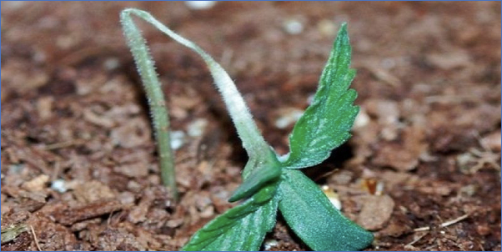
Figure 1. Cannabis plant that has been infected with a damping off causing fungus.

Taxonomy

Kingdom: | Fungi | Fungi | Fungi | Chromista | Fungi
Phylum: | Basidiomycota | Ascomycota | Ascomycota | Heterokontophyta | Ascomycota
Class: | Agaricomycetes | Leotiomycetes | Sordariomycetes | Oomycota | Dothideomycetes
Order: | Cantharellales | Helotiales | Hypocreales | Peronosporales | Botryoshaeriales
Family: | Ceratobasidiaceae | Sclerotiniaceae | Nectriaceae | Pythiaceae | Botryosphaeriaceae
Genus: | Rhizoctonia | Botrytis | Fusarium | Pythium | Macrophomina
Species: | solani | cinerea | F. solani, F. oxysporum, F. sulphurem, F. avenaceum, F. graminearum. | P.aphanidermatum; P. ultimum. | phaseolina

Introduction
Damping off, often incorrectly called dampening off, is common on many horticultural plants. The term is used to classify diseases caused by multiple fungi that affect mainly plants in the seedling stage. Typically, damping off kills the plant before or shortly after the seed germinates, but can also occur on unrooted or newly rooted cuttings. Plants that are infected with these fungi may germinate and come out of the soil but within a few days they are weakened by the fungus growing on the stem or root tissue. Often, the pathogen will infect the stem right where it emerges from the soil. This results in plants that are wilted and falling over. Once you see that a plant has fallen victim to damping off, it is typically too late to act. Plants that are infected with these fungi usually will be too damaged to recover after the symptoms are observed. The same fungi seemingly can infect a number of host plants, making the fungi that cause damping off act as generalists, similar to the bud rot causing fungus, B. cinerea, which itself may cause damping off in seedlings.
Thankfully, this disease is mainly restricted to seedlings or young plants. This occurs because as seedlings mature they express more resistance traits, including production of secondary metabolites and increased structural defence. Damping off is a particularly high risk for hemp fields, where farmers are directly sowing a large number of seeds into soil. If the soil is too cold or the conditions favorable, the pathogen can grow and infect the farmers hard work. Spores of the fungus could be waiting in the medium that the seed is planted into, on the seed coat itself, or blown in by the wind.
Although fungi can cause this disease, it is often caused by Oomycetes, or the water molds, which are not true fungi. Water molds were originally classified as fungi, but, with the aid of molecular techniques, they were found to actually be fungal-like protists of the phylum Heterokonta, which places them closely related to photosynthetic algae. Most water molds are typically parasitic or pathogenic in nature. In fact, the great potato famine of Ireland was caused by the water mold of the genus Phytophthora. Interestingly, no species of Phytophthora is known to infect Cannabis, including the generalist P. cinnamomi. Cannabis is even recommended as a crop rotation for the purpose of controlling for Pytopthora. Pythium, on the other hand, is an Oomycete that may be the most common cause damping off in Cannabis .

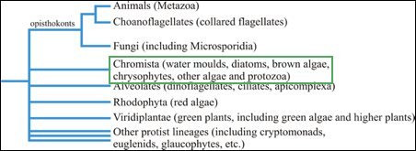
Figure 2. Phylogenetic tree showing the relationship between water molds, fungi, and animals.

Biology & Life cycle

Oomycota
Water molds share some superficial similarities with fungi, including the filamentous growth and presence of cell walls. The material that comprises the cell wall among Oomycetes is cellulose, rather than chitin as in fungi. Oomycete hyphae are coenocytic, or aseptate. This is most likely why people tell farmers when looking at soil or root samples under the microscope to beware of hyphae without septa. However, not all aseptate fungi are bad (the mycorrhizal Glomeromycota for instance) and not all fungi with septa are good (most fungal pathogens are septate). Though these organisms are thought to be related to algae, they have lost their ability to perform photosynthesis if so.
Oomycetes like Pythium have a complex lifecycle with different forms and growth patterns. Water mold’s life begin, like a fungus, with a spore. This spore begins to grow when it lands on a suitable growth substrate, such as plant tissue. The spore will begin to grow hyphae and grow into the host tissue by developing an appsorium and then haustoria to siphon nutrients. They also release extracellular enzymes to assist in entering the host and damaging host tissue.
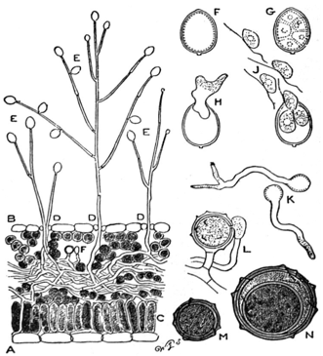
Figure 3. A) Leaf cross-section of Pytopthora infestans hyphae growing through leaf tissue, B) P. infestans sporophores sprouting through stomata. C) Palisade mesophyll layer of leaf D) Under (abaxial) side of leaf E) Sporangia hold zoospores F,G,H) Sporangium development J) Mobile zoospores K) Germinating zoospores L) Antheridium and Oogonium fusion M,N) Development of oospore
When triggered, the Oomycete can either reproduce sexually or asexually. For the asexual, or anamorph, cycle, the water mold will produce a sporophore with a sporangium on top. The sporangium will release diploid mobile zoospores. These zoospores will have flagella to help them move through aqueous environments. The zoospores can then form cysts, which act as long term storage structures. Then, when the environment is met, the cyst can germinate and infect plants. This is why once soil has been contaminated with these organisms, it can be difficult to remediate. Asexual reproduction can also produce asexual spores referred to as conidia or sporangiospores.
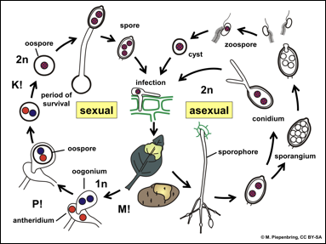
Figure 4. Life cycle of Pytpthora infestans growing on a potato plant.

Sexual reproduction in water molds occurs when compatible mating types meet. Then the water mold will form an antheridium and the other will form a oogonium, which are sexual structure where fertilization occurs. The nuclei will migrate into a new structure called an oospore. Eventually these nuclei will fuse creating a diploid oospore, which is genetically different than the parent molds. This oospore can then infect new plants and begin the life cycle again.
It seems as though oomycetes can infect plants systemically as well, especially in young plants. The hyphae of these organisms has the ability to grow through the plant and then produce sporophores through the stomata of the plant. That is a very effective dispersal strategy for wind dispersed water molds such as Phythium and Phytopthora.

Table 1. Comparison of some characteristics of Oomycota and true fungi.
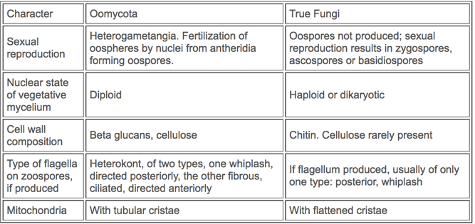

Fungi
Prevention & Treatment
Treatment of damping off depends on the disease organism, where it is (seed vs. soil), and also environmental conditions. As always, prevention is the number one way to deal with damping off disease. If planting seeds, there are various seed coat treatments that can be directly applied to seeds. Seed can be pretreated with organisms antagonistic to damping off, such as Trichoderma (e.g. Rootshield WP) or surface sterilized with a dilute bleach solution or alcohol.
Treatments can also be applied into the media prior to planting and become less effective and necessary as the seedling grows. When starting seed in pots, the media can be pasteurized to eliminate potential disease organisms. Steam sterilization may also be used to treat large areas of soil on a field and greenhouse scale. Steam sterilization should actually be called pasteurization, as it does not kill all life in the soil. In fact specific temperature range and treatment times may kill pathogenic species while retaining beneficial organisms.
Alternating what crops are grown in the contaminated soil can also reduce the population of water molds. If a crop is grown that the pathogen is unable to infect, eventually the organism will run out of a food source. Water molds still can form cysts which allow them to survive during periods of harsh times. Therefore, rotating crops until there is no longer any sign of damping off may be one long-term method of removing these pathogens from a particular field.
Avoid over-watering seedlings and do not allow seedlings to germinate in damp cool conditions. Adding a seedling heat mat indoors can resolve this issue. Outdoors, make sure you are far enough from the last frost in your area before direct sowing of seeds. Also make sure you are planting into clean soil, free of all disease organisms. Clean any equipment prior to use for seed planting as well. Having adequate airflow and temperature is always good practice when germinating seeds, reducing the chance of pathogen growth and stimulating plant growth.

Ch 11.
Vascular Wilts
Kingdom: | Fungi | Fungi | Fungi | Fungi | Fungi
Phylum: | Ascomycota | Ascomycota | Ascomycota | Basidiomycota | Ascomycota
Class: | Sordariomycetes | Sordariomycetes | Dothideomycetes | Agaricomycetes | Pezizomycetes
Order: | Hypocreales | Hypocreales | Botryoshaeriales | Atheliales | Pezizales
Family: | Nectriaceae | unresolved | Botryosphaeriaceae | Atheliales | Rhizinaceae
Genus: | Fusarium | Verticillium | Macrophomina | Sclerotium | Phymatotrichopsis
Species: | F. solani, F. oxysporum, F. sulphurem, F. avenaceum, F. graminearum. | V. dahliae, V. albo-atrum | M. phaseolina | S. rolfsii | P. omnivora

Fusarium
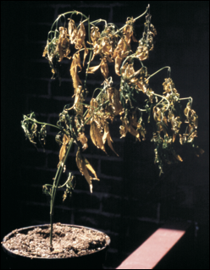
Figure 1. Cannabis plant severely affected by Fusarium wilt caused by Fusarium oxysporum. Photo by J. McPartland.

Introduction
Cannabis growers do not seem to see this pathogen very often, and even less frequently with indoor cultivation. Fusarium is a genus of soil borne fungi that can wreak havoc on a wide variety of plants. In particular, Fusarium oxysporum strains can cause Fusarium wilt on most, if not all, strains and species of Cannabis. Fusarium is most frequently identified in hemp fields, though this most likely only due to the scale and geographic range that hemp where hemp is now grown. Fusarium diseases may also be more common than recognized, as many people are not familiar with the symptoms and appearance this pathogen.
Some of the organisms that cause Fusarium wilt in Cannabis can also infect other host plants, so be aware of the plants you have near your Cannabis plants. Other hosts include coffee, tobacco, alfalfa, and soybeans. Since these fungi can spread so rapidly, early identification of this disease is of utmost importance.
Symptoms of Fusarium pathogens are typically described as an overall wilting of the plant. If the fungus is causing ‘foot rot’ the plant stems can have a brownish appearance at the soil line. Spots will begin to appear, first on lower, more mature leaves. Spots will appear in between leaf veins and will quickly spread to the newer tissue. Eventually, leaf tips will curl up before the plant succumbs to a wilt. Therefore, the traditional classification of Fusarium wilt is fitting for this disease.
The U.S. and state governments have researched Fusarium oxysporum pathovars as biocontrols capable of wiping out plantations of Erythroxylum coca (the source of cocaine) Papavera somniferum (Opium Poppy) and Cannabis (https://sciweb.nybg.org/science2/hcol/fusarium2.asp.html, K. S. Tiourebaev et al 2010 (biological control of ditchweed)https://sciweb.nybg.org/science2/hcol/fusarium2.asp.html). Apparently, the fungus was successful at destroying entire crops in trials. They even developed specific pathovars intended to attack specific host species. However, concern about this pathogen being able to jump to other host plants and cause economic and ecological damage prevented widespread application for biocontrol purposes. Ultimately, Fusarium supposedly was never sprayed in field applications, though there have been accusations the U.S. government used Fusarium as biocontrol of Coca in Peru (which the government denies).
Besides such malicious introductions, Fusarium may be naturally present in a regions soil, or dispersed into a garden via wind borne spores, imported soil and transplant rootballs, and carried by people and equipment. Regardless of where it comes from, certain environmental conditions are conducive to Fusarium growth, permitting this pathogen to grow and multiply at an alarming rate.

Biology & Lifecycle
Fusarium species are Ascomycota. This means they produce their spores in sacs and have septate hyphae without clamp connections. The sexual fruiting body is a perithecia (singular perithecium), though abundant asexual conidia are also readily produced.

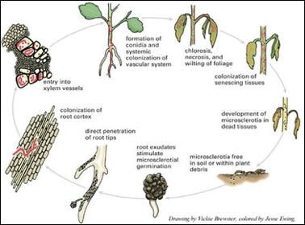
Figure 2. Life cycle of typical Fusarium species.

The life of Fusarium will again begin with a sexual or axesual spore. This spore will germinate when conditions are met and a hypha with one type of nucleus (monokaryotic) will emerge. Remember, there may be many nuclei in each hypha but at this point there is only one type of nucleus. Since Fusarium can grow saprophytically on dead material, it can grow, multiply, and persist without the presence of living host plants. When a suitable host plant is sensed, the fungus will grow toward the roots. Once contact occurs, the fungus will produce an appressorium in order to gain access to living host tissue. The fungus can also enter through wounds in the root or via the delicate root tip cells.
Shortly after the fungus invades the root, it will begin to grow into the xylem tissue, which is what the plant uses for conducting water from the roots, up to the shoots of the plant. The fungus enters the xylem through the pit cells. Continuing upward, the fungus colonizes more and more of the plant, using the xylem as the mode of transport. Fusarium can also make microcondia. These microconidia are carried through the xylem by means of sap flow and can then germinate and infect even more areas of the plant. When the plant is completely dead Fusarium will grow out of the xylem and into other areas of plant tissue. Certain conditions make it so the fungus is able to proliferate very quickly. This fungus prefers warmer temperatures, sometimes symptoms will not be observed until the temperature reaches 26C.

Prevention and Treatment
Growers can act preventatively to alter their growing environment to be less hospitable to the Fusarium pathogen by avoiding or remedying wet areas with poor drainage (McPartland et al. 2000). Excess nitrogen fertilizer can also lead to fungal persistence. Fusarium pathogens can exist in a wide range of environments and can live as saprophytes, feeding on dead organic matter, until the appropriate host presents itself and then acts as a pathogen. Unlike many other soil-borne pathogens, Fusarium species are aerobic organisms that require oxygen to survive. Therefore, compact, anaerobic soils are not likely to foster Fusarium (or grow healthy Cannabis).
Due to the aerobic nature of Fusarium prolonged field flooding has been used to reduce Fusarium wilt with variable success (Evaluation of Soil Solarization and Flooding As Management Tools for Fusarium Wilt of Lettuce, 2010). Liming acidic soils may decrease the chance of Fusarium infection (McPartland et al. 2000). Heat treatments via solarization or steam treatments can be used to treat infected soil before use. Depending upon temperature and duration of the treatment, you can sterilize the soil, which will kill the fungal spores (along with everything else), or pasteurize it to allow a population of saprophytic antagonists to persist (Cook, 197X). Plow-under cover-crops can be used to increase competition against Fusarium by non-pathogenic soil saprophytes. Brassicaceae plow-under crops have further efficacy against Fusarium due to the antifungal effects of isothiocyanates, released by mustard greens when they break down (See Section 4.X). Brassica plow-under crops should be immediately incorporated into the soil following mowing, or else the antimicrobial isothiocyanates will escape as gas without making contact with soil pathogens (MOVE TO SEC4). Remediating an entire field infested with Fusarium will be difficult and may require several years. Crop rotation can also help reduce disease load, though cannot eliminate Fusarium from a field on its own.
If a plant is identified to be infected with Fusarium it is recommended to quickly remove and destroy the plant, or destroy it in place, to reduce amplification and spread of the pathogen. Burn the plant debris after destroying it, or use a flameweeder to remove the plant. Rather than treating infected plants that are showing signs of Fusarium wilt, it is recommended to remove these plants from the field or gardens immediately. If a plant is left to the point where the fungus is releasing spores, the entire field could now be contaminated for future plantings. Movement of infected material, or soil from infected areas of the field (such as on shoes and equipment) can spread the pathogen throughout a field.
Verticillium

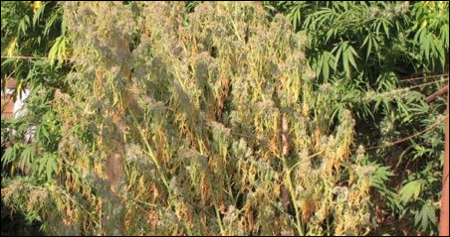
Figure 3. Verticillium species infecting a large Cannabis plant.

Introduction
Verticillium dahliae and V. albo-atrum have both been shown to cause wilt in Cannabis plants (McParland 1996, Ranalli 1999). This fungal infection looks very similar to wilt caused by Fusarium and would really take further investigation to identify the true culprit. This is a systemic disease as well, where the fungus can travel in the xylem and cut of water flow to certain areas of the plant. When cut into the stem, one will typically see a reddish-brown discoloration in the xylem tissue where the fungus was beginning to grow (McPartland 1996).
Although traditionally there have not been many reports of Verticillium impacting Cannabis farms, one would expect to see the rates of incidences to increase with the exponential growth of Cannabis being cultivated around the world in native soils.
The two species of Verticillium that are reported to infect Cannabis are also able to colonize a vast array of other host plants. Verticillium dahliae is more common and persistent in soils and has a larger number of hosts that it lives off. The hosts include cotton, potato, tomato, eggplant, and more. Verticillium albo-atrum has fewer susceptible hosts, one of which is hops, Humulus lupulus, which is a close relative of Cannabis (in same family Cannabaceae).

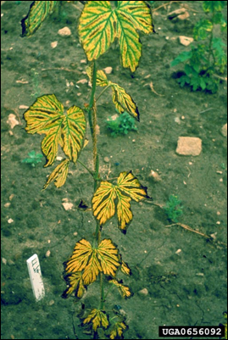
Figure 4. Verticillium wilt ‘tiger stripe’ symptoms manifesting on hop plant.

As noted previously, superficial plant symptoms are very similar to Fusarium wilts, with several small distinctions. Pacific Northwest Pest Management Handbook states that in addition to leaves turning yellow and dying, some leaves would actually display a ‘tiger stripe’ leaf pattering, similar to that seen in hops (Fig. 3). The entire plant may show symptoms simultaneously or if may appear as though only one or a few branches are infected.
Chlorotic yellow leaves and unnecessary wilting in combination with reddish-brown vascular tissue when the stem is cut in are all indicators of Verticillium wilt. Microslerotia and/or conidia are often found in the xylem when lateral cross-sections are made. Often microscopic and/or molecular techniques are required to positively identify this pathogen is the agent of cause.

Biology & Lifecycle

Verticillium is a genus of soil borne Ascomycete fungi, some of which can infect Cannabis by entering the root. Found in soils mainly as either microsclerotia or dark hyphae, these specialized structures rely on the presence and detection of root exudates before they begin to germinate. Once germinated, the hyphae will begin to grow towards the root cell.The fungus can enter the host tissue either from a wound or opening in the root tissue or by producing a specialized structure that allows the fungus to enter the root. Once in the root, the wilt fungus will move towards the vascular system of the plant, chich is essential a tube-like transport system that allows the plant to transport nutrients (phloem) and water (xylem) throughout the plant. Verticillium wilts have a particular affinity towards the xylem tissue, which is dead at maturity.
The fungus can travel as mycelium, conidia, or specialized resting structures known as microsclerotia. If the fungus gets stopped by a blockage in the xylem, mycelium will grow around it and digest the plant tissue and then sporulate on the other side of the blockage and continue to access the rest of the plant . The fungi to not seem to enter the phloem.

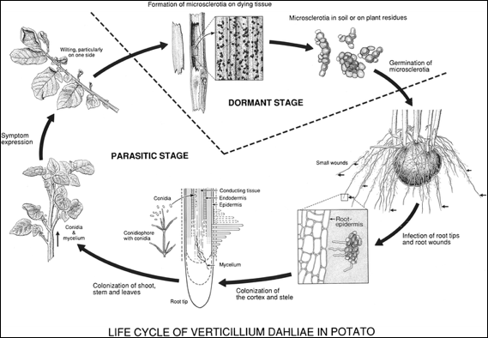
Figure 5. Life cycle of Verticillium dahliae on potato plant (Keykhasaber et al 2017).

Once inside the xylem the fungus can move throughout the plant very quickly, especially since the fungus will often produce conidia for the mode of transport which allows for much greater speeds of dispersal. It is worth noting that the hyphae found within the host vascular tissue is typically linear and unbranched. The fungus will spread and continue to steal nutrients from the plant, acting as a true parasite and killing the plant.
After the fungus has killed the plant by stealing nutrients and blocking water movement, the plant will have died. At this point Verticillium fungi can begin to act as saprotrophs, colonizing and digesting the dead host tissue.
Verticillium will form resting structure either as microsclerotia (V. dahliae) or as dark-colored hyphae (V. albo-atrum) that typically is found within the vascular tissue of the now dead host plant. The microsclerotia are thick, melanized structures that allow V. dahliae to persist in harsh environments for long periods of time until the right conditions and host is found. The dark melanized hyphal cells are also resting structures but are not able to withstand adverse environments for as long as the microsclerotia. Therefore V. dahliae is able to persist in soils longer and is more common than V. albo-atrum (Mace 2012).
These fungi have been found in almost all types of soils, and can survive in a wide variety of environments (Mace 2012).

Prevention and Treatment

Remediating a field of soil that has a population of Verticillium can be very difficult. Soil fumigation with Methyl Bromide and Chloropicrin has shown some promise for decreasing population number but is not recommended unless severe measures are needed and other methods have ceased to work (Duniway 2002). Such practices will destroy the biology and structure of your soils which can take a long time to recover.
Other potential options for removing or reducing Verticillium species from your fields include crop rotation, however, due to the broad host range of these pathogens, it is sometimes difficult to find a crop that is not susceptible (Klosterman et. al 2009). Researchers have noted that Broccoli is not very susceptible to Verticillium wilt and may make an logical choice for crop rotation in contaminated fields, but more investigation is required (Bhat and Subbarao 2001).
Alternative options include anaerobic soil disinfection (ASD) where a high carbon source is applied to the soil and then a tarp is placed over the area to deplete the oxygen and create an anaerobic environment (Washburn 2018). The idea here is a food source is give to the soil microbiology and then a tarp is placed over the area to deplete the oxygen (Blok et al. 2000). As the microbes consume the food they deplete oxygen levels even more, eliminating or greatly decreasing the population of pathogenic organisms.
Pullman et al. have researched a technique known as ‘soil solarization’ where the farmer uses a clear tarp to essentially cook the soil with the heat of the sun, eliminating a large population of pathogenic organisms, as well as the beneficial ones (Pullman et al. 1981). This is an interesting treatment option, particularly for farmers that are looking for non chemical options. However, there are obvious limitations on the last two methods, depending on the size of the farm, geographic location, and pathogen population to name a few.
Another treatment that has been researched is incorporating broccoli residue into the soil. Broccoli is rich in glucosinolates, which are broken down by soil microorganisms, releasing by-products such as isothiocyanates, thiocyanates, and nitriles (Bhat and Subbarao 2001). The resulting toxic compounds that may possess fungicidal properties that can potentially decrease the pathogen population or atleast make them less active. This phenomena is known as biofumigation. Perhaps other plant species with elevated concentrations of glucosinolates would offer similar results.
In fact, in 2003 McGuire researched using mustard greens as a cover crop and to grow a green manure that would be terminated and incorporated back into the soil while the plants were still green. Again, mustard greens are high in glucosinolates that breakdown into potential toxic compounds in the soil. Not only did the Veticillium levels decrease, but incorporating the green manure also improved water infiltration and saved the farmers a substantial amount financially from not having to purchase and apply chemical pesticides.
As always, having best management practices in place in regards to cleanliness and soil health is imperative when growing highly valuable cash crops. Doing regular applications of high quality, biologically active compost will help inoculate fields with beneficial microorganisms that can help protect plants from pathogens. Planting or breeding resistant cultivars can also greatly reduce crop loss to Verticillium wilt (Keykhasaber et al. 2017)

Macrophomina

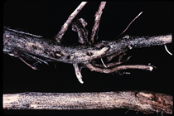
Figure 6. Microsclerotia of Macrophomina phaseolina growing on the root of a soybean crop.

Introduction

Also known as charcoal rot, Macrophomina phaseolina is yet another Ascomycete fungus that causes a number of diseases in crops, including vascular wilts. This fungus has a broad host range, with the ability to infect over 500 different plant species (Khan 2007). In addition to charcoal rot, M. phaseomina has been reported to cause damping off, basal stem rot, root rot, and seedling blight (Ijaz 2013).
Wilt from M. phaseolina can have symptoms similar to other wilt diseases, however, the pathogen may be latent and symptoms may not appear until later in the plants life (Ijaz 2013). This disease produces an array of symptoms including reduced emergence and yield, severe wilting, yellowing of leaves, chlorosis, necrosis, loss of vigor and more (Kunwar et al. 1986).
However, a tell-tale sign that this is the fungus infecting plants is if the epidermis of the plant stem is peeled off, there may be the presence of tiny black, tuber-like structures which are microsclerotia formed by the fungus (Fig. _).

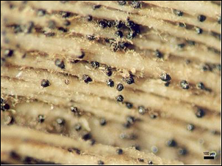
Figure 7. Microsclerotia of Macrophomina phaseolina in fibrovascular plant tissue after epidermis has been peeled.

Macrophomina phaseolina has been documented on a number of crops, in a wide variety of environments and geographical locations (Akhtar 2011). It can be transmitted through soil, the roots of transplanted plants, or even on the seed coat of particular plants (Khan 2007).
Particular care should be given when working in fields or near plants that have charcoal rot fungus. Macrophomina phaseolina has been documented as a human pathogen, particularly in immunocompromised patients (Srinivasan et al 2009). As we learn more about the various plant pathogens (and even just soil organisms in general) we may find that more and more of these organisms are able to invade susceptible human hosts as well as crops.

Biology & Lifecycle

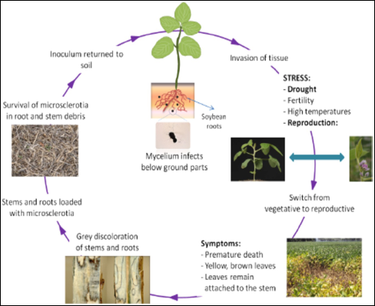
Figure 8. Lifecycle of Macrophomina phaseolina from Zafari et al. 2018.

Although initally this fungus begins as a spore, for our purposes we will begin with the microsclerotia. A microsclerotium is a small mass of cells that develop a melonized wall around the outside of the structure for protection. This allows fungi to survive harsh conditions for extended periods of time. For M. phaseolina the microscleriotia can be thought of as the infective stage of the fungus.
The microsclerotia can persist in soils anywhere from 2-15 years, depending on the conditions (Meyer et al. 1974). Then, when a susceptible crop is planted into a field containing M. phaseolina and the plant begins to release root exudates, microsclerotia near the root will begin to germinate. The fungus relies on this signal from the plant in order to grow and invade the roots.
Once the fungus has germinated it will begin to grow towards the roots. The mycelium will either enter the root through a wound or opening, or the fungus will produce an appressorium that will enter the plant cell either through mechanical forces or through enzymatic digestion. After invading the host tissue, M. phaseolina is mainly contained in the intercellular spaces of the root cortex cells (Gupta et al. 2011). However, in 1987, Burton noticed that infection on cantaloupe plants mainly occurred on secondary and tertiary roots. Perhaps the fungus invades secondary roots and then is able to travel to the primary roots where the fungus is able to live and persist. Regardless, unlike other wilt causing organisms, M. phaseolina affects the fibrovascular system of the plants, opposed to just infecting the vascular system.
This fungus can travel through the vascular system of plants, mainly in the form of microsclerotia. Mycelia and microsclerotia can clog vascular tissue, cutting off the plants supply of water and nutrients. The can manifest as black/grey mold in the vascular system, hence the name ‘charcoal rot’.
Eventually adjacent cells will begin to die, either from a loss of water and nutrients or from phytotoxic compounds that the fungus is producing (Ramezania et al. 2007). Macrophomina may act as a latent disease, where the fungus infects crops but they appear asymptomatic for a period of time, and then when conditions are right the symptoms express. Therefore, diagnosing this disease without the help of molecular techniques can be very difficult.
Gupta et al. noted that in some plant species, the plant switching to reproductive growth (flowering) could initiate the fungus to produce more microsclerotia in the plant vascular tissue. The microsclerotia will persist as the plant dies and remains in the plant residue until it is decomposed, at which point the microsclerotia will be left in the soil, awaiting new susceptible crops.
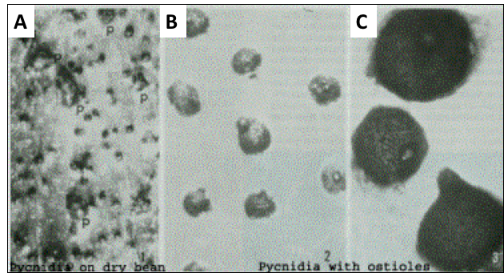
Figure 9. Macrophomina phaseolina sexual structures (pycnidia). A) is pynidia on a bean, B) is pycnidia and C) is a closeup of the pycnidia, showing the ostioles.

When M. phaseolina does produce a sexual structure, it is a pycnidium. Pycnidia are round, dark structures that house the asci that produce ascospores. This is the ‘fruiting body’ of this particular fungus and is where sexual reproduction takes place. When the ascospores are fully developed within the asci, the sacs will burst and the spores will be released through the ostioles, which is a neck with an opening at the end. Researchers have noticed that M. phaseolina only produces pycnidia in certain hosts under particular conditions or in vitro under particular laboratory conditions (Gupta et al. 2011, Gaetán et al. 2006).
Regardless of the fungus producing pycnidia or not, the fungus typically persists in the soil in the form of microsclerotia. The mycelia is not considered the major source of inoculum, but the microsclerotia are. So if you have noticed that plants have been infected with charcoal rot, it is important to get that plant and its residues out of the field before the microsclerotia re-enter the soil.

Prevention and Treatment

As always, being aware of the field you are farming and the crops you are growing can greatly alleviate any future pains of dealing with this fungus. As stated previously, M. phaseolina can persist in soils as microsclerotia anywhere from 2-15 years, depending on environment/weather/crops grown/etc. In addition to surviving long periods in soil, there is also evidence that M. phaseolina can spread via the seed coat in certain crops (Kunwar et al. 1986). It has not yet been confirmed if this can happen in Cannabis crops.
There are a number of synthetic pesticides that farmers are using to try to mitigate and control charcoal rot. Many of these compounds are powerful antifungal compounds that most likely will kill the pathogen, but are not very selective and will also kill any other fungi that the compounds come in contact with. This could have serious environmental, ecological and economical implications and would only be recommended in extreme cases where all other measures have failed.
There are, however, factors that do influence the rate of infection and yield loss to this pathogen. The overall health of the plants and how much stress they are under (abiotic and biotic), will impact the susceptibility to this fungus (Burton et al. 1987). In 1995, Diourte et al. found soil moisture and stress from high temperatures and drought to influence the rate of infection as well.
If M. phaseolina is already present in the soil and you must grow a Cannabis crop on this field, there are several options as far as reducing the pathogen populations and increasing the chance for success. Soil fumigation is a somewhat common practice in conventional soybean fields. However, less intensive methods include crop rotation, soil solarization, and perhaps even various organic amendments and changing the C:N ratio (Israel et al. 2005).
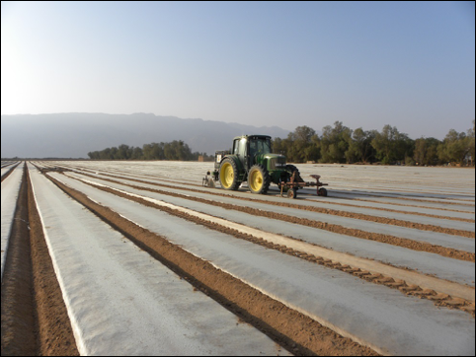
Figure 10. Tractor applying polyurethane mulch after field has been tilled and water for soil solarization to reduce pathogen levels

Crop rotations can be difficult due to the diverse number of crops that this fungus can infect. Soil solarization also shows promise but again, would likely kill everything in the soil that is not heat tolerant and capable of surviving periods of time with little to no oxygen. Adding organic amendments such as, mustard oil cake, has been shown to be effective at control the pathogen as well (Israel et al. 2005).
Bio-control options have also been researched for controlling or reducing the populations of M. phaseolina in soils (Elad et al. 1986, Arora et al. 2001, Singh et al. 2008, Gupta et al. 2011). Some of the biocontrol agents that showed promise were; Rhizobioum meliloti, Trichoderma harzainum, and Bacillus subtilis.
Avoiding soils that have known populations of M. phaseolina is the number one way to reduce your chances of getting this pathogen. However, good practices such as soil health and cleanliness will always help reduce root pathogens. Developing resistant varieties through rigorous breeding practices can also greatly help the industry as a whole reduce yield loss to wilt fungi but will take time and hard work.

Athelia rolfsii (formerly Sclerotium)

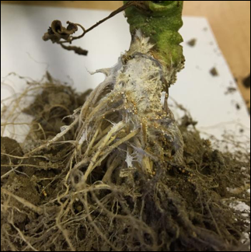
Figure 11. Southern Blight (Athelia rolfsii) growing on Cannabis root stock.
Introduction

A particularly interesting fungus that has been found to infect Cannabis is Sclerotium rolfsii (Teleomorph: Athelia rolfsii). When the pathogen was originally discovered, which was from a diseased tomato plant in Florida, it was not realized that this is the same fungus that forms a corticoid crust fruiting bodies. Therefore, the original name for the organism that causes ‘Southern Blight’ was S. rolfsii, but, since the advent of molecular techniques and the realization of the sexual state, the fungus has been moved to the genus Athelia and the name has been changed to A. rolfsii.
Due to this fungus’ predilection for warm climates, and being discovered from Fl, the common name given to the fungal pathogen is ‘Southern Blight’. Although called Southern Blight, A. rolfsii can cause damping off in seedling or wilt/blight symptoms in more mature plants. Wilts are typically characterized by drooping due to loss of water whereas blights typically affect leaves, flowers, fruits or other parts of the plant. Therefore there are a variety of symptoms that can be an expression of A. rolfsii infection.
Also known as ‘mustard seed fungus’, A. rolfsii is a facultative pathogen, meaning that in addition to surviving off susceptible host plants, this fungus can also act as a soil saprotroph, digesting organic matter from dead plant residues. This allows A. rolfsii to survive and grow in soils even when there are no hosts present.
After the food source has run out, Southern Blight can also produce sclerotia to persist in harsh conditions when the environment is not favorable. Again, this is a strategy employed by a number of pathogenic fungi that make them difficult to eliminate from soils.
As the sclerotia germinate, A. rolfsii can infect plants of all ages. If seedlings are infected, damping off can occur. If vegetative plants are infected, wilt or blight traits can be expressed. If the plant is in its reproductive growth phase, more wilt/blight-like symptoms can manifest. Often water-logged lesions can appear on the leaf tissue or stems of the plant, typically near the base of the plant where the stem meets the soil.
Southern Blight has been shown to attack about 500 species of host plants in the United States alone (Flores-moctezuma et al. 2006). In addition to Cannabis, other susceptible plants include tomatoes, sugar beets, peanuts, soybeans, and many others. Grasses such as switchgrass and corn seem to be overall less susceptible and may be logical candidates for crop rotations (Kator et al. 2015).
Menies reports that researchers have found slerotia to survive in soils without a host for at least 5 years under certain conditions (Menzies 1965). Being a facultative pathogen allows this organism to employ alternative strategies for obtaining nutrition, giving them a distinct advantage over other obligate pathogens.

Biology & Lifecycle
Athelia rolfsii is noteworthy among Cannabis pathogens in that it is a Basidomycete, meaning it is more related to a portabello than most of the fungal Cannabis pathogens discussed so far (Rhizoctonia is also a basidomycete). Althelia is a weakly pathogenic soil saprophyte. Affected plants exhibit lesions at the soil line. Though the infections are not systemic, the fungus can girdle the stem and kill the root system, resulting in total plant death.
Althelia rolfsii is generally only present as vegetative hyphae and sclerotia. The fungus survives in the soil indefinitely as a saprophyte on dead organic matter, and may persist as sclerotia during harsh conditions. When susceptible plants are present and conditions are favorable to the fungus, Althelia will attack living plants via direct contact of the mycelium with below ground portions of the host plant. The mycelium will come in proximity to the root and prior to penetrating the plant cell, the fungus will excrete enzymes that kill and even disintegrate the cell wall before contact (Farooq et al 2010).
Since this is not a systemic disease, the fungus does not travel within the body of the plant. Instead A. rolfsii will begin to kill plant cells and then digest the nutrients and will continue to do this until the plant is dead, at which point the fungus will continue to consume the dead plant material.
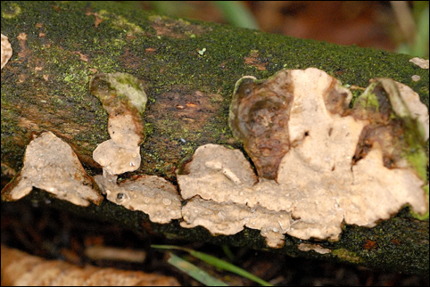
Figure 12. Example of a corticoid crust fungus Phanerochaete velutina, NOT Athelia rolfsii because no good pictures could be found of A. rolfsii in field conditions. This is the type of fruiting body that A. rolfsii will form.

Though rarely seen, Althelia rolfsii is capable of sexual spore formation. It is currently unknown what causes sexual reproduction in field conditions, however, under laboratory conditions nutrient concentration, light, and age of culture have all been shown to influence basidia formation. Since Athelia is in the phylum Basidiomycota and being in the corticoid, crust-fungus group, the sexual structures produced here are basidia that are on a flat, flush , fertile mat of hyphae. This is called a resupinate fruiting body.
The host range of Althelia is extremely broad, with over 500 plant species known to be affected. Despite its name, Southern blight is not restricted geographically, rather it thrives in warm, moist environments. It has been shown that freezing temperature will kill mycelia whereas sclerotia can persist through lower temperature.
The sclerotia of Southern Blight can vary dramatically in shape, size, and color. These structures can lie dormant until the correct environmental conditions present themselves. Biological analysis of field soil prior to plantings may help detect the presence of pathogenic organisms.

Prevention and Treatment
Southern blight is very difficult to eradicate and control once it has infected a field. Avoidance of infected fields and transfer of inocula via soil, people, and equipment is the first defense against this tenacious and persistent pathogen.
However, if Athelia is already present in the soils, farmers still have options for reducing or potentially eradicating the population. As previously mentioned, soil solarization can be an effective measure for reducing the pathogen numbers. Since Athelia is an aerobic organism that does not perform well in low oxygen environments, reducing oxygen levels make this pathogen less competitive. Other options to reduce oxygen are deep tillage and even flooding when appropriate.
Other options include crop rotations with non-susceptible host plants such as corn, sweet potatoes or cotton (Flores-moctezuma et al. 2006). However, care and strategic planning must be employed when attempting to reduce pathogen numbers with crop rotation, especially with A. rolfsii due to the diversity in host plants but also because this fungus can exist as a soil saprophyte as well.
If individual plants show symptoms, the plant and the soil around it should be removed and incinerated. Trichoderma, a fungal hyperparasite, and high nitrogen soil amendments have also been shown to be effective at reducing Althelia.

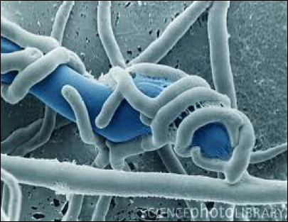
Figure 13. Trichoderma species parasitizing unknown fungal hyphae.

Trichoderma species such as T. harzianium and T. koningii can act as mycoparasites, parasitizing the mycelia and/or the sclerotia (Latunde-dada 1993). Therefore, Trichoderma have been researched as a biocontrol against A. rolfsii with promising success, depending on a number of variables (Elad et al. 1984, Punja 1985, Latunde-dada 1993). Researchers have noted that sclerotia germination is declined when other soil microorganisms are present, so perhaps increasing the soil biology by inoculating with high quality compost can help suppress Southern Blight as well (Punja 1985).
High levels of nitrogen application, including nitrogen supplements that will be converted into NH3 (ammonia) seem to have a reducing effect on pathogen populations. This could be due to toxic ammonia levels or it could be contributed to an increase in soil microbiology activity or in plant innate immunity changing, or a million other variables that we are not currently considering.
An interesting last note about the relationship between Athelia and Cannabis is that when researchers Farooq et al. were examining ways to control theis fungus, they experimented with a number of different plant extracts. One of the plant extracts they included that showed activity against A. rolfsii was the extract of Cannabis sativa (Farooq et al 2010).

Ch XX. Hemp Canker

Kingdom: | Fungi | Fungi | Fungi | Fungi | Fungi
Phylum: | Ascomycota | Ascomycota | Ascomycota | Ascomycota | Ascomycota
Class: | Leotiomycetes | Dothideomycetes | Dothideomycetes | Dothideomycetes | Sordariomycetes
Order: | Helotiales | Pleosporomycetidae | Pleosporomycetidae | Capnodiales | Hypocreales
Family: | Sclerotiniaceae | Didymellaceae | Didymellaceae | Davidiellaceae | Nectriaceae
Genus: | Sclerotinia | Phoma | Ascochyta | Cladosporium | Fusarium
Species: | S. sclerotiorum & S. minor | P. cannabis, P. exigua, P. glomerata, P. herbarum, P. piskorzii, P. nebulosa | A. Cannabina, A. arcuata | C. herbarum, C. resinae, C. tenuissiumum, C. cladosporioides | F. sulphureum, F. avenaceum, F. sulphurem, F. graminearum.

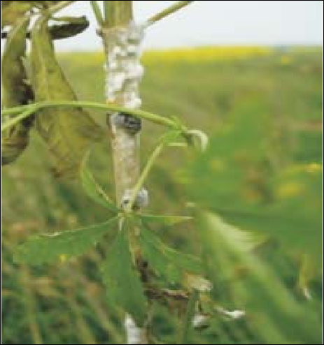
Figure 1. Sclerotinia sclerotiorum growing on Cannabis indica in India (Sharma et al. 2016).
Introduction
Hemp Canker is a disease typically caused by Sclerotinia sclerotiorum or S. minor. These fungi can infect over 350 different species of crops from a diversity of plant families. Purdy considers S. sclerotiorum one of the most nonspecific, omnivorous, and successful of all plant pathogens. In addition to occuring on hemp (Cannabis sativa), these pathogen has also been documented to infect Cannabis indica from India (Sharma et al. 2016).
Diseases caused by S. sclerotiorum are also known as cottony rot, watery soft rot, stem rot, drop, crown rot, blossom rot, and probably other names as well. Although other fungal species can cause canker infections on Cannabis, Hemp Canker is traditionally caused by S. sclerotiorum.
A canker is simply a name given to a disease expression that is caused by any number of bacteria or fungi. The symptoms typically include a lesion on the stem that can be irregular and sunken, swollen, flattened and/or cracked.
Hemp canker on Cannabis is usually first detected by white mycelium growing on the stem, possibly near nodes, that can later produce small black sclerotia. This can even girdle the stems, thus killing the plant entirely. Unfortunately, by the time this pathogen is detected, usually it is too late to save the plant.

Biology & Lifecycle
Sclerotinia sclerotiorum and Sclerotinia minor are ascomycetes within a family, Sclerotiniaceae, occupied by many other plant parasites, including Botrytis. Sclerotina are necrotrophic pathogens; they are capable of growing saprophytically, but are weak competitors. However, when they infect living hosts, like Botrytis, they require senescing host plant tissue to colonise and mount a necrotrophic attack. Once established as a weak saprophyte on dead or dying host tissue, Sclerotinia mounts an attack on nearby living host tissue in order to actively kill and consume it. The fungus can produce an array of extracellular enzymes, including oxalic acid, to damage and weaken the host cells prior to infection(Petrofeza and Nasse 2012).
Growth first appears as white cottony mycelial growth before forming hardened black structures (sclerotia). Mycelial growth and sclerotia formation may occur covertly within the stem, usually killing the plant above the diseased area. Sclerotinia sp. disseminate via windborne ascospores produced in mushroom like apothecia similar to Botryotinia (grey mold). Unlike Botryotinia, the sexual stage of the asexual Botrytis, Sclerotinia does not have a cooresponding asexual stage. Sclerotinia is a homothallic ascomycete, meaning it is capable of sexual reproduction through self fertilization. Therefore, within canopy disease amplification does not occur, rather infections represent unique isolates originating from apothecia in the environment, or from soil borne infections.
When environmental conditions are favorable fruiting bodies arise from sclerotia, which are stone-like, hardened, melanized hyphal structures that look like hardened bits of charcoal. Sclerotia are produced during the previous growing season within or on their previous plant host. Sclerotinia produces these structures to overwinter in the soil or in host plant debris at rest until the environment becomes favorable to growth again. At this time the sclerotia may grow a fruiting structure directly, to produce sexual, wind- (or occasionally insect-) dispersed ascospores. Sclerotia may also germinate vegetative hyphae and grow through the soil to infect physically proximate plants asexually, even though no asexual spores are produced.
Sclerotinia can grow in a wide variety of environmental conditions, which helps make so successful. Although this fungus prefers cool, moist climates, it has also been documented in hot dry areas as well and has been shown to grow from 0-32oC, with impeded growth nearing either extreme (Purdy 1979).

Prevention and Treatment
Sclerotinia are widely dispersed pathogens with wide host species ranges. Specific infection sources may be shared equipment and sclerotia in seed lots. The seed coat of seed itself may also harbor infective Sclerotina (Sharma et al., 2015). Antifungal seed treatments should be used for seed suspected of harboring pathogens (appendix x).
Sclerotinia sp. thrive in high moisture environments. Slerotia are dependant on moisture to break their dormancy. Excessive field moisture is positively associated with disease incidence. Deep plowing (with care not to spread disease via implements) and the incorporation of organic materials can decrease sclerotia survival. Prolonged flooding may also be effective for heavily infested fields (3-5 weeks). However, ensuring well drained soil during the growing season is also important for limiting disease pressure. Long crop rotations (3+ years) with cereal crops or other non-host plants can reduce inoculum density, though sclerotia may survive in dormancy many years. Microbial treatments, including Trichoderma viride (Kapil and Kapoor, 2005) and combinations of Pseudomonas aeruginosa, Trichoderma harzianum and Bacillus subtilis (Jain et al, 2015) were effective at reducing disease incidence and improving plant vigor in the presence of Sclerotinia.

Ch. XX. Leaf Spots
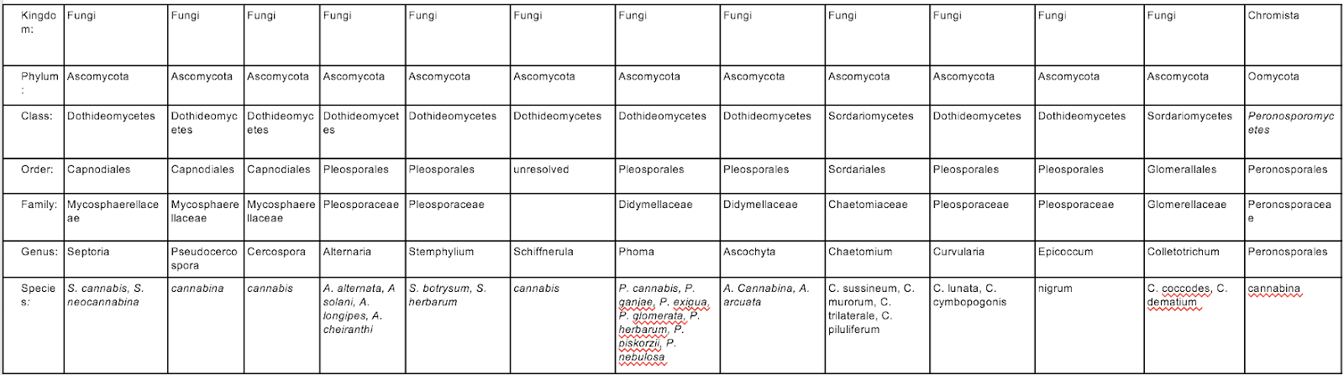
Kingdom: | Fungi | Fungi | Fungi | Fungi | Fungi | Fungi | Fungi | Fungi | Fungi | Fungi | Fungi | Fungi | Chromista
Phylum: | Ascomycota | Ascomycota | Ascomycota | Ascomycota | Ascomycota | Ascomycota | Ascomycota | Ascomycota | Ascomycota | Ascomycota | Ascomycota | Ascomycota | Oomycota
Class: | Dothideomycetes | Dothideomycetes | Dothideomycetes | Dothideomycetes | Dothideomycetes | Dothideomycetes | Dothideomycetes | Dothideomycetes | Sordariomycetes | Dothideomycetes | Dothideomycetes | Sordariomycetes | Peronosporomycetes
Order: | Capnodiales | Capnodiales | Capnodiales | Pleosporales | Pleosporales | unresolved | Pleosporales | Pleosporales | Sordariales | Pleosporales | Pleosporales | Glomerallales | Peronosporales
Family: | Mycosphaerellaceae | Mycosphaerellaceae | Mycosphaerellaceae | Pleosporaceae | Pleosporaceae |  | Didymellaceae | Didymellaceae | Chaetomiaceae | Pleosporaceae | Pleosporaceae | Glomerellaceae | Peronosporaceae
Genus: | Septoria | Pseudocercospora | Cercospora | Alternaria | Stemphylium | Schiffnerula | Phoma | Ascochyta | Chaetomium | Curvularia | Epicoccum | Colletotrichum | Peronosporales
Species: | S. cannabis, S. neocannabina | cannabina | cannabis | A. alternata, A solani, A. longipes, A. cheiranthi | S. botrysum, S. herbarum | cannabis | P. cannabis, P. ganjae, P. exigua, P. glomerata, P. herbarum, P. piskorzii, P. nebulosa | A. Cannabina, A. arcuata | C. sussineum, C. murorum, C. trilaterale, C. piluliferum | C. lunata, C. cymbopogonis | nigrum | C. coccodes, C. dematium | cannabina

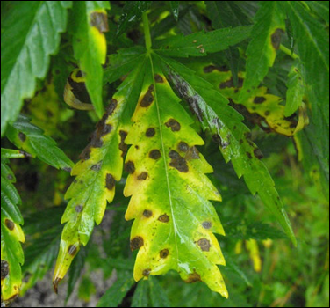
Figure 1. Yellow leaf spot symptoms on the foliage of Cannabis plant.

Introduction

Leaf spot is another general term that is used to characterize a number of different diseases caused by both bacteria and fungi. The symptoms are generally the same; irregular or regular botches on the foliage of various plants. This could eventually lead to overall defoliation if left untreated.
Being a general term, leaf spots on Cannabis can be caused by a number of different bacteria or fungi. Some of the fungi that can lead to leaf spots are listed above (Table 1). Note that all of the ‘true fungi’ belong to Ascomycota.

Biology

Spores from casual fungi land on susceptible plant surfaces, germinate, and form an appresoria with which they penetrate the plant surface to gain access to internal plant tissue. Leaf spot organisms cause localized infections. Some may exist as an asymptomatic endophyte for a period of time before causing disease (Alternaria is commonly isolated as an endophyte from a broad variety of host plants).

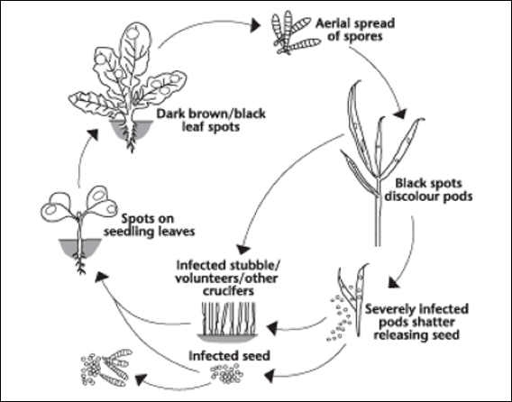
Figure 2. Disease life cycle of a typical leaf spot fungus.

Fungi which cause leaf spot either reproduce exclusively via asexual conidiospores (Cercospora, Pseudocercospora, Alternaria), or primarily so (Septoria). Because of this, secondary disease cycles can rapidly progress within a single season from a small initial inoculum source. Septoria also may form sexual fruiting structures (perithecia). Septoria overwinters on crop debris where it forms sexual fruiting bodies and disseminates via ascospores the next season.

Prevention and Treatment
Ensuring plants are healthy, vigorous, and pathogen free from the start is important for
avoiding leaf spot diseases. Proper plant nutrition will reduce disease occurrence and severity; nitrogen deficiencies are associated with leaf spot. Because leaf spot organisms survive on crop debris through the off-season, removing diseased crop residue and encouraging high saprophytic activity in the soil can reduce innocula load and survival.
Foliar applications of compost teas or other microbial inocula throughout the vegetative growth phase may also reduce leaf spot occurrence. This could be due to the leaf surface colonized with microorganisms and there is no more space for pathogens to invade or perhaps the microbes that are present are producing compounds that inhibit the pathogen.
Breeding resistant cultivars is another novel way to develop plants that are more resistant to certain fungal pathogens. This, however, takes time, space, money and the cooperation of federal governments that would allow for such breeding programs to exist.

Ch XX. Post-harvest Contamination

Kingdom: | Fungi | Fungi | Fungi | Fungi
Phylum: | Ascomycota | Ascomycota | Ascomycota | Ascomycota
Class: | Dothideomycetes | Eurotiomycetes | Eurotiomycetes | Sordariomycetes
Family: | Pleosporales | Eurotiales | Eurotiales | Hypocreales
Family: | Pleosporaceae | Trichocomaceae | Trichocomaceae | Nectriaceae
Genus: | Alternaria | Aspergillus | Penicillium | Fusarium
Species: | Alternaria alternata | Aspergillus flavus, A. niger, | Penicillium citrinum, P. paxilli, P. commune | Fusarium oxysporum,  F. solani, F. equiseti

In addition to contaminating living Cannabis plants, there are a number of fungi that can grow on Cannabis after harvest. This can occur on flower that has not been properly dried or if it was dried under improper conditions. Common contaminants include many of the ‘weedy’ mold fungi such as species of Aspergillus, Penicillium, Rhizopus, and even Botrytis. Spores of all of these fungi are very ubiquitous and are likely to already be present in many environments.
This is why we must be conscientious when drying, curing and storing our Cannabis products, especially flower. If there is too much moisture and high enough water potential, fungi will grow. Typically, dried Cannabis flower will contain about 10-15% water content when ready to be consumed (1). With this water content, there is not enough moisture for fungi to grow and the product is not crumbley, dry, or harsh to consume.
If Cannabis flowers have been dried and stored properly, it can last for long periods of time with little risk to fungal attack. As long as no moisture is added back to the material, fungi will not be able to grow on the relatively dry flowers. Glass jars with caps that screw on tightly work well for long term storage of Cannabis. On a larger scale, food grade 5 or 55 gallon buckets can be store material in relatively good condition, particularly if they are placed in storage or buried underground for temperature control.
As long as certain parameters are met, product loss to mold among plant material that has already been cut down should be minimal. The first few days represents a short window of time where mold may continue to grow. Moisture within the flower should be dropped relatively quickly at first, in order to reach a point impermissible to significant mold growth. A water activity monitor may be used to ensure proper moisture content benchmarks are reached. Flower should be dropped to 0.8 within a few days. Once this point is reached, drying should proceed slowly and at a cool temperature for up to several weeks. Most mold is unable to grow at a water potential under 0.7 and flower should reach about 0.6 before it is ready to be moved to the curing stage. Oregon and California mandate that flower must have water activity under 0.65 to prevent spoilage.

Table 1. Water activity is a measure of vapor pressure within drying Cannabis flowers divided by the partial vapor pressure of water at the same temperature.
a_{w}=p/p*
a_{w}= water activity | p= partial vapor pressure within the flower | p*=partial vapor pressure of water at a given temperature

Water activity monitors can range from several hundred to thousands of dollars, though it is the prefered method in industries with precise drying and storage requirements. Moisture content, the measure of water in a sample as represented by percent weight of water, can be approximately measured at home very cheaply: measure a sample of Cannabis, dehydrate it fully in an oven or dehydrator, and remeasure. The difference in weight between the fresh and dry sample, divided by the weight of the fresh sample is the moisture content. Ed Rosenthal has suggested using a wood moisture meter for tracing water loss through drying and curing. Wood moisture meters are designed to measure wood density and temperature, and therefore will only ever approximate true water content, but nonetheless may be informative for tracking water content of drying Cannabis if it remains consistent. Wood moisture meters can be purchased for less than $50. Moisture content is less informative than water activity for spoilage prevention; low moisture content material may still spoil if the water present is not bound, and therefore free for use by microbes for growth.

Table 2. Water content benchmarks through the drying process.
Stage | Water activity (preferred) | Moisture content⁴
fresh | >0.9 | 90%
drying | <0.8-0.65 | 16-12%
curing | 0.7-0.6 | 11-12%
storage/use | 0.6 | 10-12%

Growers should experiment with manipulating their dry room temperatures, dehumidification, and air exchange to best reach optimum drying time. The relative humidity of the dry room should be kept at 60% RH or less. This will keep spore from germinating and colonizing the organic material. Keeping the temperature below 60ºF will also discourage fungal growth. Circulating fans should be used to prevent any stale pockets of air from occurring. Not only will doing these make it less likely for fungi to grow, but it will also allow the Cannabis flowers to ‘slow dry’ creating a smooth and aromatic final product.
If you are unconcerned with the smokablility or terpene content of your final product, you may benefit from the addition of heat for drying product. Large scale hops dryers are currently being adapted for Cannabis on hemp farms that are producing huge quantities of biomass solely for extraction of CBD and other cannabinoids. Most cartridges for vaporizer pens in the THC market are also produced from distillate and isolate where the quality of the flower from which it is derived is mostly irrelevant. Among isolate and distillate processing operations, even the presence of mold may be irrelevant to many, though mold will affect the grower in terms of lost mass of THC regardless. For processing techniques that do not purify the resulting concentrate into factions, processing flower with contaminant mold may concentrate any mycotoxins that may have been produced.

Table 3. Parameters for drying Cannabis flower to ensure no loss to mold post-harvest
Relative humidity | <60%
Temperature | ~60oF
Air movement | Steady movement, no still pockets
Lighting | Kept Dark

If, despite meeting the above drying room parameters, molds are found on the flower after drying, it is likely that the fungus was mostly grown while the plant was living. Some fungi are quite inconspicuous on the growing plant and often times are overlooked by the grower. These fungi are frequently from the genera Aspergillus or Penicillium.
Most fungi that affect Cannabis post-harvest are mostly benign to humans. This includes the ubiquitous Botrytis and Powdery Mildew fungi, though the inhalation of their spores may cause respiratory issues and all fungi may elicit allergic reactions in some people. Of greater concern to human health, several species that occur on Cannabis are capable of producing very dangerous mycotoxins and/or directly causing human disease. Species of both Aspergillus and Penicillium that produce toxic compounds are able to grow on Cannabis.. Aspergilliosis fatalaties have been reported among immunocompromised people that may have been linked to exposure to Aspergillus contaminated Cannabis (2). With this disease the fungus can begin to grow and colonize the lungs and penetrate nearby tissue in a three dimensional colony called a fungus ball. Additionally, exposure to moldy Cannabis flower has been associated with allergic bronchopulmonary aspergillosis, an autoimmune response to various Aspergillus species (3).
Exposure to Aspergillus propagules in the environment is ubiquitous; you are likely breathing in and out spores at this moment. Most people without suppressed immune systems are unaffected by this onslaught. However, moldy Cannabis may contain such high numbers of pathogen spores that it overwhelms immunocompromised people or triggers a runaway immune response in those with potential allergies. Due to these serious threats poised by consuming fungally contaminated products, it is of utmost importance that all Cannabis products be screened and tested for the presence of these organisms, and to be grown and processed in a manner that reduces the occurrence of mold in the first place.

Microbial testing for Cannabis product varies from state to state. Some states do not perform any sort of microbial test, but instead measure water activity and moisture content as a proxy to infer how likely microbes will be to grow on the tissue. However, there is no standard definitive method for detecting harmful pathogens on flowers, let alone distinguishing them from benign microorganisms. As the industry develops, testing methods are likely to follow suite and become more rigorous and accurate at identifying harmful organisms. Species specific assays, based on metabolic tests and base sequence analysis of specific genes, are being developed for use among Cannabis samples. Until such testing methods are widespread, we are left to use our senses to examine our products before consuming them. If there is concern the product may be contaminated or if the end user is immunocompromised, particular caution should be exercised.
Sight, smell, feel, and taste are among our direct innate senses which we may rely on to screen contaminated product before use. If we see any fuzzy or furry growth on the material, that is indicative of the presence of a young fungal colony. Eventually you may also be able to see conidia or spore bearing structures forming inside of the flowers. Sometimes these can look very similar to trichomes to the naked eye. Often it is not until we magnify what we are consuming that we are really able to see the contaminate. Using a jeweler's loupe or dissecting scope is a good way to differentiate minor mold contamination from desirable trichome coverage. If conidia are well developed, you can see a cloud of spores injected into the air when you bread a bud apart. Trichomes may also beak off in burts from dry flower, but these will quickly fall downward; spores rise upward into the air like a puff of smoke.
Smelling for mold is a little trickier. Often if we take a big whiff of the flowers and we feel a pain in our lungs or start sneezing, this could be an indication of moldy product. If the container just smells damp or off, this could be another clue that a mold is growing that we do not want.
Sometimes when we break open a bud it feels especially dry and crumbly. Or maybe it feels soft and tears more than snaps. Either of these can be indicative of fungal contamination. If the flower feels different for some reason, inspect it further with your other senses.
If the Cannabis product tastes unusually bitter, sour, or harsh, this could be another sign that your flower is contaminated with mold. Particularly if an unusual taste is accompanied with prolonged coughing, chest pain, or burning of the throat, the product should be reexamined for signs of contamination and be discarded.

Section 4
Plant Immunity

Plant Defenses

Physical
The first line of defense plants have against pathogens is, similar to ourselves, a physical barrier. Both plants and humans have a layer of dead tissue that is constantly produced and sloughed off; among plants it is their bark, among humans it is our skin. The protection of the internal body within is an important purpose of bark and skin. On plant parts that do not develop bark, such as leaves, there are still protective layers of epidermis, coated with waxy cuticle. Many plants also possesses trichomes, for which Cannabis is especially famous (Table XX). Trichomes may serve myriad roles, such as increasing the boundary (humidity) layer near the leaf, physically detering herbivory, and secreting defensive chemicals. Each plant cell also possesses a selectively permeable plasma membrane contained within a cellulose cell wall.
One of the most susceptible areas of an undamaged plant body to infection are the stomata. Stomata are openings that allow the exchange of gas. Necessarily, these openings are physically at high risk of exploitation by organisms (pathogens, commensals, and mutualists) that grow inside plants. Often fungi will form appresoria directly on top of a stoma, permitting easier access by pushing between the two guard cells, rather breaking a new opening through the leaf cuticle and epidermis.

https://deepblue.lib.umich.edu/bitstream/handle/2027.42/142132/ajb211846.pdf?sequence=1&isAllowed=y
Table 1. Trichome types found on Cannabis
Type |  | Approximate sizes | Features
Non-glandular | Non-cystolithic | 70-125 μm | Thin, unbranched, simple in shape. Unicellular. Occur most densely on the underside of leaves and bracts.
 | Cystolithic | 250-370μm | Similar to non-cysotlithic in shape, but larger. Contains cystoliths, calcified outgrowths of the cell wall, at their base.
Glandular | Bulbous | 10-30 μm | Diminutive trichome with secretory cells. Variable structure.
 | Capitate sessile | 25-100 μm | Large glandular head with secretory cells often attached by several cells, but only one cell high.
 | Capitate-stalked | 70-150 μm, stalk up to 200 μm | Large glandular head with secretory cells situated on top of a slender, multicellular stalk.
 | Antherial Sessil | 25-100 μm | Occur only on the anthers and calyx of male flowers.

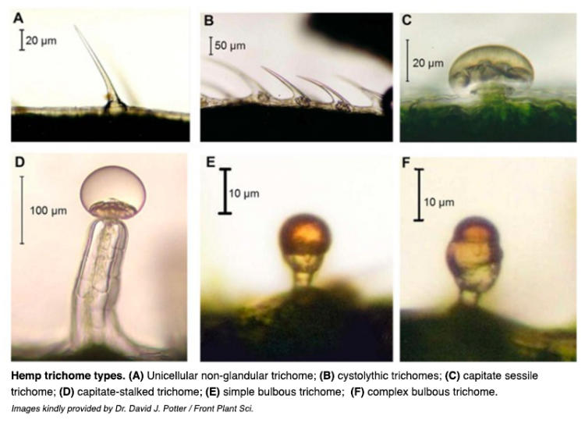

Chemical

Plants produce a variety of chemicals directly effective against pathogen attack, called secondary metabolites, a catch all term for any molecule produced by a plant not directly involved in the primary metabolism of a plant. These may include terpenes, phenolics, alkaloids, phytoalexins, defensins, and enzymes. Many secondary metabolites are important for plant health and survival by mediating microbial interactions and defending the plant against microbial or animal attack. Secondary metabolites that are produced or activated only after contact with a pathogen are called phytoalexins. Though sometimes this term is broadened to include all plant defense chemicals, defense chemicals present pre-infection are not true phytoalexins. Recent attempts to categorise the immense variety of phytoalexins and plant defense chemicals are summarised in Table 2.

Table 2. Secondary metabolites of plants involved in microbial defenses.

Non-Nitrogen Containing | Terpenes/Terpenoids  Flavonoids  Lignans  Phenylpropanoids  Coumarins  Tannins  Sterioids  Saponins  Polyacytalenes  Fatty acids
Nitrogen Containing | Alkaloids  Non-protien amino acids  Amines  Alkamides  Lectin  Peptides  Polypepdites  Enzymes  Defensins  Small interfering RNAs

Plant Immunity

Plants lack an adaptive immune response, like those found in animals. However plants are not helpless. They have innate abilities to respond to pest and pathogen attack by changing aspects of their physical growth and the production and distribution of their protective chemical arsenal.. Following a trigger, plants are able to “induce” a whole plant immune response. Depending on the nature of the trigger and subsequent signaling pathway (jasmonate or salicylate, respectively) such an induced state is called induced systemic resistance (ISR) or systemic acquired resistance (SAR) (Vallard and Goodman, 2004). Both ISR and SAR prime the immune responses of the entire plant, but ISR is a milder response than SAR. ISR is often triggered by interactions with symbiotic microbes, such as Rhizobia or mycorrhizae, whereas SAR is more often a response to pathogenic attack. In ISR and SAR plants recognize foriegn invaders via pattern triggered immunity (PTI) and effector triggered immunity (ETI).

Pattern triggered immunity (PTI) (aka basal immunity):

Pattern triggered immunity in plants has evolved a sensitivity to microbe-associated molecular patterns (MAMPs) and damage-associated molecular patterns (DAMPs). MAMPs are often fundamental, conserved portions of the microbial pathogen, such as essential cell wall or membrane components (i.e. lipopolysaccharide in bacteria and chitin in fungi) which cannot be altered by single gene mutations in the microbe genome. DAMPs, on the other hand, represent damaged cell machinery of the host plant itself (i.e. cell wall fragments, damaged proteins, DNA and RNA fragments). DAMPs recognition is more indirect then MAMPs. DAMPs are not under the control of the pathogen genes; they result from inevitable damage which occurs during pathogenic invasion of a host plant.
Recognition of necessarily conserved cell features of pathogen species (as in MAMPs) or indirect indicators of pathogen invasion (as in DAMPs) prevents the pathogen from evolving mechanisms to evade the plant immune system. PTI is so broadly responsive to basic microbial signatures, that it may be activated by most symbiotic microbes as well as pathogens. Nematode associated molecular patterns (NAMPs) are also recognized; and viral capsid, and potentially other viral molecular patterns, are grouped within pathogen associated molecular patterns (PAMPs) (Chintakuntlawar1 et al, 2010).

Effector triggered immunity (ETI):

The gene-for-gene relationship is in many ways a road map (or perhaps more appropriately a treadmill) through the evolutionary history between a host and pathogen. For each gene that enables a pathogen to cause disease, there may be a corresponding gene among the host species that counteracts the gene in the pathogen and permits plant resistance. Many of the pathogen genes which enable virulence code for metabolites called effectors (proteins), which act on the machinery (proteins) of the host plant.
Each time a gene that confers virulence to the pathogen emerges, a selective pressure is exerted on the plant host population (natural selection). Susceptible plants are either killed or diminished in their ability to reproduce; if there are some individual plants with some form of genetic resistance they will survive and reproduce more prolifically. As a result, genes for resistance become more common (are ‘naturally selected’) in the population's gene pool. This neutralizes the ability of the pathogen variety, or race, to cause disease among most plants in the population until and unless a genetic mutation arises which somehow permits the pathogen to evade the newly common gene of plant immunity, which has now spread through the host population. When this type of evolutionary interaction occurs, a single gene in the pathogen, which would allow it to act virulently in a susceptible plant host, corresponds to a single gene in a resistant host plant which neutralizes its action; hence the term ‘gene-for-gene.’
Plant genes conferring vertical resistance are mostly among the R-genes involved in ETI, of which the major two classes are genes that code for nucleotide binding site-leucine rich repeat (NBS-LRR) proteins and pattern recognition receptor (PRR) proteins. Pattern recognition receptors are also involved in pattern triggered immunity (PTI).
Some families of proteins recognizing effectors found in plants have analogues among animals. For instance the NB-LRR protein family in plants is extremely similar to the nucleotide-binding oligomerization domain leucine rich repeat (NOD-LRR) proteins among mammals (Choi and Klessig, 2016). The similarity in structure and function of these protein families is most likely the result of convergent evolution, rather than divergence from a protein present in a common ancestor of plants and mammals (Ausubel, 2005). However, the similarity is striking. If these protein families are related through descent from a common ancestor, these are in fact homologous proteins rather than unrelated analogs.

Systemic acquired resistance (SAR) and induced systemic resistance (ISR):
Both ETI and PTI are able to increase the subsequent ability of a plant to respond to pathogen attack. Depending on how the plants defenses are activated, different pathways are set in motion to increase plant resistance. Induced systemic resistance (ISR) generally occurs when PTI is activated and is mediated largely by jasmonate and ethylene, whereas ETI is associated with the plant response, systemic acquired resistance (SAR), and is mediated primarily by salicylic acid activity.
The induced immune responses among plants are not at all similar to the adaptive immunity of animals, which have antibody producing B-cells capable of producing novel antibodies and adding efficacious antibodies to their repertoire. Rather ISR and SAR activate and upregulate a variety of innate immune responses of which the host plant is capable. Plants in which ISR or SAR has been activated are more resistant to subsequent pathogen or pest attack throughout the entire plant body.
Induced systemic resistance (ISR) is a milder response than SAR. ISR can be induced by plant growth promoting rhizobacteria (PGPR), and was in fact discovered in systems researching these rhizobacteria (van loon et al. 1998). The phenotypic effect of SAR and ISR are similar in that disease occurrence and severity may be reduced. However, these pathways are activated under different conditions, by different signaling pathways, and to different effect.
SAR for instance is characterized by the production of pathogenesis related proteins (PR-proteins) and the hypersensitive response. PR-proteins are a diverse group of proteins involved in plant defense (including as enzymes and defensins) that are not produced following ISR activation. The hypersensitive response refers to localized host cell death (apoptosis) induced by a burst of toxic reactive oxygen species (ROS) in cells surrounding the diseased portion of the plant. At the same time, there are also directly overlapping effects of ISR and SAR, such as the production of callose, a beta-glucan that, among other roles, serves to modulate the permeability of plasmodesmata. Following ISR and SAR activation, callose is produced to strengthen cell walls and limit pathogen dispersal within the plant.

Table 3. Features of SAR and ISR
Systemic acquired resistance | Induced systemic resistance
- Triggered by biotic and abiotic stressors (MAMPs/DAMPs/Abiotic)  - Hypersensitive response- Localized Reactive oxygen species (ROS) burst causes host cell death around area of infection  - Pathogenesis-related proteins (PR-proteins) accumulate  - Callose production | - Salicylic acid independent  - Mediated by jasmonate/ethylene signal transduction  - Triggered by biotic inducers (MAMPs)  - Callose production

Zig Zag model of PTI and ETI

A zig-zag model is often used to interpret the interplay of PTI and ETI. PTI is triggered by nearly all microbial invasions. Some microbes have evolved effectors which act against PTI to permit their persistence in the plant host. If the plant host is resistant, it has R genes to respond to the microbial effectors, neutralizing them. Microbes may evolve new, or variations of, effectors to sidestep the host plant R genes, thus carrying on a never ending arms race.

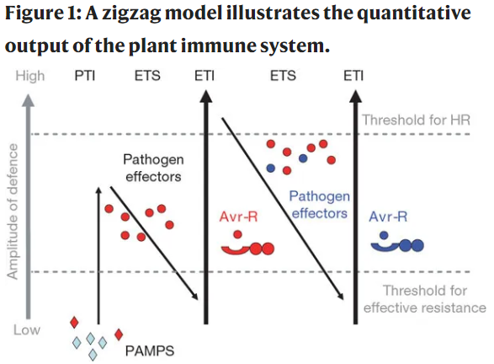(Jones and dangle 2006)

Because such a diverse group of molecules are able to trigger immune responses, and the type of plant response based on trigger molecule is not always consistent with the zig-zag model, the “danger model” has been proposed with term “danger signal” denoting all molecular triggers of plant immunity. Rather than classifying the immune response as simply PTI or ETI, it as been suggested that plant immune responses may be divided as either intracellular or extracellular, in what is called the “spatial immunity model.” This model suggests a distinct difference between extracellular immunogenic pattern (ExIP) which triggers an extracellularly triggered response (ExTR), and an intracellular immunogenic pattern (IxIP) which triggers an intracellularly triggered response (IxTR). Cell-surface receptors mediate recognition and activation of the ExTR, whereas intracellular, cytoplasmic receptors (mostly NLRs in the R protein class) recognize and activate the IxTR. The categorization of ExTR and IxTR rather than PTI and ETI may more truly represent the biology behind plant immunity. (Van der burgh and joosten, 2019).

